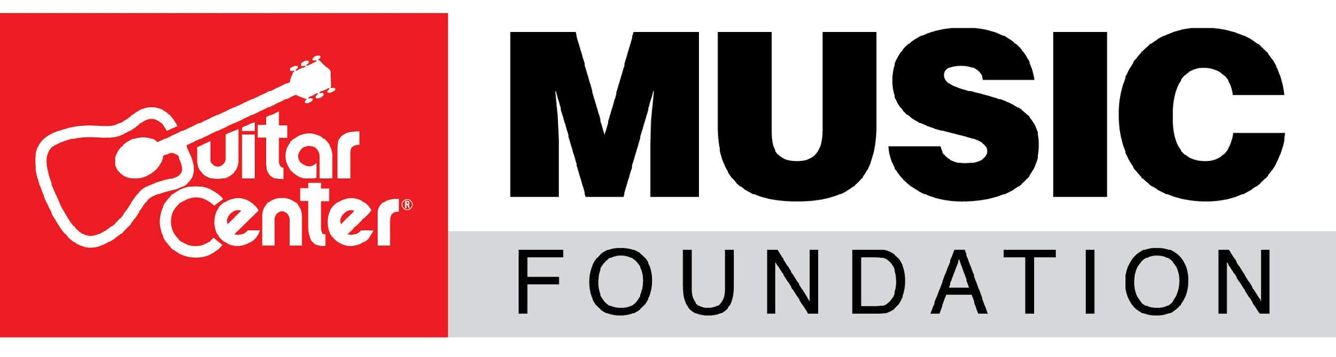

The Guitar Center Music Foundation expands Board of Directors with new appointments

Noted industry figures Alison Ball and Jae Deal join the organization’s leadership body

WESTLAKE VILLAGE, Calif., May 18, 2022 — The Guitar Center Music Foundation, a nonprofit organization focused on granting instruments to music education and music therapy organizations, announces the expansion of its Board of Directors with two new appointments: Alison Ball, the current president of TuneGO Music Technology and CEO of Alicat Media, and Jae Deal, award-winning composer and producer and USC faculty member, have joined the organization’s leadership body. The announcement was made by David Helfant, Chairman of the Board of Directors at The Guitar Center Music Foundation, and signifies the ongoing growth of the organization’s leadership team.

Alison Ball previously served as V.P. of A&R at Warner Brothers Records, and as current president of TuneGO, she has built a reputation as a leader in big data and emerging NFT technology. After commanding one of the most powerful talent rosters in Hollywood, at Warner Brothers, Ball observed the tides in the business shifting to tech. Ball’s career launched under the tutelage of legendary talent manager Shep Gordon. Today, Ball is a highly sought-after artist development coach at Alicat and is leading the new tech start-up TuneGO to new and extraordinary heights. Ball and TuneGO have even launched TuneGONFT, becoming the only transparent, secure platform for NFT management, while its patented TuneGO Vault quickly becomes the go-to-place for content security and creative rights protection.

Jae Deal is an award-winning composer, music producer and orchestrator known for his pop, gospel and hip-hop arrangements. Deal is also a session keyboardist, programmer and bassist who has worked with several prominent artists including Lady Gaga, Snoop Dogg, Diddy, Ne-Yo, Ty Dolla $ign and Wynton Marsalis. In 2019, he was the curator, music director and a producer of a Jammcard event that honored George Clinton and featured Ice Cube, CeeLo Green, Anderson .Paak and Flea. From 2008 to 2020, he was an orchestrator for Janet Jackson’s world tours. Deal has also contributed to projects for Elton John, Jill Scott and songwriter Diane Warren, performed with the Baltimore Symphony Orchestra and served as musical director for Kirk Franklin’s Youth Ministry at Faithful Central Bible Church. He was also a winner of the 2016 International John Lennon Songwriting Contest in the Hip-Hop category with co-composer Tia P., and the two were the first international winners of Australia’s Vanda & Young Songwriting Competition. He currently serves on the faculty at University of Southern California in the Music Technology program. Prior to joining USC, Deal developed and wrote the Songwriting I curriculum for the Los Angeles College of Music and taught Music Business classes at the Musicians’ Institute in Hollywood, CA.

David Helfant, Chairman of the Board of Directors at The Guitar Center Music Foundation, remarked, “Alison and Jae are welcome additions to our board. Their wealth of experience in the music industry, whether it be production, A&R, emerging technologies or beyond, affords them a set of valuable perspectives that will help shape the way the Foundation operates and the relationships we forge moving forward. Through education, mentorship and outreach, they both place a strong value on nurturing the next generation of talent, and that is very much in line with the opportunities that The Guitar Center Music Foundation makes possible through our initiatives. A hearty welcome to Alison and Jae!”

To learn more, visit http://www.GuitarCenterFoundation.org, or follow @GiveMusicLife on Twitter for more news or to discover ways to support The Guitar Center Music Foundation.

###

Photo file 1: AlisonBall.JPG
Photo caption 1: Alison Ball

Photo file 2: JaeDeal.JPG
Photo caption 2: Jae Deal

ABOUT THE GUITAR CENTER MUSIC FOUNDATION
The Guitar Center Music Foundation was founded as a 501(c)(3) in 2005. Since its inception, the foundation has placed instruments in the hands of over 300,000 people nationwide through grants to qualifying music education and music therapy programs. The foundation’s mission is to support music education programs nationally by providing those in need with instruments and by advocating for the benefits of music education and music therapy. For more information about The Guitar Center Music Foundation, please visit http://guitarcenterfoundation.org/.

ABOUT THE GUITAR CENTER
The Guitar Center is a leading retailer of musical instruments, lessons, repairs and rentals in the United States. With nearly 300 stores across the country and as one of the top direct sales websites in the industry, the Guitar Center has helped people make music for more than 50 years. The Guitar Center also provides customers with musician-based services, including lessons where musicians of all ages and skill levels can learn to play instruments in many musical genres. The Guitar Center also offers an on-site maintenance and repairs service called GC Repairs and GC Rentals, a program offering easy rentals of instruments and other sound reinforcement gear. The Guitar Center’s sister brands include Music & Arts, which operates more than 200 stores specializing in band and orchestral instruments for sale and rental, serving teachers, band directors, college professors and students. Another sister company, Musician’s Friend, is a leading direct marketer of musical instruments in the United States. For more information about Guitar Center, please visit www.guitarcenter.com.

CONTACT
Clyne Media | pr@clynemedia.com
The Guitar Center Music Foundation | info@GuitarCenterFoundation.org

