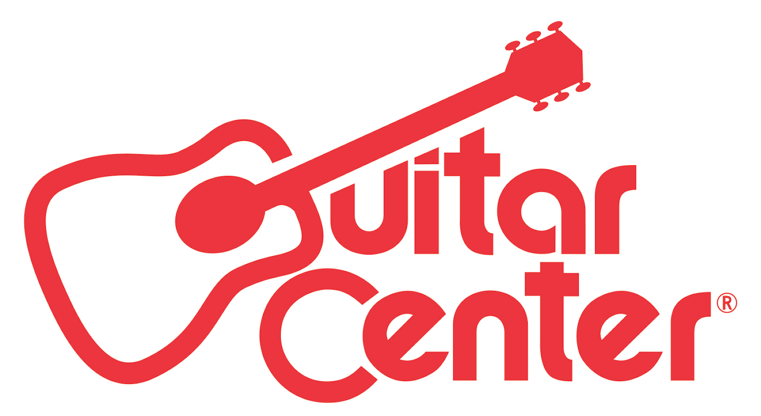

FOR IMMEDIATE RELEASE

GRAMMY® Award-Winning Producer Ariel Rechtshaid Names Kate Brady Winner of Guitar Center’s Fifth Annual Singer-Songwriter Program

ANNOUNCEMENT HIGHLIGHTS:
- Colorado native Kate Brady receives opportunity to record an EP with celebrated producer Ariel Rechtshaid, perform on Jimmy Kimmel Live!, be mentored by City and Colour, $25,000 cash, and more
- As the winner, Brady topped nearly 14,000 program entries
- The finals event hosted by Clara C included performances by Singer-Songwriter 4 winner Lanita Smith, Jessica Sanchez (American Idol) and special live set by City and Colour

Los Angeles, CA (March 17, 2016): Guitar Center has announced Boulder, Colorado native Kate Brady as the winner of the fifth annual Guitar Center Singer-Songwriter artist discovery program. As the winner, Brady will receive a career-boosting package including the opportunity to record a four-song EP with GRAMMY® Award-winning producer Ariel Rechtshaid, mentorship from folk singer-songwriter City and Colour, a performance on Jimmy Kimmel Live!, $25,000 cash, brand new musical equipment, and much more.

Out of nearly 14,000 entries this year, five finalists were selected to perform live at the grand finals event Friday, March 4, at the Troubadour in Hollywood, CA, hosted by established singer-songwriter Clara C. Following an opening performance by last year’s Guitar Center Singer-Songwriter winner Lanita Smith in collaboration with American Idol’s Jessica Sanchez, the five finalists took to the stage to perform their craft live in front of an audience and judges. City and Colour entertained the crowd with a special, intimate performance as program judge Ariel Rechtshaid deliberated, and ultimately named Brady the winner.

Watch Kate Brady’s winning performance here: https://youtu.be/sm9qgeEKbb8

"Thank you so much again to Guitar Center and everyone involved for making this possible. I feel incredibly fortunate to have been selected by such a team of musical geniuses, and with their help, I can't wait to make my artistic goals a reality."
- Kate Brady, Winner of Guitar Center Singer-Songwriter 5

As Guitar Center’s Singer-Songwriter 5 Winner, Kate Brady Will Receive:
- 4-song EP and studio time with Ariel Rechtshaid
- Mentoring songwriting session with City and Colour
- Performance slot on Jimmy Kimmel Live!
- $25,000 Cash
- Showcase performance on the Grand Plaza Stage at the 2017 Winter NAMM show
- New gear from top instrument retailers from AVID, Bose®, Martin, Gibson Memphis, Shure, Roland, D’Addario, TC-Group, Dunlop, Acoustic Amplification and Zoom
- A Write Up in American Songwriter Magazine

“Guitar Center’s Singer-Songwriter program has quickly become a premier platform for aspiring songwriters to share their music with the world. There’s nothing more important to us than helping people make music, and we’re excited to be the catalyst to help incredibly talented artists like Kate Brady attain a successful career in music.”
– Jake Cheung, Manager, Music Marketing + Artist Relations, Guitar Center

“This is one of those rare and great opportunities for an aspiring artist. It's very cool and generous that Guitar Center has a program set up to help unsigned DIY musicians around the country by providing all these resources with no strings attached. Helping an artist like Kate Brady, from Boulder, Colorado, who has talent and ambition, is why I took part in this. I want to dig deeper and find great talent with a point of view from anywhere in the world, who only needs an opportunity. Helping artists realize their vision is a big part of why I do what I do.”
- Ariel Rechtshaid, GRAMMY Award-winning producer and Guitar Center Singer-Songwriter Judge

-30-

Photo file: KateBrady.JPG
Photo caption: Kate Brady, winner of Guitar Center Singer Songwriter 5. | Credit: Guitar Center.

About Kate Brady:
Kate Brady is a senior at University of Colorado, Boulder, studying creative writing and poetry. She grew up in the Rocky Mountains and her sound and lyrics reflect the area's natural aesthetics and call for quiet contemplation. She's been writing songs and poems since the early years of childhood and her primary intention is to create community with her music.

About Ariel Rechtshaid:
Ariel Rechtshaid is a GRAMMY® Award-winning producer, engineer, multi-instrumentalist and songwriter. He is known and praised for his work with a diverse list of artists, including Haim, Sky Ferreira, Vampire Weekend, Charli XCX, Brandon Flowers, Madonna, Tobias Jesso Jr., Usher, Carly Rae Jepson, Cass McCombs and Justin Bieber among many others. In 2014, Rechtshaid was nominated for a "Producer of the Year" GRAMMY and won for his production on Vampire Weekend's Modern Vampires of the City, which was awarded "Best Alternative Music Album." Of Rechtshaid, The New Yorker asserts, "His sounds have an odd brightness, so that even intensely personal songs end up feeling buoyant, and—here is where the labels start writing checks—he is exceptionally good at getting the best out of singers. His approach differs from that of producers who make their name with a sound that watermarks each song and can risk overshadowing the vocalist," while Stereogum proclaims, "If anyone working right now can change the way pop music sounds, it’s Ariel Rechtshaid." Moreover, Pitchfork calls him, "...a go-to pop producer of the highest caliber."

About Guitar Center:
Guitar Center is the world’s largest retailer of guitars, amplifiers, drums, keyboards, recording, live sound, DJ, and lighting equipment. With more than 270 stores across the U.S. and one of the top direct sales websites in the industry, Guitar Center has helped people make music for more than 50 years. In addition, Guitar Center’s sister brands includes Music & Arts, which operates more than 140 stores specializing in band & orchestral instruments for sale and rental, serving teachers, band directors, college professors and students, and Musician’s Friend, a leading direct marketer of musical instruments in the United States. With an unrivaled in-store experience, an industry-leading online presence and passionate commitment to making gear easy-to-buy, Guitar Center is all about enabling musicians and non-musicians alike to experience the almost indescribable joy that comes from playing an instrument. For more information about Guitar Center, please visit www.guitarcenter.com.

You can visit our press room at http://www.guitarcenter.com/pages/press-room and send media inquiries to media@guitarcenter.com.

FOR MORE INFORMATION PLEASE CONTACT:
Natania Reed | ANTHEMIC Agency | 323.464.4745 x 806 | natania@anthemicagency.com
Robert Clyne | Clyne Media, Inc. | 615-662-1616 | Robert@clynemedia.com
Syvetril Perryman | Guitar Center | 818.735.8800 | media@guitarcenter.com

