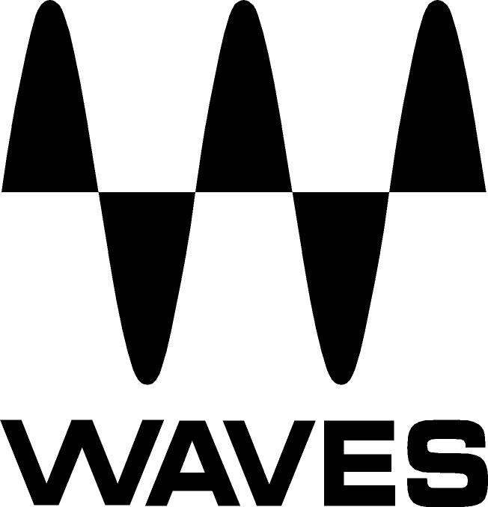
PRESS RELEASE
Contact: Clyne Media, Inc.
Tel: (615) 662-1616

FOR IMMEDIATE RELEASE

Waves Now Shipping the Free COSMOS AI-Powered Sample Finder

Knoxville, TN, February 15, 2022 — Waves Audio, the world’s leading developer of professional audio signal processing technologies and plugins, is now shipping the free COSMOS AI-Powered Sample Finder (also included in the Waves CR8 Creative Sampler).

If you’re a musician or a producer, your sample collection is a creative treasure—but only if you can find the right sample when you need it, without searching for misplaced or misnamed samples in disorganized folders. Waves COSMOS solves this issue by bringing all the one-shots and loops on your hard drive into one easy-to-search place. It uses advanced Waves Neural Networks technology in order to analyze, auto-tag, and sort your entire collection of samples into one unified database where you can easily find everything. No matter where you placed your samples, or how the files are named – COSMOS will find them for you.
COSMOS allows you to see all your samples visually laid out in front of you, in three accessible views: Waveform, List, and Cosmos. You can filter and search all your one-shots and loops by instrument, BPM, key and even sonic characteristics such as brightness, saturation, and dynamics.
Need to find a distorted kick? Just type “distorted” and “kick” in COSMOS, and all your distorted kicks will show up, no matter what the files are actually named. Need to find a bright, reverby drum loop in 120 BPM? Or a saturated synth sample in F#-minor with a cinematic feel? Just choose the appropriate tags, and COSMOS will deliver the samples you’re after, instantly.

You can easily listen to your samples from within COSMOS, with just one click. Then just drag-and-drop the sample you want straight into your sampler or DAW.

COSMOS can open as a standalone app – or from within the new Waves CR8 Creative Sampler plugin, with which it integrates seamlessly for a super-fast and creative workflow.

COSMOS also comes pre-packed with over 2500 royalty-free one-shots and loops.

COSMOS features:
- Turns all your sample folders into one instantly searchable database
- Analyzes and auto-tags all your one-shots & loops using AI
- Search all your samples by instrument, BPM, key, character & more
- Three accessible browsing views: Waveform, List and Cosmos
- Create sample collections and favorites for quick future use
- Compatible with all WAV, AIF, OGG and FLAC files
- Use standalone or with the Waves CR8 Creative Sampler
- Powered by Waves Neural Networks technology
- Includes over 2500 free samples

With Waves COSMOS, you can finally search your entire collection of samples faster and easier than ever – without ever again needing to waste precious time digging through multiple disorganized folders.

Waves COSMOS videos:

NEW & FREE! Waves COSMOS AI-Powered Sample Finder: https://youtu.be/6xNqnz3VGu4

How to Find Your Samples with Waves COSMOS: https://youtu.be/XQNzPz79NzQ

…ends 423 words

Photo file 1: COSMOS.JPG
Photo caption 1: Waves COSMOS AI-Powered Sample Finder interface

About Waves Audio Ltd.:
Waves is the world’s leading developer of audio DSP solutions for music production, recording, mixing, mastering, sound design, post-production, live sound, broadcast, commercial and consumer electronics audio markets. Since its start in the early '90s, Waves has developed a comprehensive line of over 250 audio plugins and numerous hardware devices. For its accomplishments, Waves received a Technical GRAMMY® Award in 2011, and its early flagship plugin, the Q10 equalizer, was selected as an inductee into the TECnology Hall of Fame.

Increasingly leveraging pioneering techniques in artificial intelligence, neural networks and machine learning, as well as the company’s three decades of accumulated expertise in psychoacoustics, Waves technologies are being used to improve sound quality in a growing number of market sectors. Around the world, Waves’ award-winning plugins are utilized in the creation of hit records, major motion pictures, and top-selling video games. Additionally, Waves now offers hardware-plus-software solutions (including the revolutionary eMotion LV1 mixer) for professional audio markets. The company’s WavesLive division is a leader in the live sound sector, spearheading the development of solutions for all live platforms. Products from Waves Commercial Audio enable A/V system integrators and installers to deliver superior sound quality for corporate, commercial, government, educational, entertainment, sports and house-of-worship applications. Under its Maxx brand, Waves offers semiconductor and licensable algorithms for consumer electronics applications, used in laptops, smartphones, smart speakers, gaming headsets, TVs and more from industry leaders such as Dell, Google, Fitbit, Acer, Asus, Hisense and others.

North America Offices:
Waves, Inc., 2800 Merchants Drive, Knoxville, TN 37912;
Tel: 865-909-9200, Fax: 865-909-9245, Email: info@waves.com,
Web: http://www.waves.com

Corporate Headquarters Israel:
Waves Ltd., Azrieli Center, The Triangle Tower, 32nd Floor, Tel Aviv 67023, Israel;
Tel: 972-3-608-4000, Fax: 972-3-608-4056, Email: info@waves.com,
Web: http://www.waves.com

Waves Public Relations:
Clyne Media, Inc., 169-B Belle Forest Circle, Nashville, TN 37221;
Tel: 615-662-1616, Email: robert@clynemedia.com,
Web: http://www.clynemedia.com

