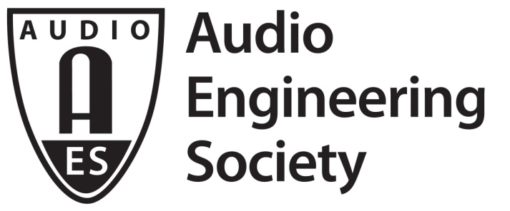

FOR IMMEDIATE RELEASE

The Audio Engineering Society Celebrates 70 Years of the Art and Science of Audio: President’s Message from David Scheirman

— The AES continues to lead the cutting edge of audio engineering technology and techniques, building on its core involvement in the advancement of the art and science of audio —

New York, NY, October 15, 2018 — The Audio Engineering Society, founded in 1948, has grown to become the preeminent international organization unifying audio engineers, creative artists, scientists and students worldwide by promoting advances in audio and disseminating new knowledge and research. Now, in celebrating its 70th year, the AES continues to forge ahead with new and exciting opportunities and offerings for its members and the audio engineering community worldwide, serving as the only professional society devoted exclusively to audio science and technology and hosting a forum through which ideas and personas continue to reach higher levels of audio excellence and understanding.

AES President David Scheirman shares the following message with the AES Membership and the entire professional audio engineering community:

2018 marks the 70th year of existence of The Audio Engineering Society. When we consider what that really means, it’s a remarkable achievement. As industry, research, academia and technical applications are all drawn more closely together, the Society’s mission remains a constant: to promote the science and practice of audio by bringing leading people and ideas together.

The first AES meeting took place on February 17, 1948, at New York City’s RCA Victor recording studios. An original volunteer executive committee of five individuals (J.D. Colvin, C.J. LeBel, C.G. McProud, N.C. Pickering and C.A. Rackey) worked to assist the young professional society in establishing its first ‘constitution,’ now known as the Society’s Bylaws. Remarkably durable, the Audio Engineering Society’s Bylaws have guided our corporate governance efforts now for seven decades.

70 years ago, the audio industry – and indeed our entire culture – was very different. In 1948, technology advances in the news included the LP (Long Playing) record and the transistor radio, and the new-fangled television set was just starting to become more common in private homes. Things we now take for granted were surprising the world and turning heads: the Porsche automobile company was founded that year, the first Random Access Storage Device became available, and a new swimming suit style known as the bikini was making a splash. The Soviets were blockading West Berlin, and Israel was being established as an independent state.

Within our industry, it was noted that ‘engineers engaged in the field of audio are generally agreed that there is a definite advantage to a professional society as a means of disseminating information and promoting intelligent study of the problems pertaining to their interests, but there has been considerable doubt that their field has been covered adequately.’ So stated the March 1948 issue of Audio Engineering. This was the reason for establishing the then-named Organizing Committee for the Formation of the Audio Engineering Society. These early pioneers focused on their common interests when coming together as a group. Public address systems, studio design and use, tape and wire recording, and high-quality home reproduction were key areas of interest.

Today, 70 years hence from that first meeting, audio professionals still gather to discuss, learn about, and advance the art and practice of these disciplines, along with many more. Emerging technologies and the results of audio research continue to be highlighted in the Journal of the Audio Engineering Society, historical developments in the field from those seven decades can be sourced within the Society’s online E-Library, and the new AES Live: Videos series brings a new dimension to learning about audio.

With good fortune (knock on neodymium!), many current members and a host of today’s professional audio and software companies who proudly support the AES will be on hand to help celebrate the Audio Engineering Society’s 100th Anniversary, a momentous event to look forward to in 2048.

Scheirman will address attendees of the AES New York 2018 International Convention during the Opening Ceremonies, taking place Wednesday, October 17, 12:15 pm – 2:15 pm at the Javits Convention Center.

The Opening Ceremonies and other Special Events presentations at the AES New York 2018 Convention, including the keynote address by Thomas Dolby and Heyser Lecture by John Meyer, are open to all AES New York 2018 attendees, and access is free with your Exhibits-Plus advance registration (use code AES18NOW at checkout). All Access registration is the ticket to everything the Convention has to offer. Advance registration is open through Monday, October 15 at aesshow.com. AES Members, including student members, enjoy substantial discounts on All Access registration. Registration at any level for AES New York 2018 includes access to the NAB Show New York exhibition.

...ends 726 words

Photo File: Scheirman.JPG
Photo Caption: AES President David Scheirman

About the Audio Engineering Society
The Audio Engineering Society, celebrating its 70th anniversary in 2018, now counts over 12,000 members throughout the U.S., Latin America, Europe, Japan and the Far East. The organization serves as the pivotal force in the exchange and dissemination of technical information for the industry. Currently, its members are affiliated with 90 AES professional sections and more than 120 AES student sections around the world. Section activities include guest speakers, technical tours, demonstrations and social functions. Through local AES section events, members experience valuable opportunities for professional networking and personal growth. For additional information visit aes.org.

Join the conversation and keep up with the latest AES News and Events:
Twitter: #AESorg (AES Official)
Facebook: facebook.com/AES.org

AES Marketing Communications:
Email: robert.clyne@aes.org
Tel: 615-662-1616, Fax: 615-662-1636,
Clyne Media, Inc.,
169-B Belle Forest Circle, Nashville, TN 37221;
Web: http://www.clynemedia.com

