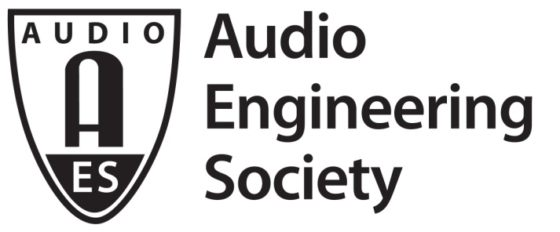

FOR IMMEDIATE RELEASE

AES Academy 2020 Advance Registration Opens Today!

— Held in conjunction with The 2020 NAMM Show, the AES Academy offers four days of career enhancement for the professional audio community —

New York, NY, August 28, 2019 — The Audio Engineering Society has announced that Advance Registration opens today, August 28 for AES Academy 2020. Held in conjunction with The NAMM Show in Anaheim, CA, January 16 – 19, 2020, the AES Academy features presentations that offer a unique opportunity for the pro-audio community to experience the latest production tools and techniques for studio and stage applications.

“AES Academy events provide audio engineers an opportunity to refresh their skills and learn best practices in expert-led sessions while networking with other professionals at a key time of the year for the industry,” states AES Academy Program Director Mark Frink.

The four-day AES Academy (formerly AES@NAMM) comprises a series of Training Academies and related sessions covering line-array technologies, live-sound mixing consoles, studio and wireless microphones and control room environments, in addition to tutorials on sound system measurement and optimization and other insights into the audio sciences and their application.

AES Academy sessions are held in the NAMM U Education Center on the fourth floor of the Anaheim Hilton on The NAMM Show campus.

Key activities in AES Academy 2020’s comprehensive schedule of training sessions and career enhancement activities include:

The Measurement & Optimization Academy returns with AFMG’s Bruce Olson and Excelsior’s Charlie Hughes presenting Thursday and Friday morning, Rational Acoustics’ James Anderson and Chris Tsanjouries present Thursday through Saturday afternoons and iSEMcon’s Wolfgang Frank finishes each day with a presentation on measurement microphones.

In its third year, the Live Console Academy returns with four days of sessions where technical partners Yamaha and Allen & Heath will host a variety of twice daily, half-day hands-on console training workshops. The Line Array Academy also offers four days of workshops in a classroom setting. Bringing the boom is the focus of the newly developed Electronic Dance Music (EDM) Academy on Saturday. Daily live sound Keynote sessions will be held on the AES Academy’s Main Stage: Live.

On Thursday, Audio Science & Technology sessions present specially curated topics in one-hour sessions. The Control Room Academy will present four two-hour training sessions, both Thursday and Friday, on control room applications of leading technologies.

On Friday, the In Ear Monitor Academy returns with sessions covering all aspects of IEM fundamentals. As in previous years, Free Hearing Screening and Free Digital IEM Scanning by Ultimate Ears will be available in the AES Academy registration area on the Hilton’s fourth floor. Microphone Academy events on Friday will explore DPA Microphone’s piano, orchestra and choir mic solutions, Townsend Labs’ virtual microphone and Royer Labs’ ribbon mics. On Saturday, the Wireless Academy returns, leading off with a special 2020 spectrum update panel highlighting recent changes to U.S. RF spectrum availability. Saturday also features a special House of Worship focus of console and wireless sessions.
Recording guru and noted author Bobby Owsinski returns by popular demand for a special Main Stage Studio series of Saturday sessions. Also on Saturday, the new Audio Education Academy sessions will offer innovative educational insights to high school and college audio educators.

All AES Academy sessions are available to current AES members, including students, at a $25 advance registration rate. AES Memberships ($125 for professionals, $50 for students) are available online if you wish to join prior to registering. Non-member Advance Registration is $150 for professionals and $75 for students. Credential pickup will be in the Anaheim Hilton’s fourth-floor AES registration lounge (on-site registration rates will be higher than Advance Registration fees).

AES Academy registrants can purchase discounted badges to The 2020 NAMM Show exhibits and may additionally purchase tickets to Saturday night’s TEC Awards, in advance or at on-site registration. NAMM Exhibits badges are just $25 for AES Academy attendees before November 1.

Find out more at aesacademy2020.com, and register now to join us in Anaheim.

...ends 619 words

Photo File: AES_Academy_2020.JPG
Photo Caption: Registration opens August 28 for the upcoming AES Academy 2020 in Anaheim in January

About the Audio Engineering Society
The Audio Engineering Society, celebrating over 70 years of audio excellence, now counts over 12,000 members throughout the U.S., Latin America, Europe, Japan and the Far East. The organization serves as the pivotal force in the exchange and dissemination of technical information for the industry. Currently, its members are affiliated with 90 AES professional sections and more than 120 AES student sections around the world. Section activities include guest speakers, technical tours, demonstrations and social functions. Through local AES section events members experience valuable opportunities for professional networking and personal growth. For additional information, visit aes.org.

Join the conversation and keep up with the latest AES News and Events:
Twitter: #AESorg (AES Official)
Facebook: facebook.com/AES.org
Official hashtag for The 2020 NAMM Show: #NAMMShow

AES Marketing Communications:
Email: robert.clyne@aes.org
Tel: 615-662-1616, Fax: 615-662-1636,
Clyne Media, Inc.,
169-B Belle Forest Circle, Nashville, TN 37221;
Web: http://www.clynemedia.com

