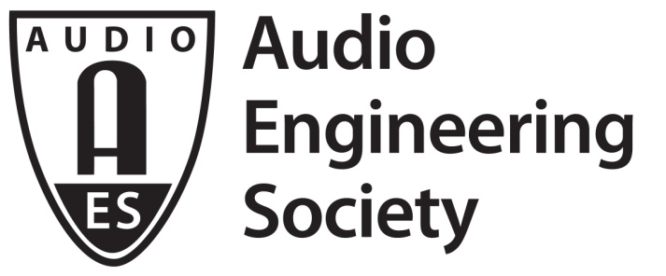 | PRESS RELEASE  Conference contacts:  Co-Chair Linda Gedemer  2016avar_chairs@aes.org| +1 818.943-5706  Co-Chair Andres Mayo  2016avar_chairs@aes.org | +54 (11) 4718-1234

FOR IMMEDIATE RELEASE

Top Industry Experts Slated for AES Conference on Audio for Virtual and Augmented Reality

— Conference will focus on VR/AR creative process, applications workflow and product development —

New York, NY, August 29, 2016 — The inaugural AES International Conference on Audio for Virtual and Augmented Reality, to be held on September 30 and October 1, 2016, will feature some of the most cutting edge content developers, researchers and manufacturers currently working in audio for VR/AR such as Magic Leap, BBC, Dolby, Sennheiser, Qualcomm, NASA, Fraunhofer, DTS, and many more. Presentations at the conference, co-located with the 141st AES Convention at the Los Angeles Convention Center’s West Hall, will appeal to wide audience, from those who are currently involved in the audio for VR/AR industry to anyone who is interested in entering in this exciting field. The companion technology showcase will feature displays and demonstrations of the latest offerings from leading manufacturers in VR / AR audio.

"This industry is moving so fast that it's been really exhilarating to watch it evolve. Audio takes on a new role when it comes to VR/AR content as sound is now part of the experience, not just an aid in conveying story," states Linda Gedemer, conference co-chair and CTO of Source Sound VR. Linda further explains; "We can hear in 360º unlike our visual field, which is obviously limited to what is seen directly in front of us. Because of this, audio now takes a leading role for content creators by aiding them to direct their audience on where to look next; it is central to guiding the audience through the story."

The conference program has been carefully developed to provide a comprehensive overview of VR/AR creative processes, applications, workflows and product developments. Presentations will cover a variety of technical and practical aspects of audio for VR/AR, including papers on the latest developments in research to workshops and tutorials demonstrating cutting edge production tools. The opening keynote speech will be given by Philip Lelyveld, who runs the Virtual Reality / Augmented Reality Initiative at the University of Southern California's Entertainment Technology Center which is a think tank within USC's School of Cinematic Arts. The closing keynote will be given by George Sanger, 'Grand Vizier of Noise' for Magic Leap. In his role as Audio Director, George guides the Sonic Arts team at Magic Leap - a startup that is reimagining reality and inventing the future using digital lightfields.

The two-day program of technical papers, workshops, tutorials along with a manufacturer’s technology showcase will highlight challenges as well as creative and technical solutions to providing spatial audio for virtual reality and augmented reality media. This conference proves timely as virtual and augmented reality are demonstrably the fastest-growing section of the entertainment-audio markets.

This must-attend conference will be held within a recently-remodeled 300-seat theater and companion seminar room at the LA Convention Center. Conference registrants can also attend the 141st AES Convention’s companion exhibition along with select educational sessions and special events free of charge with an Exhibits-Plus badge included in the cost of their conference fees.

Costs to attend range from $125 for AES students members, $195 for a 1-day pass for AES members ($295 for a member 2-day pass), to $280 / $435 for non-members.

For further information on the 2016 International Conference Audio for Virtual and Augmented Reality, visit http://www.aes.org/conferences/2016/avar/. Follow us on Twitter (https://twitter.com/audioforvr) and Facebook (http://bit.ly/1R4leDI). For more about the 141st Audio Engineering Society International Convention in Los Angeles, visit http://www.aes.org/events/141/. Find out more about the Audio Engineering Society at aes.org.

...ends 593 words

Photo File: 2016AVAR.jpg
Photo Caption: Logo for AES AVAR Conference

About the Audio Engineering Society
The Audio Engineering Society was formed in 1948 and now counts near 14,000 members throughout the Americas, Europe, Asia, the Middle East and Africa. The organization serves as the pivotal force in the exchange and dissemination of technical information for the industry, ranging from foundational science to practical application. Society members are affiliated with more than 75 AES professional sections and more than 95 AES student sections around the world. Through local AES section events, members experience valuable opportunities for professional networking and personal growth. Section activities may include guest speakers, technical tours, demonstrations and social functions. For additional information visit http://www.aes.org.

Join the conversation and keep up with the latest AES News and Events:
Twitter: #AESorg (AES Official) | Facebook: http://facebook.com/AES.org

AES Marketing Communications:
Email: robert.clyne@aes.org
Tel: 615-662-1616, Fax: 615-662-1636,
Clyne Media, Inc.,
169-B Belle Forest Circle, Nashville, TN 37221;
Web: http://www.clynemedia.com

