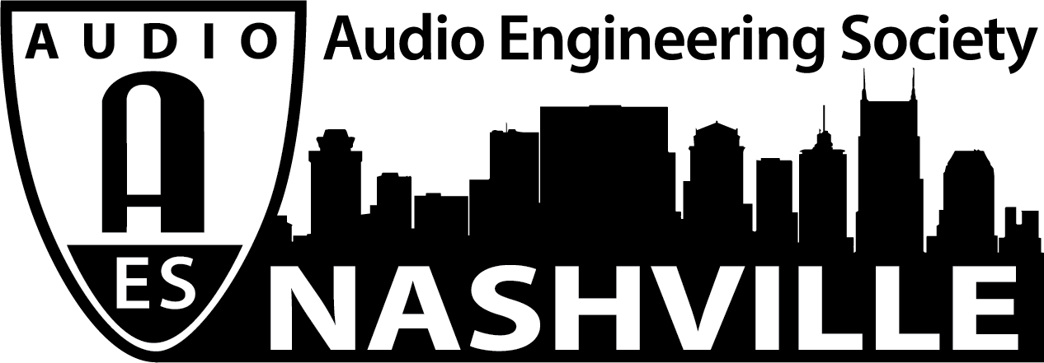

FOR IMMEDIATE RELEASE

AudioMasters Nashville Pro Audio Golf Tournament Welcomes 2020 Title Sponsors DiGiCo and Westlake Pro

- The DiGiCo AudioMasters Live and the Westlake Pro AudioMasters will take place May 14 and 15 in Nashville —

Nashville, TN, February 14, 2020 — The AudioMasters Nashville Benefit Golf Tournament has announced this year’s title sponsors for its 23rd annual event; the DiGiCo AudioMasters Live takes place May 14 and the Westlake Pro AudioMasters on May 15 at the Harpeth Hills Golf Course in Nashville, TN. “Live Day” title sponsor DiGiCo, and “Studio Day” title sponsor Westlake Pro will play host to dozens of audio professionals from the Nashville community and beyond, for one of the most anticipated events of the year, which also serves as the primary funding mechanism for the local 501(c)(3) non-profit Nashville Engineer Relief Fund (NERF).

“The AudioMasters and the Nashville Engineer Relief Fund show how Nashville audio professionals are truly a community. DiGiCo is proud to be plugged in to that unique community, and to show our support by returning as the title sponsor of the AudioMasters Live,” said Matt Larson, VP Professional Audio, Group One Ltd.

“The AudioMasters is great fun for a great cause,” shared Westlake Pro President Joe Taupier. “Westlake Pro has been honored to participate since the opening of our Nashville location and to do our part in supporting our local audio engineering community.”

Golfers can register now at audiomastersnashville.com to join in on the fun. Each day will feature a variety of golf and networking activities, from breakfast on the driving range, to the catered awards reception, dubbed “the 19th hole.” Every course hole is sponsored by an array of area studios, live sound providers, service and sales companies, industry organizations, manufacturers and others with ties to the Nashville audio community, with activities at every tee, ranging from food and beverage, to swag, competitions and more.

The tournament is produced by the Nashville AES Section with AudioMasters Nashville 2020 event coordinator Karen Dunn of KMD Productions. Sponsorship opportunities range from hole sponsors, to drink carts, to the awards reception – limited sponsorship opportunities are still available.

Find out more and register now at audiomastersnashville.com and follow the AudioMasters Nashville on Instagram, Facebook, and Twitter for the latest updates and information.

...ends 335 words

Photo File1: AMN2020_Logo.JPG

For more information, contact Karen Dunn: karen@kmdpro.com or (925) 728-0307

