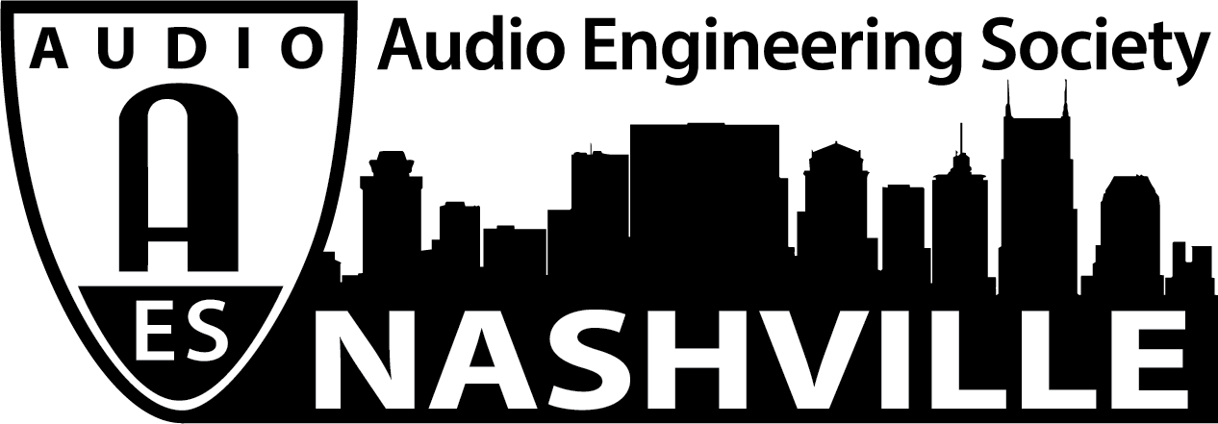

FOR IMMEDIATE RELEASE

The Nashville Engineer Relief Fund and AES Nashville Section Present “Shine On – The Making of And We All Shine On: A Tribute to John Lennon from Music City”

— NERF and the Nashville audio community shift focus to online charity event in place of 2020 AudioMasters Golf Tournament —

Nashville, TN, August 7, 2020 — The Nashville Engineer Relief Fund (NERF) and AES Nashville Section announce “Shine On – The Making of And We All Shine On: A Tribute to John Lennon from Music City” – a free online event rediscovering the music created for the 2012 NERF fundraiser album helmed by Steve Marcantonio, longtime AES Nashville Section member and audio engineer for John Lennon and countless others. Set to take place on Tuesday, August 11, from 7:00pm – 9:00pm CDT, the Zoom-based event will feature a live-streamed moderated discussion with three of the album’s producers: Marcantonio, Nicole Cochran and Sharon Corbitt, with special guests including long-time Lennon producer-engineer Jack Douglas and artist Bill Lloyd. In addition to delving into the album’s inspiration and production along with tributes to John Lennon’s songwriting, recording and personal legacy, the album will be made available to those who wish to make a donation to NERF as it continues its outreach through these extraordinary times. We invite you to join us as we celebrate the Nashville audio community and examine an exemplary piece of our cultural heritage. The event is sponsored by the Recording Academy Producers and Engineers Wing, in partnership with the AES Nashville Section, and 100% of the proceeds will go to the Nashville Engineer Relief Fund.

And We All Shine On was put together by Marcantonio as a heartfelt tribute to John Lennon, and released originally in 2012 as a benefit tribute with all proceeds going to NERF. The album includes 10 handpicked favorites from Lennon's solo works, performed by some of Nashville's finest musicians utilizing several of Nashville's top studio facilities including Starstruck Studios, Ben’s Studio, Blackbird, Sony Tree Studios, Ocean Way Nashville, and more. All proceeds from Shine On will go to NERF, the beneficiary of the beloved AudioMasters Nashville Benefit Golf Tournament and other community events that provide financial support to the ultimate beneficiaries – Nashville audio engineers and their families in times of need. The event is made possible by support from the Producers and Engineers Wing of The Recording Academy – a perennial supporter of the AudioMasters, the Audio Engineering Society and the AES Nashville Section.

Track listing and artists featured on And We All Shine On include:
Love – Gretchen Peters
Whatever Gets You Through the Night – Jeff Hanna and Matraca Berg
Look at Me – Rosanne Cash
Nobody Loves You – Billy Falcon
Jealous Guy – Shawn Camp
Oh My Love – Rodney Crowell
Isolation – Judson Spence
Mother – James House
Crippled Inside – Foster and Lloyd
Instant Karma – The Vinyl Kings

Find out more and register now at https://aes-nerfjohnlennontribute.eventbrite.com/ and follow AudioMasters Nashville on Instagram, Facebook, and Twitter for the latest updates and information.

...ends 434 words

Photo File1: Shine_On_2020.JPG
Photo Caption1: The Nashville Engineer Relief Fund (NERF) and AES Nashville Section present “Shine On – The Making of And We All Shine On: A Tribute to John Lennon from Music City” free online event set for Tuesday, August 11

For information, contact Karen Dunn: karen@kmdpro.com or (925) 728-0307

About the Album And We All Shine On: A Tribute to John Lennon from Music City
And We All Shine On: A Tribute to John Lennon from Music City will be reissued with a virtual kick-off on August 11 at 7:00 pm. The project was produced by Nashvillian Steve Marcantonio, one of Lennon’s engineers, who was working with him at the Record Plant in New York City an hour before he was shot in front of his home in 1980.

Marcantonio hand-picked the artists that appear on And We All Shine On based on their shared love for the slain music icon and his music. They include: Rodney Crowell who sings “Oh My Love”, Foster and Lloyd reunited to brilliantly cover “Crippled Inside,” Jeff Hanna and Matraca Berg sing “Whatever Gets You Through The Night” and songstress Gretchen Peters offers the song ”Love” to the collection of Lennon songs.

And We All Shine On is the only Lennon tribute recorded with Yoko Ono’s consent. John Lennon had a personal affection for audio engineers, so Ono was quick to give Marcantonio her blessing if a promise was made that 100% of the profits benefit the Nashville Engineer Relief Fund (NERF) – a benevolent fund that gives a hand-up to area engineers in times of crisis, which is also very close to Marcantonio’s heart. Like most professions worldwide, sound engineers have been dramatically impacted by the Covid-19 pandemic. Frank Wells, an AES Past President and Secretary of NERF (an independent 501(c)(3) non-profit charitable corporation founded by the Audio Engineering Society Nashville Section) shares, “Our annual fundraiser, the AudioMasters Benefit Golf Tournament, was canceled for 2020 as a result of Covid and this record is one of our greatest assets. We are so grateful to Steve and Yoko for allowing us to release it digitally as we first did in 2011 with the still available CD.” And We All Shine On will be exclusively distributed digitally by TuneCore, with details available soon.
A virtual event featuring Marcantonio, Wells, NERF President (also an AES Past President) Jim Kaiser, executive producers Sharon Corbitt and Nicole Cochran, as well as other surprise guests connected to the project will be online on August 11 at 7:00 pm. Event info, registration and CD ordering info can be found at theaudiomasters.org.

