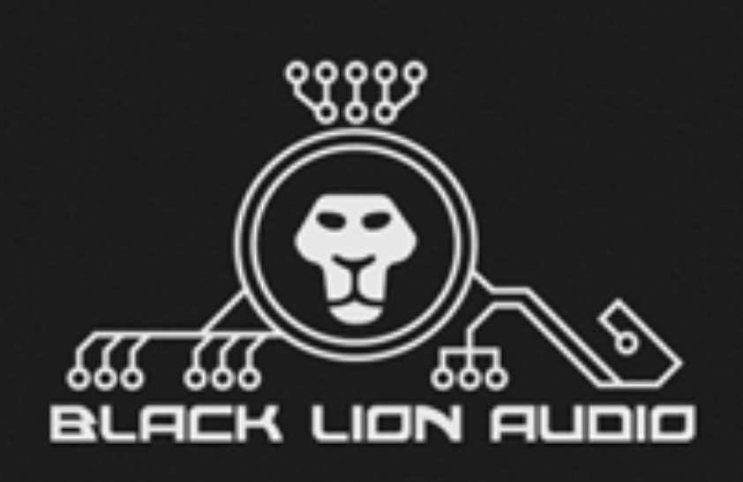
Press Contact:  Robert Clyne  President  Clyne Media, Inc.  (615) 662-1616  robert@clynemedia.com |  | Company Contact:  Nate Bierdeman  CEO  Black Lion Audio  773-549-1885  nate@blacklionaudio.com

Black Lion Audio Offers 20-Percent Mod Sale

Famous Black Lion Audio gear mods on sale for the entire month of April

Chicago, IL, April 1, 2016 - Black Lion Audio (BLA) built its reputation on making gear better, taking the conversion and interface products already in engineers’ racks and improving the circuitry for greater sonic fidelity. For the month of April, the entire suite of BLA modification services is on sale for twenty-percent off the normal pricing.

“Everyone can use a tax season break, and a way to stretch their budget,” says Nate Bierdeman, BLA CEO, “so we’re offering our modification services at a discount for all of April. Black Lion Audio modifications are a great way to improve your signal chain sonics by affordably upgrading gear you already own or can often buy inexpensively.”

BLA’s modifications include both analog and digital circuitry, depending on the possibilities offered by the original hardware design. Improving analog stage circuitry can make a drastic difference for tracking, mixing and mastering, with amazing micro-dynamics and space the result of op-amp and signal path capacitor upgrades. Proprietary decoupling of power supplies and digital signal paths in A/D and D/A converter designs reduces the noise generated during conversion, resulting in crisp, clear audio. Additional possibilities include improvements in digital clocking for improved signal clarity, nuance and articulation.

“We put sound quality first,” Bierdeman proclaims, “continuously chasing perfect sound, and our modification techniques grew out of that pursuit. We want to amaze our customers as we were amazed by the improvements our modifications and our own product designs offer.”

The BLA modification menu includes gear from Alesis, Antelope, Apogee, Avid, Behringer, Dangerous Music, Digidesign, Echo Audio, Focusrite, Mackie, M-Audio, MOTU, RME, Steinberg, SPL and Universal Audio.

For more information on the complete range of Black Lion Audio modification services and products, visit www.blacklionaudio.com.
…ends 279 words

Disclaimer: Other brand and product names may be trademarks of the particular companies with which they are associated.

