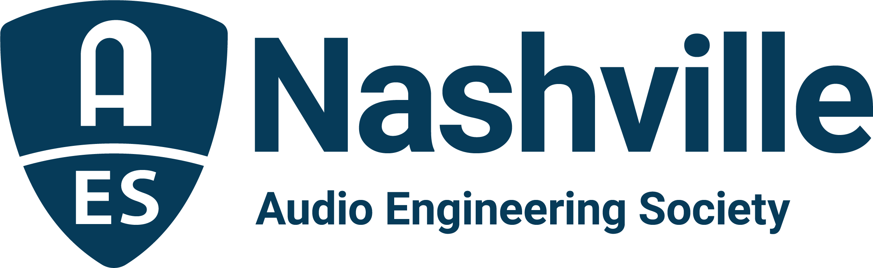

FOR IMMEDIATE RELEASE

Music City Audio Community Hits the Links for 25th Annual AudioMasters Nashville Benefit Golf Tournament, May 18 and 19

— AES Nashville Section annual event draws an industry-wide roster of players and sponsors for two days of fun and industry networking in support of the Nashville Engineer Relief Fund —

Nashville, TN, May 8, 2023 — Celebrating 25 years of supporting the Nashville audio engineering community, this year’s AudioMasters Nashville Benefit Golf Tournament is set to take place at Harpeth Hills Golf Course, May 18 and 19. Offering more than just a typical day on the links, the AudioMasters was founded to support the Nashville Engineer Relief Fund (NERF) and has become a highlight social event for the Nashville audio community, taking over the entirety of the course with industry sponsors and players for fun and camaraderie throughout both days. This year’s tournament will pay special tribute to “Dr.” Bil VornDick, a co-founder of NERF and of the AudioMasters tourney, as well as a beloved member of the Nashville audio community.

Returning sponsors for the AudioMasters 25th anniversary tournament include Live Day title sponsor DiGiCo, as well as API, the Audio Engineering Society, Audio-Technica, Black River Entertainment, Blackbird Studios, Clair Global, Clyne Media, Corky’s Ribs and BBQ of Brentwood, DPA Microphones, Design Technik, Earthworks Audio, Froggy’s Fog, Genelec, Loeb & Loeb, Mix Magazine, The NAMM Show, Nashville Recording Supply, RF Venue, The Recording Academy® Producers and Engineers Wing®, The Recording Studio Insurance Program, Shure, Solotech, Sound Emporium, Sound Image, Trew Audio, Teegarden Audio, VEVA Collect and Welcome to 1979 Studios, with new sponsors PRG (Production Resource Group) and QSC also joining in on the action.

While on the links, players are offered a variety of opportunities to meet with area studios, live sound providers, service and sales companies, professional audio press, industry organizations, manufacturers and others with ties to the Nashville audio community, who make each hole a welcome destination. Whether you’re on your game or not, everyone wins with complimentary activities and consumables, which, throughout the tournament’s history, have included everything from gourmet food and exotic beverages to swag and contests, or even a massage or a chance to fire a golf ball cannon – each aimed at maximizing the fun for everyone involved while fostering a variety of opportunities for sponsors and players to come together for a great cause. And both days will also keep a Bil VornDick tradition alive with round-the-course visits from Dr. Bil’s Magic Elixir Golf Cart, with sponsor QSC riding along on Thursday (Friday sponsorship still available). The AudioMasters Nashville Benefit Golf Tournament serves as the primary funding mechanism for the home-grown 501(c)(3) non-profit Nashville Engineer Relief Fund.

“When we held the first AudioMasters tournament 25 years ago,” recalls NERF Secretary Frank Wells, “we knew we wanted to draw our amazing community together to be able to give a hand up in times of need. The AudioMasters became a singularly unique, incredibly fun event, but best of all it has kept NERF funded and able to help out scores of our colleagues over the years.”

Golfers will also have the chance to participate in a putting contest hosted by ErgoLab/Stealth Chairs, with a chance to putt to win a Stealth chair for a nominal donation to NERF, and the Recording Academy® Producers and Engineers Wing® and Audio Engineering Society-sponsored lemonade cart will once again keep players hydrated. A Closest-to-the-Pin contest (measured in Hz, of course!) is sponsored by Genelec, among other contest opportunities available around the course, including a chance to win $10,000 and other prizes for a hole-in-one.

The tournament is produced by the AES Nashville Section with event coordinator Karen Dunn of KMD Productions. Complete details, player registration and sponsor opportunities are available online with the latest updates available by following the AudioMasters Nashville on Instagram, Facebook and Twitter.

...ends 581 words

Photo File1: AudioMasters_2023.JPG
Photo Caption1: The Nashville audio community will return to the links for the 25th Annual AudioMasters Benefit Golf Tournament, May 18 and 19, in support the Nashville Engineer Relief Fund.

Photo File2: AudioMasters_VornDick.JPG
Photo Caption 2: This year’s tournament will pay special tribute to “Dr.” Bil VornDick, a co-founder of NERF and of the AudioMasters tourney, as well as a beloved member of the Nashville audio community.

For more information, contact Karen Dunn: karen@kmdpro.com or (925) 708-0307.

