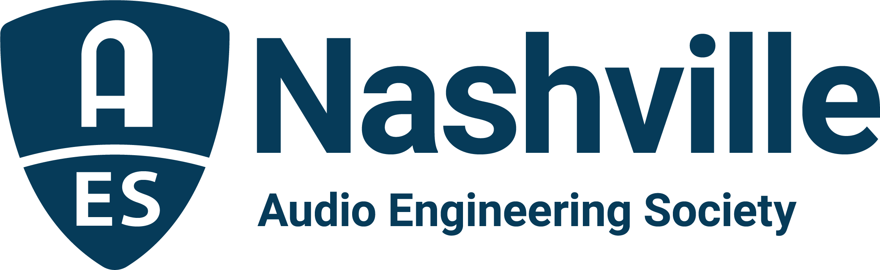

FOR IMMEDIATE RELEASE

AES Nashville Lines Up 2022 Spring Training Exhibition

— The AES Nashville Section is hosting live sound professionals and leading manufacturers for a free three-day in-person exhibition and training event on February 24-26 —

Nashville, TN, February 9, 2022 — The Nashville Section of the Audio Engineering Society presents Spring Training Exhibition 2022, its second annual in-person live sound training event and product showcase. Based on the inaugural event’s enthusiastic attendance in March 2021 and the expressed desire for a longer event by attendees and sponsors, the free-to-attendees Spring Training Exhibition 2022 will span three days, February 24-26. The extended schedule means more slots for training sessions for attendees, while the 2022 event will also spread throughout the rehearsal rooms of both of SoundCheck Nashville’s two buildings to offer additional demonstration and training space.

“AES Nashville’s Spring Training 2021 was a great success, despite the trying times,” says Ken Porter (Spectrum Sound), lead on the event planning team. “As we began work on Spring Training 2022, the overwhelming request was for more opportunity to learn and share. The expanded schedule and footprint of Spring Training Exhibition 2022 fulfills those requests for more. We encourage live sound pros working in touring, houses of worship, clubs, corporate meeting and event production, educational facilities & integrators and contractors to join us to learn about the latest in hardware and software. Sound company and facility managers are looking forward to meeting face-to-face with manufacturers to discuss strategies for retooling their inventories and coping with supply chain issues. Spring Training Exhibition 2022 is the place to gear up for the coming year.”

Spring Training Exhibition 2022’s premier sponsors d&b audiotechnik, DiGiCo/KLANG, EAW and Martin Audio/Focusrite Pro will equip SoundCheck’s largest rooms for demos and scheduled training. In SoundCheck’s adjacent building, Allen & Heath/Shure and Yamaha/NEXO will host training rooms alongside the exhibition where Allen & Heath, Avid, DiGiCo, DirectOut, KLANG, Harman, Harrison, JBL, Lectrosonics, Link USA, Multipoint, RCF, Sennheiser, Shure, Soundcraft, Solid State Logic, Waves and Whirlwind will each host a demonstration area to share their latest innovations and answer attendees’ questions. Informative sessions led by expert presenters will cover the latest live sound tools and techniques.

The exhibition area will be open from 10AM to 6PM on Thursday and Friday, February 24 and 25, and from 9AM till 2PM on Saturday, February 26. Food will be available for purchase from vendor Southern Spoon from 9AM till 4PM on Thursday and Friday, and from 8AM till 2PM on Saturday.

Free exhibition registration for AES Nashville’s Spring Training Exhibition 2022 covers attendees for all three days. Training Sessions require individual registration as class space is limited. To join the hundreds of live sound professionals already registered, attendees should visit aesnashville.org/spring-training/ to learn more, register and sign up for training sessions.

www.aesnashville.org

...ends 425 words

Photo file 1: AES_Nashville_Spring Training_2022.png
Photo caption 1: The AES Nashville Section’s Spring Training Exhibition 2022 brings live sound professionals and leading manufacturers together for a free three-day in-person exhibition and training event on February 24-26.

