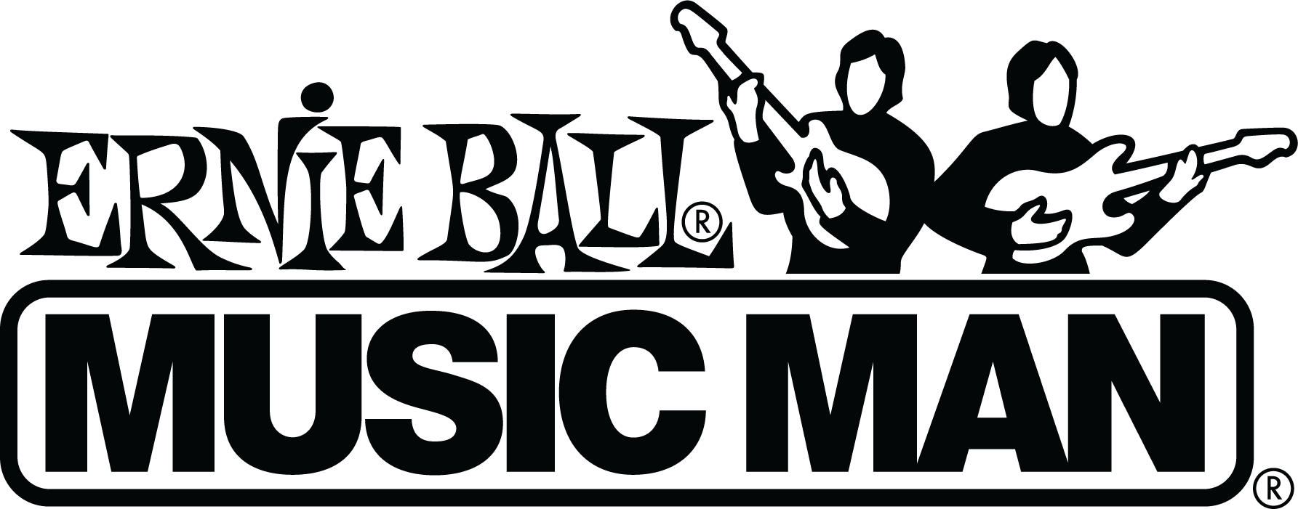

Ernie Ball Music Man Announces New Colors for Its 2020 Instrument Line

2020 brings new colors to the core line of the company’s instrument line

(San Luis Obispo, CA – March 9, 2020) – Ernie Ball Music Man, the world’s leading manufacturer of musical instruments, guitar strings and accessories, is proud to announce availability of new 2020 colorways for many of its most popular guitar and bass models.

Available now:
Valentine: The Ernie Ball Music Man James Valentine guitar features a slab ash body, two Ernie Ball Music Man-designed pickups (1-humbucker/1-single coil) with 3-way custom lever switch, with 10-inch-radius maple fingerboard and 22 stainless-steel frets. New colors include Shell Pink, TV Yellow, and Classic Natural. The James Valentine “Valentine” guitar is now available starting at $2499.00 SRP.

Stingray Special 4 and 5: The Stingray Special 4- and 5-string basses include an enhanced contour that is rounded for more comfort in any playing position, a sculpted neck joint for uninhibited upper fret access and lightweight aluminum hardware providing a more balanced instrument. StingRay electronics feature neodymium magnets and 18-volt three-band preamp for a clean powerful signal. Available in the following new colors: Maroon Mist, Tectonic Blue Sparkle, Firemist Silver, Ghostwood, Ghost Pepper, and Burnt Amber. StingRay Special 4-String is available starting at $2099.00 SRP. StingRay Special 5-String is now available starting at $2199.00 SRP.

Upcoming:
Cutlass RS: The Ernie Ball Music Man Cutlass guitar pays homage to the vintage styling and cosmetic appeal of Leo Fender’s original Music Man models. Ernie Ball Music Man-designed vintage-inspired pickups, super smooth modern tremolo system, roasted figured maple neck, and lightweight alder body are now standard appointments. New Charging green, Ghostwood, and Maroon Mist colors have been announced. The Cutlass RS guitar is available starting at $2,149.00 SRP and will be in stores beginning June 2, 2020.

Stingray RS: The Ernie Ball Music Man Stingray guitar also pays homage to Leo Fender’s original Music Man models. Ernie Ball Music Man-designed vintage-inspired pickups, super smooth modern tremolo system, roasted figured maple neck, and lightweight Okoume body are now standard appointments. New Charging green, Ghostwood, and Maroon Mist colors have been announced. The Stingray guitar is available starting at $2149.00 SRP and will be in stores beginning June 2.

Photo file: Cutlass-Maroon-Mist.JPG
Photo caption: Ernie Ball Music Man’s new Cutlass guitar in Maroon Mist

Additional product Images are available here.

ABOUT ERNIE BALL
In 1962, veteran player and guitar teacher Ernie Ball created Slinkys®, the innovative light gauge electric guitar strings widely revered by thousands of iconic players including Eric Clapton, Keith Richards, Jimmy Page, Paul McCartney, Metallica, Brad Paisley, Slash, John Petrucci, Angus Young and John Mayer. The strings are all crafted in Coachella, CA. Ernie Ball also offers state-of-the-art instrument accessories that are carried in more than 6,000 stores in the U.S. and 120 countries worldwide. Officially purchasing the Music Man® company in 1984, Sterling, joined later by his sons Scott and Brian, has built a team of dedicated professionals based in San Luis Obispo, CA who collectively share a common goal: crafting the highest level of hand-crafted instruments available. Originally founded by Tom Walker, Forrest White and Leo Fender in 1974, Music Man built its name leading an industry revolution, introducing active electronics on its production instruments. As part of the team during the 70’s, Sterling Ball played an important role on the design and development of the iconic StingRay basses. The family-run company maintains its founder's dedication to preserving the musician's playing experience and delivering superior sound quality through the development of new products, such as Cobalt Slinkys, M-Steel, Earthwood and the revolutionary Element Shield Packaging, keeping each set as fresh as the day they were made. The company also fosters artist development through musician-focused programs such as the world's largest and longest running unsigned artist programs, where bands compete each year for the chance to play live on national tours, festivals and events. Visit them online at www.ernieball.com and www.music-man.com.

YOUTUBE | TWITTER | FACEBOOK | INSTAGRAM | OFFICIAL SITE

For more information about ERNIE BALL, please contact:
Luke Noffke
luke@ernieball.com

