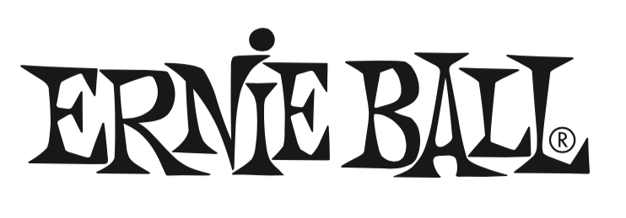

FOR IMMEDIATE RELEASE

Ernie Ball Offers New “Ultra” and “Burly” Slinky String Sets

(The NAMM Show, Anaheim, CA – January 24, 2019) – Ernie Ball (Booth 4320, D5), the world's premier manufacturer of guitar strings, musical instrument accessories and volume pedals, announces two new additions to its acclaimed Slinky guitar string family: “Ultra” and “Burly” Slinky® string sets, offering gauge combinations that have not been offered before.

These new hybrid gauges combine popular slinky string sets for new musical options in terms of tone and feel. The “Ultra” set combines Regular and Power Slinky sets, with gauges of .010, .013, .017, .028, .038, .048"; and the “Burly” set combines Power and Skinny Top Heavy Bottom Slinky sets, with gauges of .011, .014, .018, .030, .042, .052".

Offering classic balanced tone and the signature slinky feel, Slinky strings are precision-wound with nickel plated steel and a tin plated high carbon steel core, complementing all guitar types and playing styles. Element Shield™ packaging prolongs string life and keeps strings as fresh as the day they were made. Crafted in Southern California, USA, featuring the finest and freshest materials.

Photo file 1: EB_Ultra.JPG
Photo caption 1: Ernie Ball Ultra Slinky strings

Photo file 2: EB_Burly.JPG
Photo caption 2: Ernie Ball Burly Slinky strings

About Ernie Ball:
In 1962, veteran player and teacher Ernie Ball created Slinkys®, the iconic light gauge electric guitar strings widely revered by hundreds of guitar greats including Eric Clapton, Keith Richards, Jimmy Page, Paul McCartney, Metallica, Brad Paisley, Slash, John Petrucci, The Edge and John Mayer. In addition to industry-standard strings, as well as hand-crafted high-end Music Man® guitars and basses, Ernie Ball Inc. offers state-of-the-art instrument accessories that are carried in more than 6,000 stores in the U.S. and 120 countries worldwide. The family-run company maintains its founder's dedication to preserving the musician's playing experience and delivering superior sound quality through the development of new products, such as Cobalt Slinkys, M-Steel, Earthwood and the revolutionary Element Shield Packaging, keeping each set as fresh as the day they were made. The company also fosters artist development through musician-focused programs such as the world's largest and longest running Battle of the Bands, where unsigned bands compete each year for the chance to play live on national tours, festivals and events. Visit them online at www.ernieball.com and www.music-man.com.

FOR PRESS INQUIRIES, PLEASE CONTACT:
Clyne Media, Inc. / info@clynemedia.com

FOR PRODUCT INFORMATION, PLEASE CONTACT:
Ernie Ball Customer Service / customerservice@ernieball.com

Ernie Ball/Music Man is exhibiting at Booth 4320, D5 at the 2019 NAMM Show in Anaheim, California.

