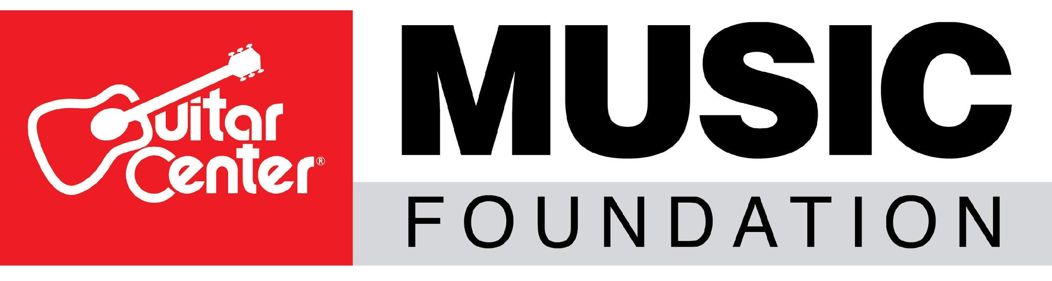
The Guitar Center Music Foundation Names Myka Miller as New Executive Director

With over 19 years of experience in the non-profit world, Miller will help take The Guitar Center Music Foundation to the next level in expanding its philanthropic efforts
Westlake Village, CA (October 19, 2021) – The Guitar Center Music Foundation, a non-profit organization focused on granting instruments and other musician services to various music education organizations, announces the appointment of Myka Miller as the non-profit’s new Executive Director. The announcement was made by the Foundation’s Board of Directors and reflects the organization’s goal of growing its charitable initiatives in 2021 and beyond.

In her new role, Miller will be responsible for the successful operation and performance of The Guitar Center Music Foundation. Additional responsibilities will include working closely with the Board to sustain and grow existing funding while establishing new relationships and partnerships with prospective donors, fundraising networks, and the music industry at large, while actively seeking to expand the scope and reach of the Foundation.

Miller is an award-winning and accomplished non-profit executive with more than 19 years of prior experience in entrepreneurship, program design, board development, fundraising, performance management, and cost management analysis. Most recently, Miller served as Executive Director/CEO at Harmony Project, a music education organization in Los Angeles. While there, she increased the program size from 250 students at one community site to over 3,500 participants in sixteen underrepresented communities and seven other cities nationwide.

Under her leadership at the Harmony Project, Miller also launched new initiatives and nurtured cost-sharing partnerships with the Los Angeles Philharmonic, Los Angeles Unified School District, LA City College, California Arts Council, the Sheriff’s Foundation and many other community organizations and school districts.

As a musician, Miller is uniquely aware of the needs and challenges of musicians today as well.

“I am pleased to welcome Myka to The Guitar Center Music Foundation team. She truly believes in the power of music to transform lives and has the energy, drive and ability to make a difference on a larger scale with the Foundation and its amazing initiatives,” said David A. Helfant, Chairman of the Board for The Guitar Center Music Foundation. “I look forward to working closely with her and our Board with the goal of putting more instruments in the hands of many people and school districts in need.”

Miller has a master’s degree in Music and Business Administration from the University of Southern California. She is also a member of the El Sistema USA Board of Directors and sits on the founding board of the Compton Youth Activities League and Extera Public Schools in Boyle Heights.

The Guitar Center Music Foundation’s mission is to offer as many individuals as possible the invaluable experience of learning and playing a musical instrument. Since its original formation in 2005, the Foundation‘s charitable efforts have put instruments in the hands of over 300,000 persons nationwide during its rich history of supporting musicians through music education, music therapy programs and other music-centric non-profits.

To learn more, visit www.GuitarCenterFoundation.org and follow @GuitarCenterFoundation for more news or discover ways to support The Guitar Center Music Foundation.

###

Photo file: MykaMiller.JPG
Photo caption: Myka Miller, Executive Director of The Guitar Center Music Foundation

ABOUT THE GUITAR CENTER MUSIC FOUNDATION
The Guitar Center Music Foundation was founded as a 501(c)(3) in 2005. Since its inception, the Foundation has placed instruments in the hands of over 300,000 persons nationwide through grants to qualifying music education and music therapy programs. The Foundation’s mission is to support music education programs nationally by providing those in need with instruments and by advocating the benefits of music education and music therapy. For more information about The Guitar Center Music Foundation, please visit http://guitarcenterfoundation.org/

ABOUT GUITAR CENTER
Guitar Center is a leading retailer of musical instruments, lessons, repairs and rentals in the U.S. With nearly 300 stores across the U.S. and one of the top direct sales websites in the industry, Guitar Center has helped people make music for more than 50 years. Guitar Center also provides customers with various musician-based services, including Guitar Center Lessons, where musicians of all ages and skill levels can learn to play a variety of instruments in many music genres; GC Repairs, an on-site maintenance and repairs service; and GC Rentals, a program offering easy rentals of instruments and other sound reinforcement gear. Additionally, Guitar Center’s sister brands include Music & Arts, which operates more than 200 stores specializing in band & orchestral instruments for sale and rental, serving teachers, band directors, college professors and students, and Musician’s Friend, a leading direct marketer of musical instruments in the United States. For more information about Guitar Center, please visit www.guitarcenter.com.

FOR MORE INFORMATION PLEASE CONTACT:
Clyne Media | 615.662.1616 | pr@clynemedia.com
Guitar Center | 818.735.8800 | media@guitarcenter.com
The Guitar Center Music Foundation | info@GuitarCenterFoundation.org

