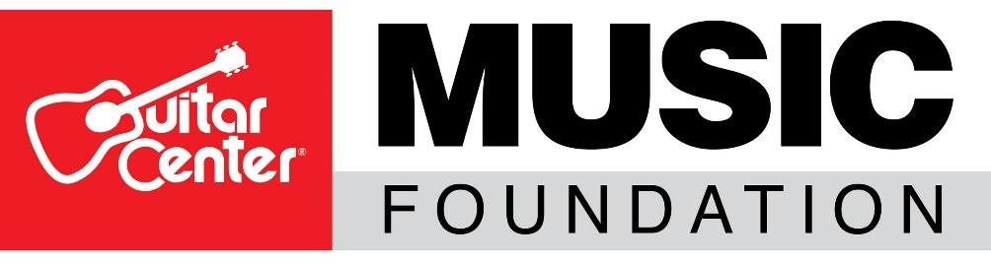

*** TIP SHEET FOR THURSDAY, AUGUST 6, 2020 ***

Guitar Center® Music Foundation Relief 4 Musicians Online Fundraiser Continues with Blues-Rock Guitarist Joe Bonamassa

WHO: The Guitar Center Music Foundation (GCMF) is a non-profit charity organization focused on granting instruments and equipment to musicians through music education and music therapy programs. GCMF supports these programs nationally by providing those in need with instruments and by advocating the benefits of music education.

WHAT: As part of its ongoing effort to provide needed funding relief to musicians and music programs suffering loss of resources as a result of the COVID-19 pandemic, the Guitar Center Music Foundation announces that blues-rock musician Joe Bonamassa will be the next featured guest on Relief 4 Musicians. This is the latest installment for the foundation’s Relief 4 Musicians streaming event series fundraiser. This online event will be free with an opportunity for viewers to make donations during the event, as well as bid on collectible artist-signed items. One-hundred percent of the funds donated will go to support musicians in need and provide struggling music education and music therapy programs affected by the COVID-19 pandemic with the much-needed funding for musical instruments and gear, remote learning capabilities, scholarships and more.

The event features Joe Bonamassa in his first-ever tour of “Nerdville East,” his Nashville, TN home, where he will share some never-before-seen historic instruments and other items. He will also be playing and signing two amazing guitars – a Gibson 1956 Les Paul Gold Top re-issue and a Gibson Hummingbird Acoustic guitar – both to be part of the items available for the charity auction via links provided online during and after the event. This particular event will be a collaborative effort between Relief 4 Musicians & Joe Bonamassa’s Fueling Musicians Program fundraising efforts, with 75% of all proceeds raised from the event used to support Fueling Musicians and 25% to help music programs via Relief 4 Musicians.

WHERE/WHEN: The Relief 4 Musicians event will be streaming live on Thursday, August 6, 2020, at 5 p.m. EDT / 2 p.m. PDT on Joe Bonamassa’s Facebook page and YouTube channel and will remain there for one week following the event.

For those who want to donate, please visit https://bit.ly/3jVa7V5 or text R4MJL20 to 44-321 on your mobile phone to make a donation via Give Lively

Additional auction items will be available for bidding during the event via BetterWorld, which will be open for bidding through August 12.

ABOUT JOE BONAMASSA AND THE FUELING MUSICIANS PROGRAM: As legendary blues-rock guitarist and singer Joe Bonamassa approaches his 26th year as a professional musician, he continues to blaze a remarkably versatile artistic trail and amass an authentic, innovative and soulful body of work. His career began onstage opening for B.B. King in 1989, when he was only 12 years old. Today, he is hailed worldwide as one of the greatest guitar players of his generation and is an ever-evolving singer-songwriter with over 30 albums to date all under his own label, J&R Adventures.

The Fueling Musicians Program is part of Joe Bonamassa’s Keeping The Blues Alive® Foundation and is an emergency relief program for touring musicians affected by the COVID-19 crisis. This initiative is designed to support musicians by providing financial assistance for essential living expenses such as food, shelter, and more. Fueling Musicians provides immediate cash payments of $1,000, as well as pre-paid gas cards of $500 to help struggling musicians get back on the road again when it is safe.

ABOUT THE GUITAR CENTER MUSIC FOUNDATION:
Since its inception in 2005, the Guitar Center Music Foundation has put instruments in the hands of over 300,000 people nationwide through donations to qualifying music education and therapy programs. For more information about this event or the Guitar Center Music Foundation, visit www.guitarcenterfoundation.org.

FOR MORE INFORMATION PLEASE CONTACT:
Lynn Robison, Guitar Center Music Foundation
info@GuitarCenterFoundation.org

Syvetril Perryman, Guitar Center Inc.
media@guitarcenter.com

Photo file 1: JR_JB01.JPG
Photo caption 1: Joe Bonamassa’s Relief 4 Musicians event will be streaming live on Thursday, August 6, 2020, at 5 p.m. EDT / 2 p.m. PDT

