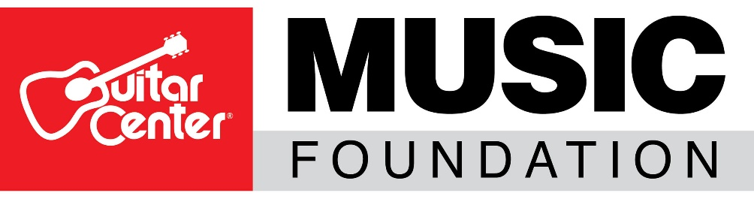
*** TIP SHEET FOR THURSDAY, JULY 9, 2020 ***

Guitar Center® Music Foundation Relief 4 Musicians Online Fundraiser to Feature Iconic Drummer Russ Kunkel

WHO: The Guitar Center Music Foundation (GCMF) is a non-profit charity organization focused on granting instruments and equipment to musicians and music education and music therapy programs. GCMF supports music education programs nationally by providing those in need with instruments and by advocating the benefits of music education. Since its inception in 2005, the foundation has put instruments in the hands of over 300,000 persons nationwide through donations to qualifying music education and music therapy programs.

WHAT: As part of its ongoing effort to provide needed funding relief to musicians and music programs suffering loss of resources as a result of the COVID-19 pandemic, the Guitar Center Music Foundation announces that legendary session/touring drummer Russ Kunkel will be the featured guest on Relief 4 Musicians. Hosted by noted photographer and drummer Rob Shanahan, this is the latest installment for the foundation’s Relief 4 Musicians streaming event series fundraiser. This online event will be free with an opportunity for viewers to make donations during the event, as well as bid on collectible artist-signed items. One-hundred percent of the funds donated will go to support musicians in need and struggling music education and music therapy programs affected by the COVID-19 pandemic. Additionally, funds raised through donations and auction items will help these programs with the much-needed funding for musical instruments and gear, remote learning capabilities, scholarships and more.

WHERE/WHEN: Relief 4 Musicians, Thursday July 9, 2020 at 5 p.m. PDT, streaming on http://www.facebook.com/drumchannel

ABOUT RUSS KUNKEL: Russ Kunkel’s credits read like a Who’s Who of the music industry and include artists like Jackson Browne, James Taylor, Linda Ronstadt, Bob Dylan, Stevie Nicks, Lyle Lovett and dozens more. He has created and co-produced film scores for Mike Nichols’ Heartburn, Joyce Chopra’s Smooth Talk and New World Films’ Certain Fury. Production work includes Clannad, Jimmy Buffett, The Derek Trucks Band, Dan Fogelberg, Aaron Neville and others.

For those who want to donate, please visit http://ow.ly/lskU50Ajf6i.
For more information about this event or the Guitar Center Music Foundation, visit www.guitarcenterfoundation.org.

FOR MORE INFORMATION PLEASE CONTACT:
Lynn Robison, Guitar Center Music Foundation
info@GuitarCenterFoundation.org

Syvetril Perryman, Guitar Center Inc.
media@guitarcenter.com

