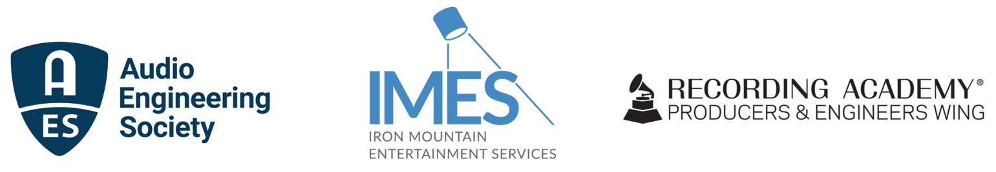

Iron Mountain Entertainment Services, Recording Academy Producers & Engineers Wing and the Audio Engineering Society industry survey reveals trends and concerns in Audio Archiving

— Backup and archival practices revealed as important concerns with opportunity for ongoing education and training —

September 15, 2022 — Based on key topics raised during an Iron Mountain Entertainment Services (IMES) and Recording Academy Producers & Engineers Wing (P&E Wing) co-hosted 2021 summit “Protecting Legacies: The Art, Science and Value of Music Archives,” IMES, the P&E Wing and the Audio Engineering Society (AES) developed a survey to assess current practices and challenges in audio archiving. The survey was sent to approximately 4,000 members of the P&E Wing and 11,000 members of the AES.

“Not only does this survey tell us where we are now,” said Lance Podell, Senior Vice President and General Manager of IMES, “it provides a baseline for future measurement of progress towards systematic protection of the rich heritage embodied in archived audio content.”

That baseline includes insights such as near 65% of the survey respondents sharing that they advised their clients on how and where they should preserve their work, with 70% sharing that they mentored younger professionals on archiving issues – evidence that a majority of those respondents see archiving as a significant area of concern. Despite that concern, a surprising 22% said they never check their backups to ensure they are still functional, and 16% let at least a year pass between backup quality control checks. 62% are checking backups more frequently: 21% check backups at least monthly, 15% check backups at least quarterly, 26% at least once a year.

Abundantly available and affordable hard drive storage dominates backup and archival media choices. 83% of the respondents said they used external, often portable backup hard drives for master file archival purposes, with 59% using internal computer drives and 43% cloud storage (the total exceeding 100% as users often deploy multiple methodologies). The survey responses were similar for working file backup – 86% rely on external drives, 64% on computer drives and 43% on cloud storage. Factors shared for hard drive reliance included reluctance to rely on cloud storage based on factors such as overall cost, download/upload time and security concerns.

The survey also provides a snapshot in time of how the respondents describe their work, their years of experience (with most of the participants having 21+ years of experience), how they stay up-to-date on archival and preservation issues and their responsibility level for archiving (over half stating they had archival responsibilities and more than 30% stating that their archival responsibility couldn’t be characterized by a cut and dry ‘Yes’ or ‘No’ answer). Only 25% of those taking the survey said they were familiar with the Producers and Engineers Wing Delivery Recommendations, developed in partnership with the AES to guide content producers to practices that promote sustainable retrievability of archived assets.

Further survey questions addressed the identification of archival tracks with potential for distribution and monetization, access to archival content, file structure and file sharing methodologies.

“The survey results will enable us to focus on areas where additional education and training will be most effective in protecting our recorded music legacy,” said Maureen Droney, Vice President, Producers & Engineers Wing. “Preservation of recorded audio content is a perennially important topic for our members,” says AES President Josh Reiss. “The survey data provides an important understanding of current practices and where they might fall short, informing our ongoing discussions on the vital issues of content protection, storage, cataloging and retrieval.”

The full results of the survey are available for review at https://www.imes.media/s/PE-Archive-and-Preservation.pdf. Plans are under way to conduct the first follow-up survey later this year to dig into key themes unearthed in the initial survey and further define educational and awareness needs and opportunities.

Photo file 1: Protecting_Legacies.JPG
Photo caption 1: Click to review the full results of the document “Protecting Legacies Survey 2022.”

Photo file 2: SURVEY_3_logo_graphic.JPG
Photo caption 2: Iron Mountain Entertainment Services, Recording Academy Producers & Engineers Wing and the Audio Engineering Society have revealed the results of a survey regarding trends and concerns in Audio Archiving

For more information, contact:
Robert Clyne
Clyne Media, Inc.
Email: robert@clynemedia.com
Tel: 615-300-4666
169-B Belle Forest Circle, Nashville, TN 37221;
Web: http://www.clynemedia.com

