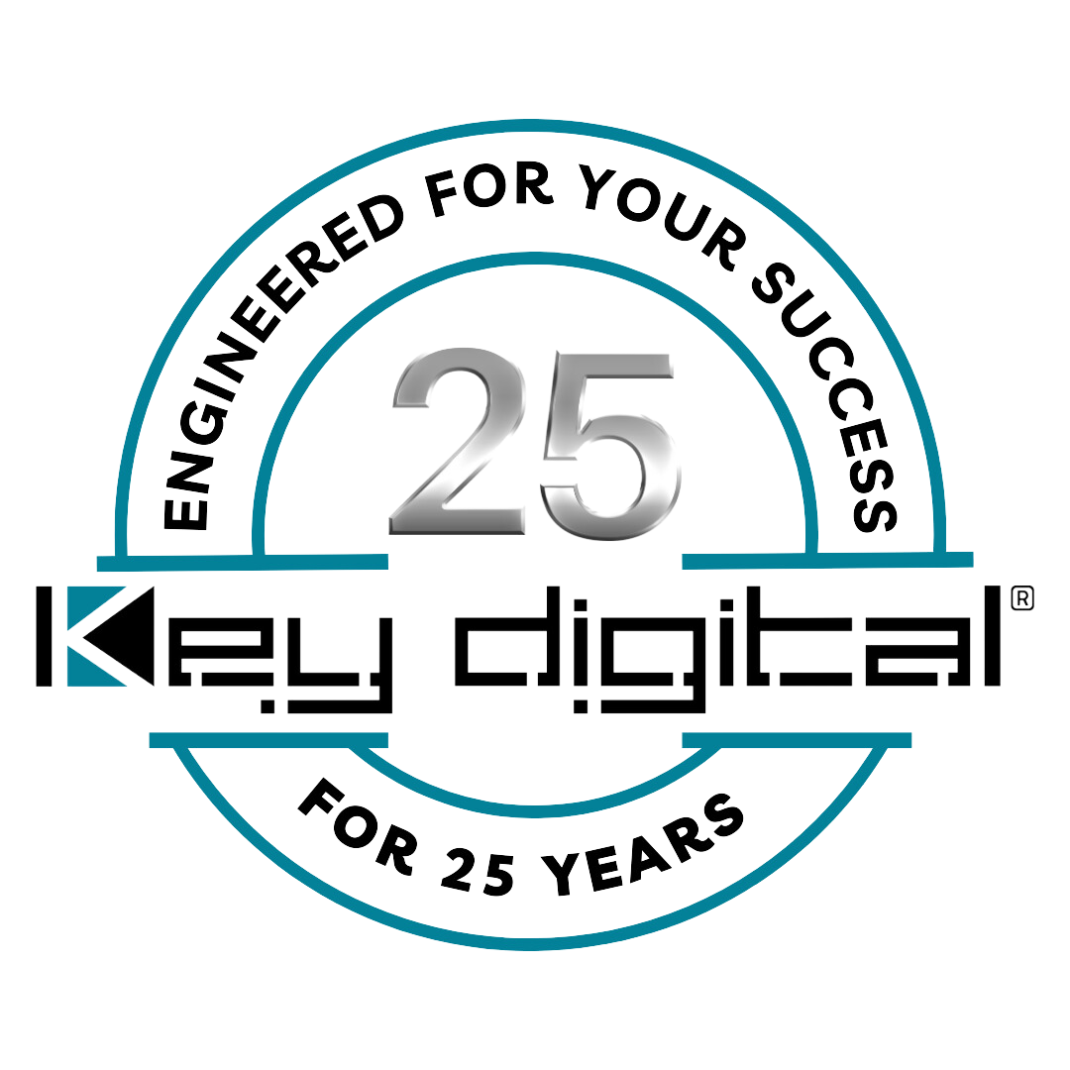

Contacts:

Key Digital

Masha Lakhter, COO

917.701.3238

masha@keydigital.com

Clyne Media, Inc.

Frank Wells, Senior Account Manager

615.585.0597

frank.wells@clynemedia.com

Key Digital celebrates 25th anniversary

— The family-owned and -operated technology firm has built its success upon innovation, reliability and affordable performance —

MOUNT VERNON, NY, March 6, 2024 – Key Digital Systems, an award-winning developer and manufacturer of leading-edge digital video processing and video signal distribution solutions, is celebrating its 25th anniversary in 2024. In 1999, Key Digital’s first product was a video distribution amplifier custom-designed for retailer Best Buy’s display televisions. That modest beginning was hardly indicative of the depth of knowledge and experience of Key Digital founder Mike Tsinberg, whose work in HD and digital video began along with the infancy of the technologies in the 1980s. Working with Thomson-CSF, Philips, and Toshiba, Tsinberg pioneered ideas that played a major role in the development and refinement of digital television – both broadcast and streaming, digital video recording and the DVD (for which the Toshiba team he was on received an Emmy Award). His portfolio now includes more than 40 patents.

Tsinberg’s philosophy of innovation has propelled Key Digital forward. He says, “My ambition was always to create technology from scratch,” which gives Key Digital enormous latitude for creativity. For his Key Digital engineering team, it’s not sufficient to merely deliver the core capabilities expected in a product category. Instead, built-in to their designs are elegant and transparent solutions for a host of connectivity issues that plague many AV installs, such as addressing the alphabet soup of inter-device communications (HDCP, EDID, CEC, etc.). Each product in the growing and evolving Key Digital product line is designed for value with no compromise in performance or quality and feature sets that redefine customer expectations. Signal extension in Key Digital’s product line is accompanied by control, beginning with bidirectional IR repeaters, and extending to IP and Open API control.

“Beyond our knowledge of how the technologies work and also their limitations, we listen to our customers,” says Tsinberg. “If we can build in product features that make their lives easier, we are committed to doing so. That’s why we pair signal and control distribution, why we opt for flexibility and sophistication without complex programming, why our AV over IP systems are modular for right-sizing to a project’s needs, why we integrated control within our AV over IP systems while they were still in R&D, why we offer power over Ethernet whenever feasible, and why we offer the free KD-App with its intuitive iOS interface for simplified yet sophisticated system control. It’s our attention to detail and real-world needs that keep our loyal customers coming back.”

The 21st Century Key Digital offers an extensive product line spanning applications from restaurants and clubs to government, houses of worship, education, retail and residential. The product line ranges from extenders to switchers, matrix switchers, multi-view and video wall matrix processors, presentation switchers (including multi-format wall plate models) with extension transmission built-in, wireless extension and BYOD collaboration solutions, scalable AV over IP systems and the Compass Control Pro integrated iOS-based control system that which can extend unified iPad control to include a host of Compass Alliance partner systems beyond AV including lighting, HVAC, power and security.

“We are proud of what we’ve accomplished in our first 25 years,” says Tsinberg. “We can’t begin to thank our customers enough for believing in our vision. All corporations are made of people, and we have the best and thank them as well for all they do. We are also excited about the explosion of technological advancements that will shape our products and progress for the next 25 years. Just wait until you see what’s already on the drawing board!”

For more information:
Key Digital
Key Digital Innovation Timeline
Mike Tsinberg Profile (35th anniversary of first patent)

Photo File 1: 25thAnnivCake.jpg
Photo Caption 1: Key Digital COO Masha Tsinberg (middle left) and Mike Tsinberg, founder and president of Key Digital (middle right) flanked by booth staff for the presentation of a cake commemorating Key Digital’s 25th Anniversary

Photo File 2: MikeTsinberg_EarlyKeyDigital.jpg
Photo Caption 2: Digital video innovator Mike Tsinberg, founder and president of Key Digital, in the early days of his company

About Key Digital:
Established in 1999, Key Digital® designs and engineers intuitive digital A/V connectivity and control solutions that embody excellence. Key Digital delivers reliable, superior-quality, easily-implemented, versatile, high-performance products for corporate, education, government, house-of-worship, bar & restaurant, digital signage and residential A/V applications.

Founded by innovator Mike Tsinberg, holder of over 40 digital video and HDTV patents, Key Digital designs and engineers its products in-house at its USA headquarters in Mount Vernon, New York. The result of meticulous research, development and testing, Key Digital products showcase the company’s extensive, unparalleled technical knowledge and expertise, as well as its market-driven approach, serving as a partner to consultants, designers, and system integration firms in the A/V industry. Key Digital works as its clients’ extended engineering team, developing customized solutions for specific applications. Key Digital is an lnfoComm, CEDIA, CES, and NAHB award-winning manufacturer.

Key Digital®, Engineered for Your Success™

For more information, visit our webpage at www.keydigital.com.

Follow Key Digital on social media:

