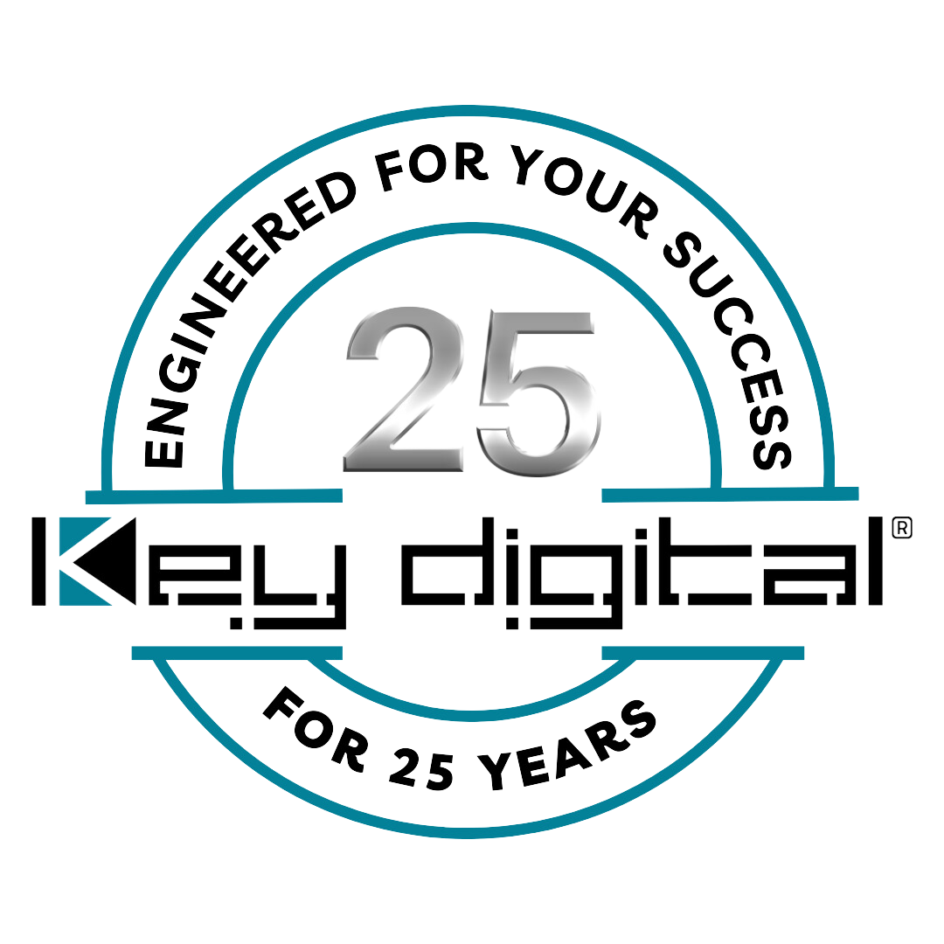

Contacts:

Key Digital

Masha Lakhter, COO

917.701.3238

masha@keydigital.com

Clyne Media, Inc.

Frank Wells, Senior Account Manager

615.585.0597

frank.wells@clynemedia.com

Key Digital demonstrates AV solutions at Integrated Systems Europe 2024

— ISE 2024 attendees proved an enthusiastic audience for Key Digital’s comprehensive line of easily implemented and operated AV solutions —

MOUNT VERNON, NY, February 7, 2024 – Key Digital Systems, an award-winning developer and manufacturer of leading-edge digital video processing and video signal distribution solutions now celebrating its 25th anniversary, shared its latest innovations and core products with clients both current and new during Integrated Systems Europe 2024, January 30 – February 2 in Barcelona, Spain.

“From our anchor position in the HDBaseT Alliance booth,” says DeWayne Rains, Key Digital VP of Sales, “we demonstrated our host of HDBaseT enabled products including a fully functional Key Digital ‘Conference Room in a Box’ system along with ancillary support hardware and control software.”

“Key Digital’s ISE 2024 presentation was unlike any other,” adds Key Digital VP of Product Education Jonathon Ferry. “Attendees were able to dive into a complete integrator and user experience that let them truly understand how Key Digital has made AV installations easier and more transparent than ever before.”

“The number one question we get asked,” Ferry continues, “is ‘How easy is it to install and operate your systems?’ Well, that’s what our presence at ISE with complete solutions in the booth was all about. The answer is, ‘Easy setup, easy install – including wireless options – and easy control.’ From beginning to end it’s an easy process to specify, implement and operate Key Digital solutions. We put a high degree of thoughtfulness into every product so that with Key Digital your business can be done effectively, affordably and with uncompromised technical performance, yet without the stress of unnecessarily complicated setup and operation.”
Key Digital’s “Conference Room in a Box” solutions exemplify that ease of setup. “An integrator, says Ferry, “can simply install the devices, enter IP address and user-friendly names for each input and display, and be presented with an iOS control interface without any programming. Or, for factory-shipped systems, we’ll do the configuration for them at no charge.” Key Digital’s cost-free and auto-populated KD App for iOS provides remarkably sophisticated full-system control that’s equally remarkably end-user friendly with a familiar and intuitive touch, swipe and tap operation. “Or, for those users desiring a more physical control interface,” says Ferry, “the KD–WP8–2 8-button control keypad was demonstrated, including real-time configuration and updating of the system control file right there on the tradeshow floor.” The single-gang box mount KD-WP8-2 can send preset salvos of commands via IP/Open API, IR and RS-232 to Key Digital hardware, Compass Control® Alliance devices and third-party systems. “The KD-WP8-2,” Ferry concludes, “can reconfigure entire systems with a single button push and now even integrates into the Q-SYS ecosystem via a Certified Q-SYS plugin.”
“We also demonstrated our LeCAMbio line of integrated corporate conferencing solutions at ISE,” says Rains. Developed in partnership with TOA Electronics. LeCAMbio systems link microphone beam-steering technology from a separately purchased TOA LENUBIO soundbar with Key Digital’s KD-CAMUSB PTZ camera to automatically deliver simultaneous voice and camera tracking of active meeting participants. “ISE attendees,” he continues, “were amazed at how smooth LeCAMbio works.”

“Included in our display system was the KD-BYOD4K 4K Wireless Presentation Gateway – a complete, affordable, single-chassis solution for the Bring-Your-Own-Device (BYOD) collaboration model,” Rains continues. “We delight in showing off how easy it is to wirelessly cast content from a phone, tablet or computer to a monitor in our demonstration area. And, thanks to the HDBaseT Alliance, we were able to send content to their video wall display on occasion, which made for a dramatic presentation of our system capabilities.”

Also on the wireless front, and perhaps “marking a real changing point in our industry,” Rains says that Key Digital’s new KD-4KWHCEX HDMI 4K 60Hz 100 ft Wireless Extender Kit was a hit with ISE attendees. “The KD-4KWHCEX,” he explains, “uses 5G WiFi technology to deliver reliable, cost-effective high-resolution AV signal and IR control extension for temporary setups, such as outdoor events, or in fixed installs where running wire isn’t feasible, and even where walls and ceilings are obstacles.”

“Demonstrated live, the benefits of Key Digital solutions are obvious,” says Rains. “ISE reliably allows us to give hands-on presentations to an international audience. We also had the opportunity to further introduce Maik Maagerø, CEO of our Key Digital Europe affiliate, and share how the expansion of Key Digital Europe’s distribution, tech support and logistics center in Norway will provide our European distributors and customers with rapid response product support and faster delivery of Key Digital hardware. ISE 2024 was a great success for Key Digital.”

For more information:
Key Digital
Key Digital Europe
Conference Room in a Box
KD-WP8-2 8-Button Programmable Control Keypad
LeCAMbio Conferencing Systems
KD-BYOD4K Wireless Presentation Gateway
KD-4KWHCEX HDMI 4K 60Hz 100 ft Wireless Extender Kit

Key Digital ISE Videos
Hot Products & Solutions Preview for ISE 2024
Day One Showcasing LeCambio Conferencing System
Day Two showcasing KD-WP8-2, KD-4KWHCEX
Day Three showcasing Classroom in a Box, Conference Room in a Box
Day Four showcasing KD-BYOD4K

Photo File 1: KeyDigital2024ISE.jpg
Photo Caption 1: Key Digital’s ISE 2024 team – Business Development Manager Leon Tsinberg (standing, rear), VP of Sales DeWayne Rains, Key Digital Europe CEO Maik Maagerø, VP of Product Education & Experience Jonathon Ferry and Chief Technology Officer Edison Yu (front, L-R)

Photo File 2: KeyDigital2024ISE2.jpg
Photo Caption 2: With the Key Digital demonstration area shown in the background on the HDBaseT Alliance video wall, Key Digital Business Development Manager Leon Tsinberg discusses AV solutions with ISE 2024 attendees

About Key Digital:
Established in 1999, Key Digital® designs and engineers intuitive digital A/V connectivity and control solutions that embody excellence. Key Digital delivers reliable, superior-quality, easily-implemented, versatile, high-performance products for corporate, education, government, house-of-worship, bar & restaurant, digital signage and residential A/V applications.

Founded by innovator Mike Tsinberg, holder of over 40 digital video and HDTV patents, Key Digital designs and engineers its products in-house at its USA headquarters in Mount Vernon, New York. The result of meticulous research, development and testing, Key Digital products showcase the company’s extensive, unparalleled technical knowledge and expertise, as well as its market-driven approach, serving as a partner to consultants, designers, and system integration firms in the A/V industry. Key Digital works as its clients’ extended engineering team, developing customized solutions for specific applications. Key Digital is an lnfoComm, CEDIA, CES, and NAHB award-winning manufacturer.

Key Digital®, Engineered for Your Success™

For more information, visit our webpage at www.keydigital.com.

Follow Key Digital on social media:

