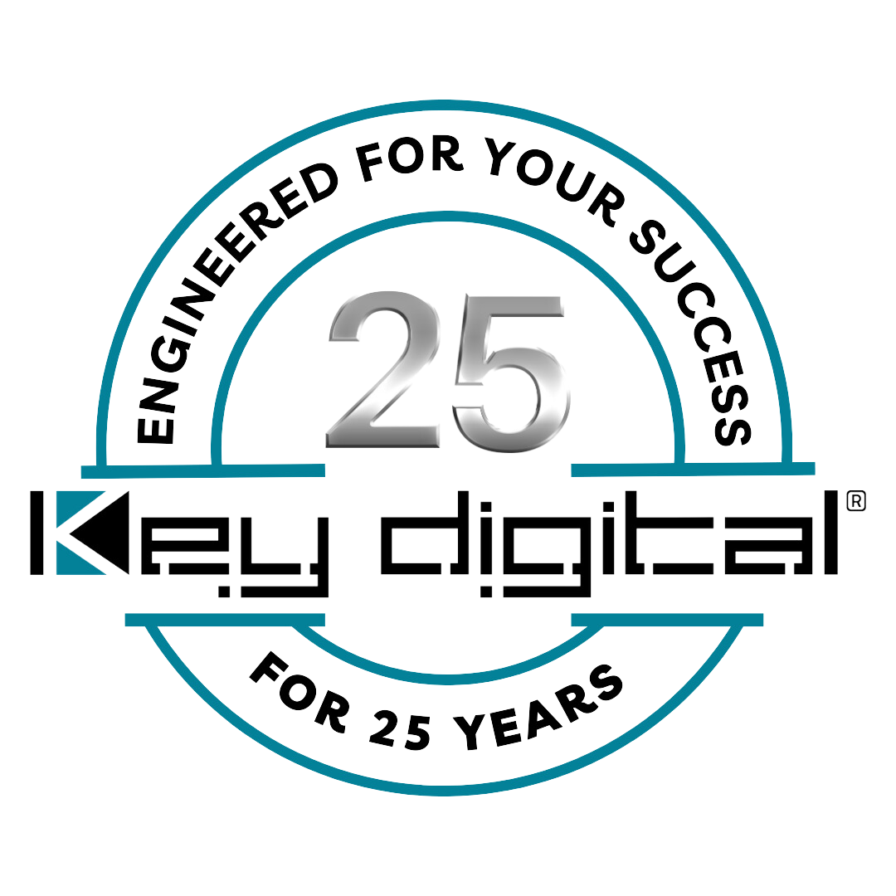

Contacts:

Key Digital

Masha Tsinberg, COO

917.701.3238

masha@keydigital.com

Clyne Media, Inc.

Frank Wells, Senior Account Manager

615.585.0597

frank.wells@clynemedia.com

Key Digital COO Masha Tsinberg celebrates 25th anniversary in company leadership

— Over her quarter-century tenure at Key Digital, Tsinberg has always maintained a “can do” attitude, emerging as a powerful motivational leader and exemplary figure —

MOUNT VERNON, NY, April 1, 2024 – As Key Digital celebrates its 25th anniversary, Masha Tsinberg, the Chief Operating Officer (COO) of the award-winning developer and manufacturer of leading-edge digital video processing and video signal distribution solutions, is also marking 25 years with the company and five as its Chief Operating Officer. Tsinberg’s ascent to the role of COO was paved by her tenure of fifteen years in the firm’s marketing department, during which she exhibited exceptional leadership, consistently driving growth, fostering innovation, and forging lasting connections with clients and colleagues alike.

As Vice President of Marketing and Public Relations, Tsinberg played a pivotal role in the company's trajectory, spearheading the development and meticulous execution of strategic marketing campaigns and comprehensive corporate branding initiatives, enhancing the customer experience while ensuring a cohesive and impactful presence in the marketplace.
Upon assuming responsibility for Key Digital’s overall strategy and execution for marketing, engineering, and operations, says Tsinberg, “the goal was to hone the architecture and processes of the company for continued growth while maintaining the established excellence in every department, including a focus on an enhanced customer experience.” As a direct link between Key Digital and end users employing its products, loyalty in the field has always been monumentally important to Key Digital, so she focused on improving the customer experience by implementing a customer feedback system and establishing a dedicated customer support team. This led to a 40% increase in customer satisfaction ratings and a significant reduction in customer attrition.

Another important element for Masha was looking at Key Digital’s staff. “I have always believed in the philosophy that companies are made of people, and we have some of the best in the business,” stated Tsinberg. Recognizing that company employees represent the brand and are the direct connection to key customers, she prioritized employee development by launching training and mentorship programs aimed at enhancing skills and fostering leadership qualities among Key Digital staff. As a result, employee satisfaction and retention rates increased by 25% over the course of her tenure.

Upon Masha Tsinberg's elevation to the role of COO, Key Digital founder and CEO Mike Tsinberg hailed her appointment as a significant milestone, marking the company's strides in fostering diversity and embracing female leadership within the AV industry. He emphasized that her promotion exemplified Key Digital's commitment to progress and excellence. “We knew that Masha had the credentials and proven operational background that would lead to that goal being realized,” says Mike Tsinberg. “It delights me to confirm that we’ve exceeded all of our expectations. Her initiative and expertise have been crucial to our growth and her positive influence permeates our corporate culture.”

“There is no glass ceiling at Key Digital,” says Masha Tsinberg. “I had a voice and the opportunity for growth from the very start 25 years ago, and we’re proud of our record of empowerment as Key Digital grew from a one-product company to take a leadership role in the AV industry that ranges from technological innovation in the R&D lab to diversity in the board room.”

For more information:
Key Digital

Photo File 1: Masha_Tsinberg.jpg
Photo Caption 1: Key Digital Chief Operating Officer Masha Tsinberg

About Key Digital:
Established in 1999, and celebrating its 25th anniversary this year, Key Digital® designs and engineers intuitive digital A/V connectivity and control solutions that embody excellence. Key Digital delivers reliable, superior-quality, easily-implemented, versatile, high-performance products for corporate, education, government, house-of-worship, bar & restaurant, digital signage and residential A/V applications.

Founded by innovator Mike Tsinberg, holder of over 40 digital video and HDTV patents, Key Digital designs and engineers its products in-house at its USA headquarters in Mount Vernon, New York. The result of meticulous research, development and testing, Key Digital products showcase the company’s extensive, unparalleled technical knowledge and expertise, as well as its market-driven approach, serving as a partner to consultants, designers, and system integration firms in the A/V industry. Key Digital works as its clients’ extended engineering team, developing customized solutions for specific applications. Key Digital is an lnfoComm, CEDIA, CES, and NAHB award-winning manufacturer.

Key Digital®, Engineered for Your Success™

For more information, visit our webpage at www.keydigital.com.

Follow Key Digital on social media:

