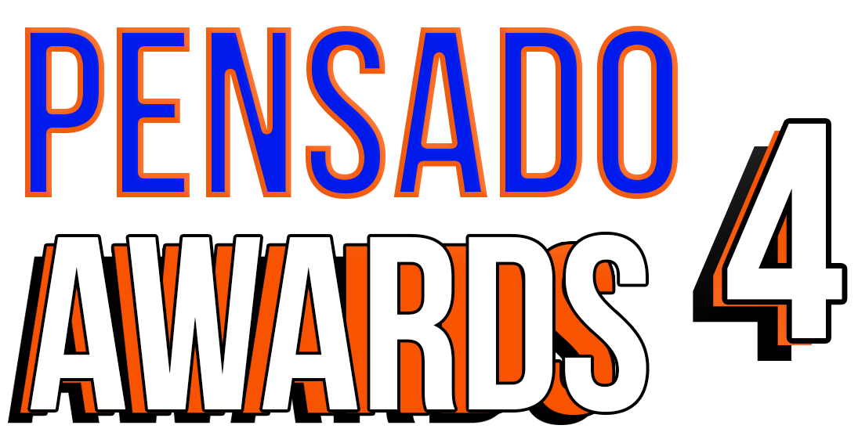

Fourth Annual Pensado Awards to Honor Greg Wells with Pensado Giant Award

Greg Wells to receive the Pensado Giant Award, which acknowledges an industry leader for their contributions and achievements in the field of record-making

Awards show, set to take place Sunday, December 3, 2017, at L.A.’s legendary Fonda Theatre, will once again “recognize the faces behind the sound” and feature returning co-hosts Samantha Maloney and Chris Lord-Alge and new co-host Kosine from Da Internz

Sponsors include 1500 or Nothin’, The Blackbird Academy, NAMM, Avid, Westlake Pro, LANDR and Heavyocity Media. The awards will feature a who’s-who of the recording community

LOS ANGELES, CA, October 27, 2017 — The Pensado Awards (taking place on Sunday, December 3, 2017, at Los Angeles’ historic Fonda Theatre, 6126 Hollywood Boulevard, Los Angeles, California 90028), dubbed by insiders as the must-attend audio event of the year, will soon be announcing its nominees, but one category already has a winner: the Pensado Giant Award this year will be presented to multiple GRAMMY®-nominated producer, musician and mixing engineer Greg Wells (Adele, OneRepublic, Keith Urban, Katy Perry, Twenty One Pilots), who has songs on over 85 million units sold. This award acknowledges an industry leader for their contributions and achievements in the field of record-making. Past recipients include famed engineer/producers Chris Lord-Alge, Bruce Swedien and Al Schmitt, who received this award in 2016, 2015 and 2014, respectively.

Few producers in music can rival the pedigree and resume of GRAMMY-nominated producer, mixer, songwriter and multi-instrumentalist Greg Wells. Wells’ career has transcended sonic guidance, as the fluent guitarist, bassist, drummer and keyboard player has mastered the balance between hands-on help and drawing out an artist’s own sound regardless of genre. In contrast to many of his peers, Wells’ career has never been about creating an aural stamp to imprint a “signature sound.” Despite his vast knowledge and lifelong interest in music, Wells prefers to be a guiding sensei in the studio rather than an overshadowing presence. “You have to jump into the pool with the artist and quickly assess what’s happening,” says Wells. “You want to hear somebody lost in their own performance with a complete lack of self-consciousness. For me, the goal is to shine the best light on the artist themselves and help them be as true to themselves as possible. I’m more the basketball coach than the player.” It’s this philosophy that has helped Wells write and produce some of the best-selling and highest-charting tracks of the past 15 years, with such artists as Katy Perry, Keith Urban, Twenty One Pilots, Adele, Pharrell Williams, Grace VanderWaal, Mayer Hawthorne, Greg Holden, Rufus Wainwright, Holychild, Theophilus London, Timbaland, OneRepublic, Deftones, Otep, Pink, Kid Cudi, Burt Bacharach, k.d. lang, Mika, Sir George Martin, and the Count Basie Orchestra.

Created by Herb Trawick and Dave Pensado of Penwick Media (the producers of Pensado's Place and other industry-leading audio-related media), the Pensado Awards, dubbed by insiders as the must-attend audio event of the year, were founded as a means of acknowledging talented music producers, engineers, mixers, songwriters and their work, serving as a grand opportunity for the best pros, amateurs, brands and press to come together as one community to celebrate the uncelebrated. Since its inception, the show has continued to gain momentum and garner attention throughout the industry and beyond. The Fonda Theatre will provide an intimate backdrop for Pensado Awards 4, which will feature an entirely new vibe and new show format using cutting-edge technology, plus additional surprises throughout the night. This year’s co-hosts are drummer Samantha Maloney (Hole, Mötley Crüe, Peaches), legendary producer, engineer and mixer Chris Lord-Alge (Pink, Foo Fighters, Avril Lavigne, Green Day) and Kosine of acclaimed production duo Da Internz (Ludacris, Nicki Minaj, John Legend). Hip-hop production collective 1500 or Nothin' will serve as the Premier Sponsor for the fourth annual Pensado Awards. Other main sponsors include The Blackbird Academy, NAMM, Avid, Westlake Pro, LANDR and Heavyocity Media.

Herb Trawick stated, “Greg Wells’s legendary career speaks for itself. We couldn’t be prouder to honor this man and his career on December 3. The previous recipients of this award – Chris Lord-Alge, Bruce Swedien and Al Schmitt – represent a rarified class, and we are glad to add Greg Wells to this list!”

More about the Pensado Awards:
The Pensado Awards are a natural outgrowth of the ethos behind Pensado’s Place. In recent years, developments in music and technology have changed the landscape for producers, songwriters, engineers and musicians, encouraging artists and composers of all types to hone their craft. From the self-taught basement enthusiast to the seasoned industry producer, all manner of music professionals are discovering new methods of working and novel ways to reach fans. The science and art of music-making are in a rapid state of flux, with exciting opportunities awaiting among the talented figures in and out of the spotlight – the people who are currently engineering the next sound that will move the world in the music, film, television and digital realms. Over 100,000 albums and millions of songs are released every year, not to mention the hundreds of thousands of concerts put on worldwide, but the awards often end up in the hands of a lucky select group. So the brilliance and hard work of all those producers, songwriters, DJ’s, engineers, mixers, live wizards and behind-the-scenes technicians in audio often go unnoticed. The Pensado Awards, founded as a means of acknowledging these talented individuals and their work, are a grand opportunity for the best pros, amateurs, brands and press to come together as one community to celebrate the uncelebrated.

###

Photo file: GregWells.JPG
Photo caption: Multiple GRAMMY®-nominated producer, musician and mixing engineer Greg Wells

About Pensado’s Place
The hour-long weekly web series Pensado’s Place was created over five years ago. Co-hosted by legendary mix engineer Dave Pensado (Black Eyed Peas, Beyoncé, Christina Aguilera, Kelly Clarkson, Michael Jackson and more) and show creator Herb Trawick, Pensado’s Place includes interviews with top music industry artists, engineers, producers, mixers, and record executives, as well as in-depth tutorials in production, engineering and mixing. Pensado’s Place has positioned itself as “the most influential show for audio engineers,” mixers and producers (Forbes Magazine). Pensado’s Place is more than just a show, as it highlights the very best in the audio industry from music, film, TV, gaming, live, hardware and software with a presence in live events. As a leading educational resource, Pensado’s Place is helping build the next generation of audio greats. http://www.pensadosplace.tv/.

PR Contacts:
Robert Clyne / Clyne Media / 615-662-1616 / Robert@clynemedia.com / www.clynemedia.com/
Lisa Roy / Rock & Roy / 310-463-1563 / lisaroyaudio@mac.com

