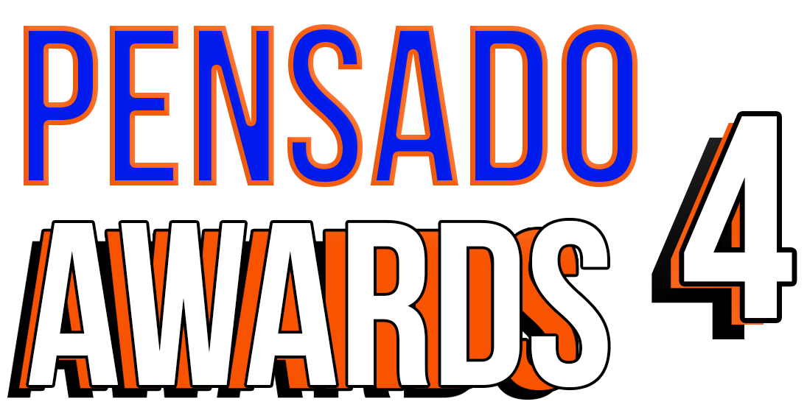

Nominees Announced for the Fourth Annual Pensado Awards, Sunday, December 3, 2017

Dozens of talented individuals fill 13 categories, from up-and-comers to legends of the industry

Awards show, set to take place Sunday, December 3, 2017, at L.A.’s legendary Fonda Theatre, will once again “recognize the faces behind the sound” and feature returning co-hosts Samantha Maloney and Chris Lord-Alge and new co-host Kosine from Da Internz

Sponsors include 1500 or Nothin’, The Blackbird Academy, NAMM, Avid, Westlake Pro, Roland, Recording Academy® Producers & Engineers Wing®, LANDR and Heavyocity Media. The awards will feature a who’s-who of the recording community

LOS ANGELES, CA, November 9, 2017 — The fourth annual Pensado Awards (taking place on Sunday, December 3, 2017, at Los Angeles’ historic Fonda Theatre, 6126 Hollywood Boulevard, Los Angeles, California 90028), dubbed by insiders as the must-attend audio event of the year, has announced its nominees in 13 categories.

A few key highlights among the categories and nominees include Game Changer of the Year (nominees: Shampoo, Press And Curl – Bruno Mars; Busbee – Keith Urban; Metro Boomin – Future; Terrace Martin – Kendrick Lamar; Jeff Bhasker – Harry Styles; Oak Felder – Demi Lovato); Spin Doctor DJ Award (nominees: Flume; Marshmello; Don Diablo; Kygo; Dillon Francis); and Break Thru Songwriter (nominees: James Fauntleroy; Erika Ender; Ed Sheeran; Julia Michaels; and Luke Laird). Other categories include OMG! Mix of the Year, Master of Mastering, Tracking Engineer, Outstanding Brand, Break Thru Mixer Award, Live/FOH, AIR Award (Best Assistant, Intern or Runner), Pensado Giant Award, Dave Pensado Educator Award and Herb Trawick Visionary Award. A full list of nominees can be found at http://www.pensadoawards.com.

The pool of nominees will be voted on by The Pensado Awards Pro Committee, which is made up of leading artists, engineers, producers and industry notables (many of whom have been featured guests on Pensado’s Place). This year’s Pro Committee includes such notable recording/audio professionals as Al Schmitt (Bob Dylan, Paul McCartney), Ross Hogarth (Van Halen, Ziggy Marley), Tony Maserati (Lady Gaga / Beyoncé), Amy Burr (Larrabee Studios), Gavin Lurssen (Foo Fighters / Queens Of The Stone Age), Candace Stewart (Eastwest Studios), Rob Burrell (Carrie Underwood / Lady Antebellum), Jordan “DJ Swivel” Young (The Chainsmokers), Zoe Thrall (Studio at the Palms Las Vegas) and others.

Created by Herb Trawick and Dave Pensado of Penwick Media (the producers of Pensado's Place and other industry-leading audio-related media), the Pensado Awards were founded as a means of acknowledging talented music producers, engineers, mixers, songwriters and their work, serving as a grand opportunity for the best pros, amateurs, brands and press to come together as one community to celebrate the uncelebrated. Since its inception, the show has continued to gain momentum and garner attention throughout the industry and beyond. The Fonda Theatre will provide an intimate backdrop for Pensado Awards 4, which will feature an entirely new vibe and new show format using cutting-edge technology, plus additional surprises throughout the night. This year’s co-hosts are drummer Samantha Maloney (Hole, Mötley Crüe, Peaches), legendary producer, engineer and mixer Chris Lord-Alge (Pink, Foo Fighters, Avril Lavigne, Green Day) and Kosine of acclaimed production duo Da Internz (Ludacris, Nicki Minaj, John Legend). Hip-hop production collective 1500 or Nothin' will serve as the Premier Sponsor for the fourth annual Pensado Awards. Other main sponsors include The Blackbird Academy, NAMM, Avid, Westlake Pro, Roland, Recording Academy® Producers & Engineers Wing®, LANDR and Heavyocity Media. Tickets for the live ceremony are available for $50.00 here.

Herb Trawick stated, “We are only a few weeks out from the awards show date, and we are extremely proud to unveil our nominees. The categories for Pensado Awards 4 are truly a cross-section of the music industry, and each nominee is a winner in their own right. We are looking forward to the awards show on December 3rd, and our entirely new show format guarantees numerous surprises throughout the night that you just don't want to miss!”

More about the Pensado Awards:
The Pensado Awards are a natural outgrowth of the ethos behind Pensado’s Place. In recent years, developments in music and technology have changed the landscape for producers, songwriters, engineers and musicians, encouraging artists and composers of all types to hone their craft. From the self-taught basement enthusiast to the seasoned industry producer, all manner of music professionals are discovering new methods of working and novel ways to reach fans. The science and art of music-making are in a rapid state of flux, with exciting opportunities awaiting among the talented figures in and out of the spotlight – the people who are currently engineering the next sound that will move the world in the music, film, television and digital realms. Over 100,000 albums and millions of songs are released every year, not to mention the hundreds of thousands of concerts put on worldwide, but the awards often end up in the hands of a lucky select group. So the brilliance and hard work of all those producers, songwriters, DJ’s, engineers, mixers, live wizards and behind-the-scenes technicians in audio often go unnoticed. The Pensado Awards, founded as a means of acknowledging these talented individuals and their work, are a grand opportunity for the best pros, amateurs, brands and press to come together as one community to celebrate the uncelebrated.

###

Photo file: Pensado_Trawick.JPG
Photo caption: Pictured L-R: Dave Pensado and Herb Trawick

About Pensado’s Place
The hour-long weekly web series Pensado’s Place was created over five years ago. Co-hosted by legendary mix engineer Dave Pensado (Black Eyed Peas, Beyoncé, Christina Aguilera, Kelly Clarkson, Michael Jackson and more) and show creator Herb Trawick, Pensado’s Place includes interviews with top music industry artists, engineers, producers, mixers, and record executives, as well as in-depth tutorials in production, engineering and mixing. Pensado’s Place has positioned itself as “the most influential show for audio engineers,” mixers and producers (Forbes Magazine). Pensado’s Place is more than just a show, as it highlights the very best in the audio industry from music, film, TV, gaming, live, hardware and software with a presence in live events. As a leading educational resource, Pensado’s Place is helping build the next generation of audio greats. http://www.pensadosplace.tv/.

PR Contacts:
Robert Clyne / Clyne Media / 615-662-1616 / Robert@clynemedia.com / www.clynemedia.com/
Lisa Roy / Rock & Roy / 310-463-1563 / lisaroyaudio@mac.com

