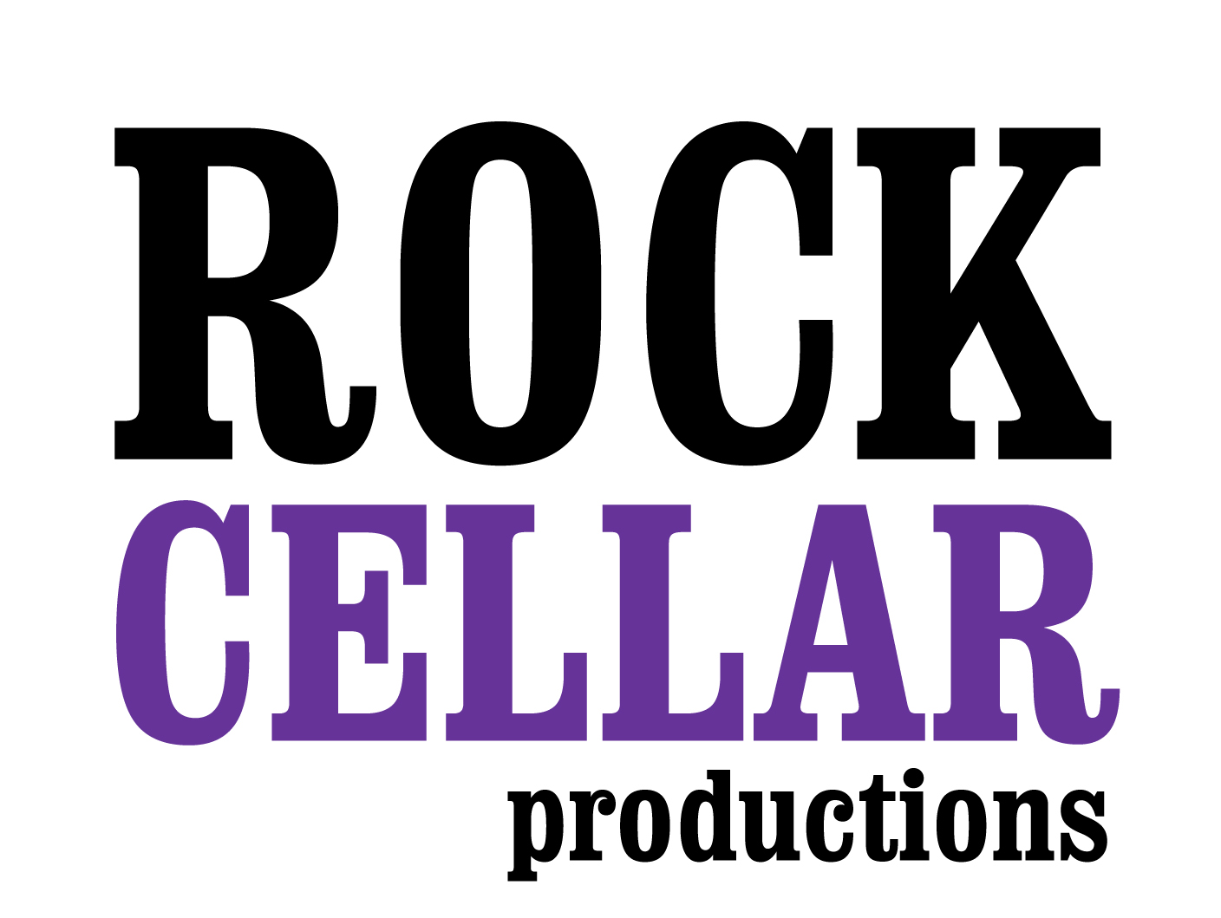

FOR IMMEDIATE RELEASE:

Rock Cellar Productions to Present Labor Day Weekend Live-Streamed Countdown Concert Featuring the All-Time Favorite Beatles Songs, Performed by The Tribe Band

– Countdown will be hosted by Chris Carter, noted radio personality and host of the long-running program Breakfast with The Beatles –

Los Angeles, CA, August 18, 2020 – On Saturday, September 5, 2020, at 6 p.m. PDT, on the occasion of the Labor Day weekend, Rock Cellar Productions will be presenting a FREE special event celebrating the music of The Beatles, live-streamed on www.alerttheglobe.com and Rock Cellar Magazine’s Facebook Live page www.facebook.com/RockCellarMagazine/live. The program, titled Labor Day Weekend Countdown: “The Beatles Top 50 All-Time Favorite Songs,” will take the form of a top-50 countdown and live concert performed by The Tribe Band with a rotating roster of amazing singers.

Chris Carter, host of America’s longest running Beatles show, Breakfast with The Beatles, SiriusXM, 95.5 KLOS, will serve as the event’s emcee, counting down the Top 50 All-Time Favorite Beatles Songs, as voted on by readers of Rock Cellar Magazine, and he’ll be introducing the performances by The Tribe Band. The show will be live-streamed from the Coach House in San Juan Capistrano, CA, with adherence to proper health precautions, and will feature such legendary Beatles tracks as “Hey Jude,” “Let It Be,” “Come Together,” “Yesterday,” and many more fan faves.

“Their music is timeless, their influence far-reaching and extends into nearly every aspect of culture. What better way to celebrate the greatest rock & roll band that ever lived than with an end of the summer all-time favorite Beatles countdown, with songs chosen by the readers of Rock Cellar Magazine?” stated Kevin Wachs, Rock Cellar Founder and drummer in The Tribe Band. “Our Labor Day weekend countdown is just the beginning of our re-branding of Rock Cellar, so stay tuned as we unfold a myriad of new resources, activities, and programs keeping true to our mission of bringing people together through music.”

Visit the Facebook event page here: https://www.facebook.com/events/2752510321646674
Facebook page: https://www.facebook.com/RockCellarMagazine
Instagram: https://www.instagram.com/rockcellarmag/

Photo file 1: TheTribeBeatles-LiveStreamConcert-1.JPG
Photo caption 1: On Saturday, September 5, 2020, at 6 p.m. PDT, on the occasion of the Labor Day weekend, Rock Cellar Productions will be presenting a FREE special event celebrating the music of The Beatles, live-streamed on www.alerttheglobe.com and Rock Cellar Magazine’s Facebook Live page www.facebook.com/RockCellarMagazine/live. The program, titled Labor Day Weekend Countdown: “The Beatles Top 50 All-Time Favorite Songs,” will take the form of a top-50 countdown and live concert performed by The Tribe Band with a rotating roster of amazing singers.

About Rock Cellar Productions
Recently, Los Angeles-based Rock Cellar Productions has expanded its brand far beyond its online publication, Rock Cellar Magazine. The production company encompasses many other aspects of media including a recording studio, live streamed concerts done from the studio, and a music school for students in the local southern California area. Maintaining its philosophy of “bringing people together through music to make great things happen,” Rock Cellar does it all, from cultural entertainment to supporting important causes that engage and unite music-loving enthusiasts and concerned citizens with the latest in cultural entertainment.

# # #

Contacts: Kevin Wachs, Co-founder, Executive Director kevin@rockcellarmagazine.com
Lauri Reimer, Special Projects Coordinator lauri@rockcellarmagazine.com

Media Contacts:

Robert Clyne
Clyne Media, Inc.
615.662.1616
robert@clynemedia.com

Lisa Roy
Rock & Roy Entertainment
310.463.1563
lisaroyaudio@mac.com

More information: www.rockcellarmagazine.com / 818-727-7884 / www.thetribeband.com

