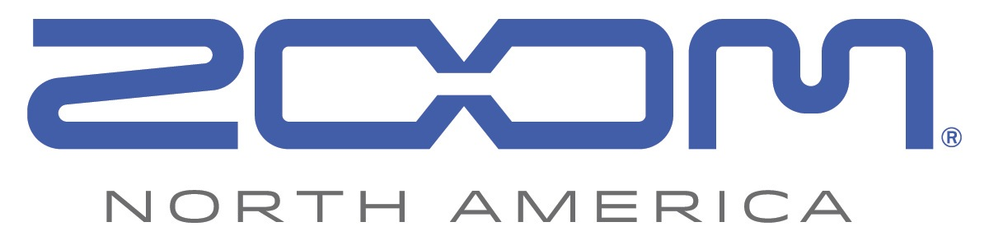
PRESS RELEASE: PRODUCT ANNOUNCEMENT

Zoom Expands Its Audio-for-Video Solutions Lineup with the New
F1-SP Field Recorder + Shotgun Mic

Perfect for on-the-move filmmakers and videographers, the Zoom F1-SP Field Recorder + Shotgun Mic delivers professional audio recording when mounted to a DSLR camera.

zoom-na.com/f1-sp

April 5, 2018 — Zoom North America now offers its new F1-SP Field Recorder + Shotgun Mic system, which comes with the F1 Field Recorder and the SGH-6 shotgun mic. The recorder and mic system mounts to DSLR cameras with a hot shoe. The F1-SP’s compact, low-profile overall form factor and outstanding mix of features and performance offer filmmakers and videographers an easy way to capture professional quality audio to meet the demands of their video action.

With more filmmakers, vloggers and journalists using portable DSLR cameras for professional-quality shoots, digitally savvy creators are demanding better audio for their video projects. The Zoom F1 Field Recorder + Shotgun Mic bundles the F1 Field Recorder with the SGH-6 Shotgun Mic to offer exceptional sound quality in a rugged and versatile on-the-go recording system.

Setup is quick and easy. The included SMF-1 shock mount connects the F1-SP to a DSLR thus eliminating unwanted thumping sounds caused by vibrations when shooting on the move. The F1’s audio output connects to the camera’s input using the included 3.5mm stereo cable, and while recording, the F1 can also record to a microSD card, creating a separate stereo audio file that provides flexibility in post-production.

The F1 Field Recorder and SGH-6 mic feature compact, lightweight, durable aluminum construction to allow filmmakers and videographers to get the most out of their audio recordings without having to carry bulky equipment. The F1 features a newly designed LCD display that ensures readability even in direct sunlight. Users can monitor levels, battery life, rumble filter lo-cut settings and more, while the one-touch controls that surround the display make recording levels, limiter settings and volume output easily accessible. The F1-SP combination can record high-resolution audio up to 24 bit/96 kHz.

Other essential features for videographers include a tone generator, sound markers, auto-level recording, on-board limiter, USB connectivity, and more. The F1 can be powered using two AAA batteries (included) or with the optional AD-17 power adapter.

In addition, the F1 Field Recorder uses a proprietary 10-pin connector for compatibility with all of Zoom’s interchangeable mic capsules, to provide options for virtually any recording situation.

The Zoom F1-SP system is currently available at authorized Zoom resellers at $249.99 MAP.

F1-SP Key Features:
- Two-channel Zoom Field Recorder (Model F1)
- Includes SGH-6 shotgun mic, specially designed SMF-1 shock mount, SMC-1 stereo mini cable and WSS-6 windscreen
- Ideal for recording on-the-go video
- Rugged, compact, lightweight aluminum body
- Improved 1.25-inch monochrome LCD display
- Intuitive menus and one-touch button controls for easy operation
- Stereo 1/8-inch Mic/Line In mini phone jack with plug-in power (2.5V)
- Stereo 1/8-inch Phone/Line Output jack with dedicated volume control
- Built-in limiter and auto level control
- Pre-Record function
- Supports up to 24-bit/96 kHz audio in BWF-compliant WAV format
- Records directly to SD and SDHC cards up to 32 GB
- Tone generator for calibrating audio levels between the F1 and a DSLR or video camera without the need for an attenuator cable
- Sound Marker function for easy syncing of audio and video
- Micro USB port enables use as an audio interface with computer or IOS device, and for data exchange
- Runs on two standard AAA alkaline (included), Lithium, or NiMH rechargeable batteries or AC adapter (AD-17)
- Compatible with Zoom microphone capsule system

Photo file 1: F1S_wWindscreen.JPG
Photo caption 1: Zoom F1-SP Field Recorder + Shotgun Mic system, shown mounted on a camera

Photo file 2: F1-SPwSkateboarder2.JPG
Photo caption 2: Zoom F1-SP Field Recorder + Shotgun Mic system application photo

Photo file 3: F1_SP_Package.JPG
Photo caption 3: Zoom F1-SP Field Recorder + Shotgun Mic system

Image Assets via Dropbox:
https://www.dropbox.com/sh/p06iweu4gt38qsc/AAAspQgyl_TaK2rixS1A9zAha?dl=0

About Zoom North America:
Zoom North America is the U.S. affiliate of Zoom Corporation (Japan). The company prides itself on offering its customers the very highest level of service and support.
info@zoom-na.com | Tel: 631-542-5270 | Fax: 631-542-5299

For more information, please contact:
Frank Doris
631-645-5668
Email: frankdoris@frankdoris.com

