For Immediate Release

Bose® Professional Systems Give Cabot High School’s Renovated Auditorium the Coverage It Needs
Cabot High School, recognized as a “Center for Excellence” by the Arkansas Dept. of Education, needed a sound system to match the school’s high standard of quality, and Bose® RoomMatch® loudspeakers with PowerMatch® amplifiers and ControlSpace® DSP were the right choice for the job
Framingham, Massachusetts, February 19, 2013 – Cabot High School, in Little Rock, Arkansas, is deemed a “Center For Excellence” by the Arkansas Department of Education. So it goes without saying that when Cabot High’s auditorium was scheduled for renovation last year, a high-quality sound system was a must. What had to be contended with, however, were the challenging dimensions of the room, which is far wider than it is deep, making even sound coverage difficult. Fortunately, Little Rock-based Curtis Stout Audio Visual saw this as an opportunity to test out what RoomMatch® loudspeakers and PowerMatch® amplifiers from Bose® Professional Systems Division could accomplish. Curtis Stout AV installed a system consisting of four PowerMatch PM8500N amplifiers; two RoomMatch RM12020, two RM12060 and two RM9010 loudspeakers; two RoomMatch RMS215 subwoofers; and Bose ControlSpace® DSP. As it turned out, they accomplished exactly what the job needed.
Richard Malott, Principal Design Engineer for Curtis Stout AV, says the Bose technology hadn’t yet been tested by them, but that the auditorium’s design called for a specialized approach. “The other system that they had been considering would never have been able to provide consistent coverage for that kind of a room,” he says. “It was really a challenging project.”
The incredible precision-aiming capability of the RoomMatch array modules allows integrators to predict with a high degree of accuracy how dispersion will take place, so that when the modeling of the room was completed, the system went right into place with little additional tuning needed. “Not only did the system do exactly what we needed it to do, but Bose also gave us great support, helping us with speaker locations and room modeling and allowing us to have every seat covered,” says Malott.
The Bose ControlSpace software offers the school, which uses the auditorium for applications ranging from drama classes to theatrical and musical presentations, as well as school assemblies and presentations, the ability to run the sound system in several basic configurations without having to use the room’s FOH console. “It’s set so that they can use podium and handheld microphones through the auto-mix inputs without requiring the use of an operator, which makes the whole auditorium more accessible to students and teachers,” he explains.
Mark Chard, Division Manager for Curtis Stout AV, adds that the ControlSpace software also made it easy to design, configure and operate the system. But the proof was in the sound. “The sound is simply nothing short of premier – nothing else comes close,” he says. “The client was delighted and we now have a flagship installation that we can use to show other clients how the Bose system’s quality speaks for itself.”
About RoomMatch Array Module Loudspeakers
Introduced in 2011 and recently expanded with several new modules, the Bose RoomMatch series offers a new class of curvilinear arrays – the progressive directivity array – providing both concert-quality sound for live music and clear vocals for spoken word, with unmatched seat-to-seat tonal balance consistency for installed sound systems. The full-range modules are available in 20 different combinations: horizontal coverage patterns of 55, 70, 90 or 120 degrees, and vertical coverage patterns of 5, 10, 20, 40 or 60 degrees.
The progressive directivity array offers the ability to vary both the horizontal and vertical coverage patterns for each module in the array based on the room dimensions. More precise coverage control helps sound system designers ensure good intelligibility with spoken-word program material, especially in reverberant rooms, as well as the best possible tonal balance throughout the listening area.

# # #

Photo File 1: Bose_CabotHS_Photo1.JPG
Photo Caption 1: The auditorium at Cabot High School in Little Rock, Arkansas, the recent renovation of which included a new PA system consisting of RoomMatch® loudspeakers and PowerMatch® amplifiers from Bose® Professional Systems Division.
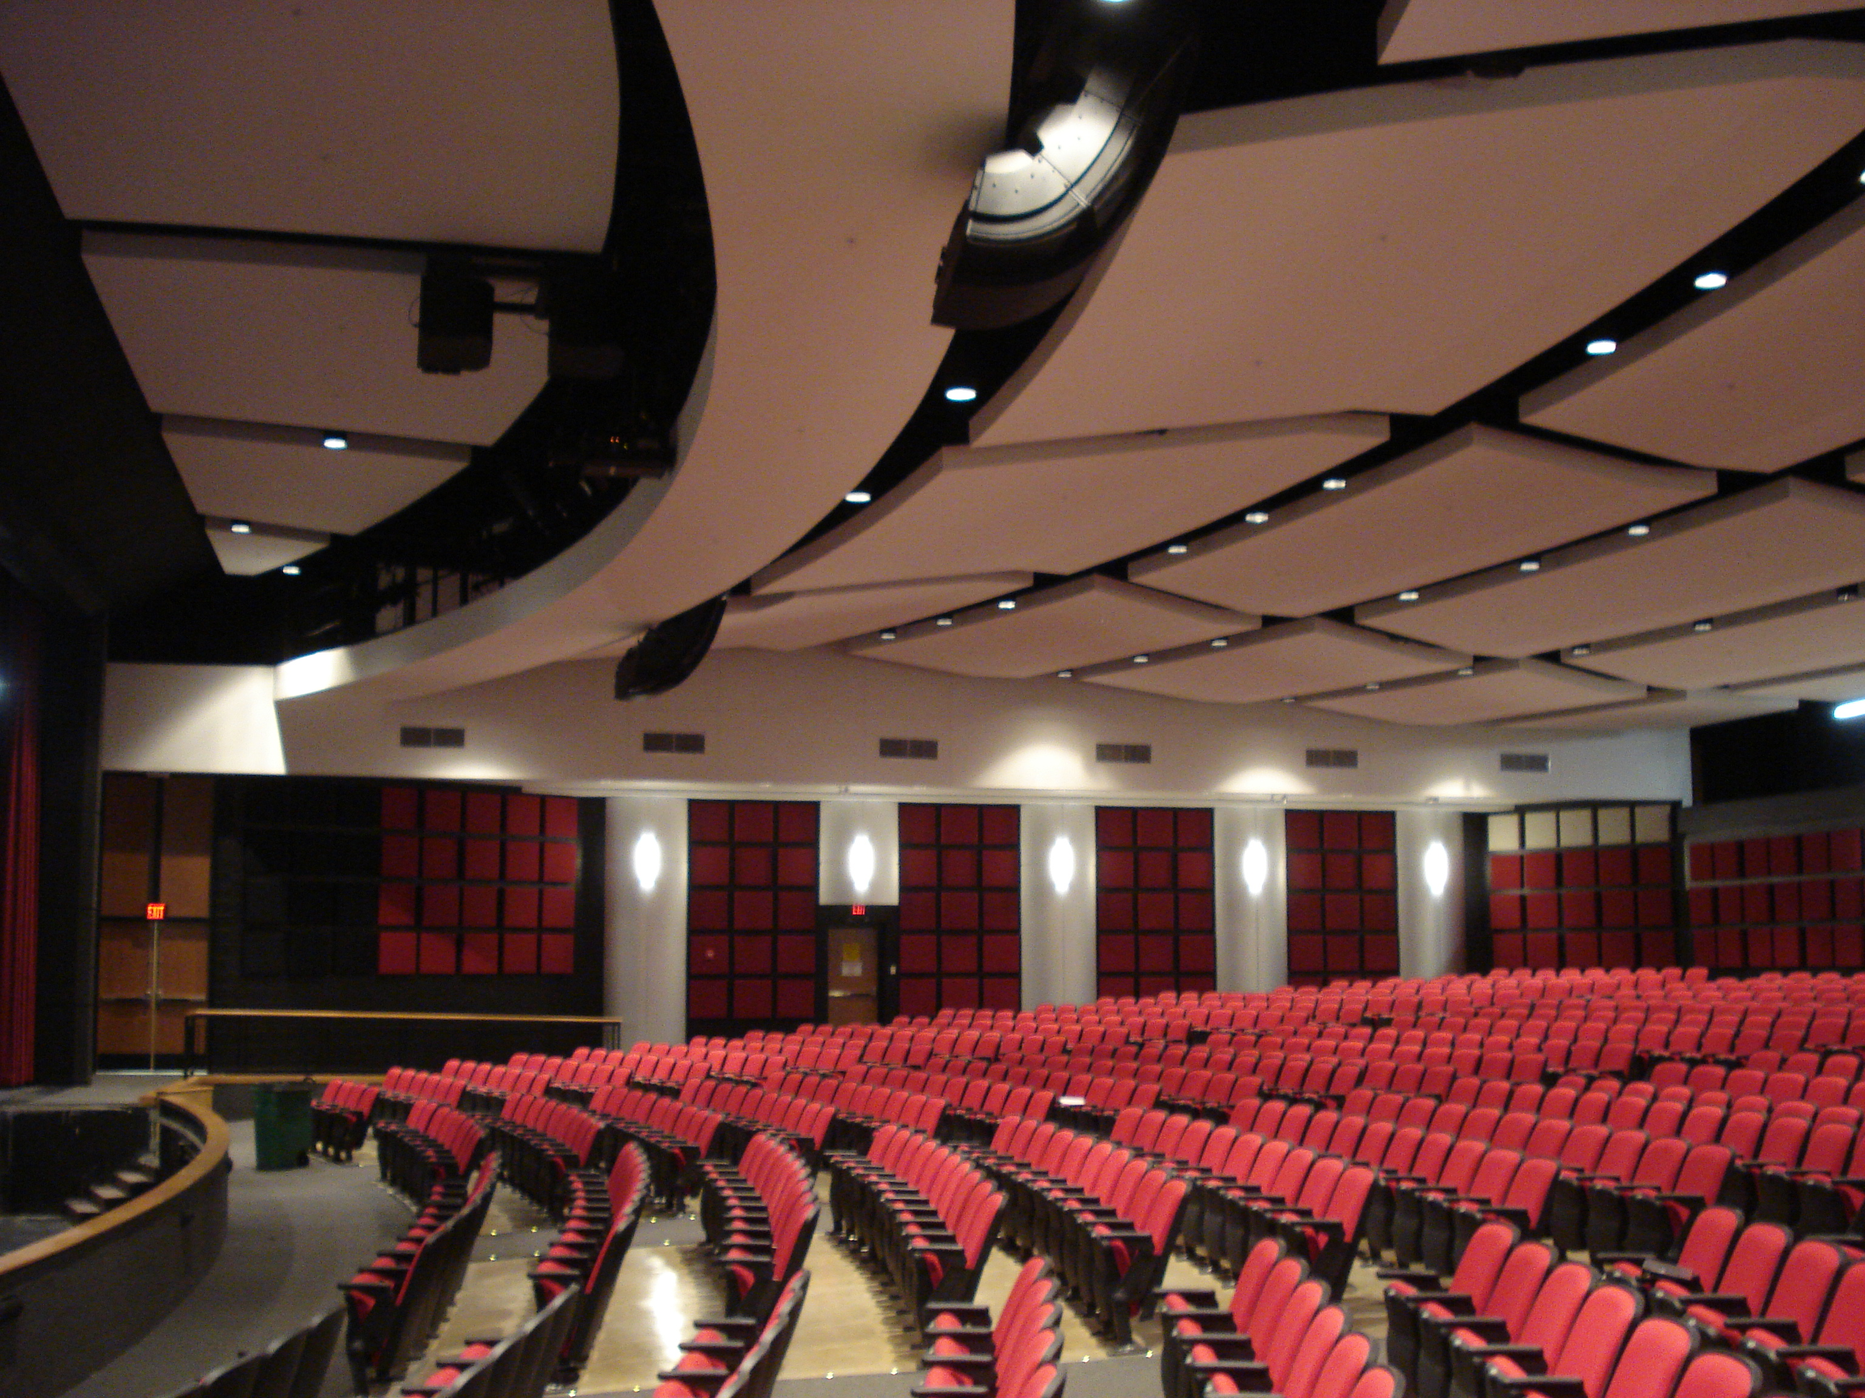
Photo File 2: Bose_CabotHS_Photo2.JPG
Photo Caption 2: The auditorium at Cabot High School in Little Rock, Arkansas, the recent renovation of which included a new PA system consisting of RoomMatch® loudspeakers and PowerMatch® amplifiers from Bose® Professional Systems Division.
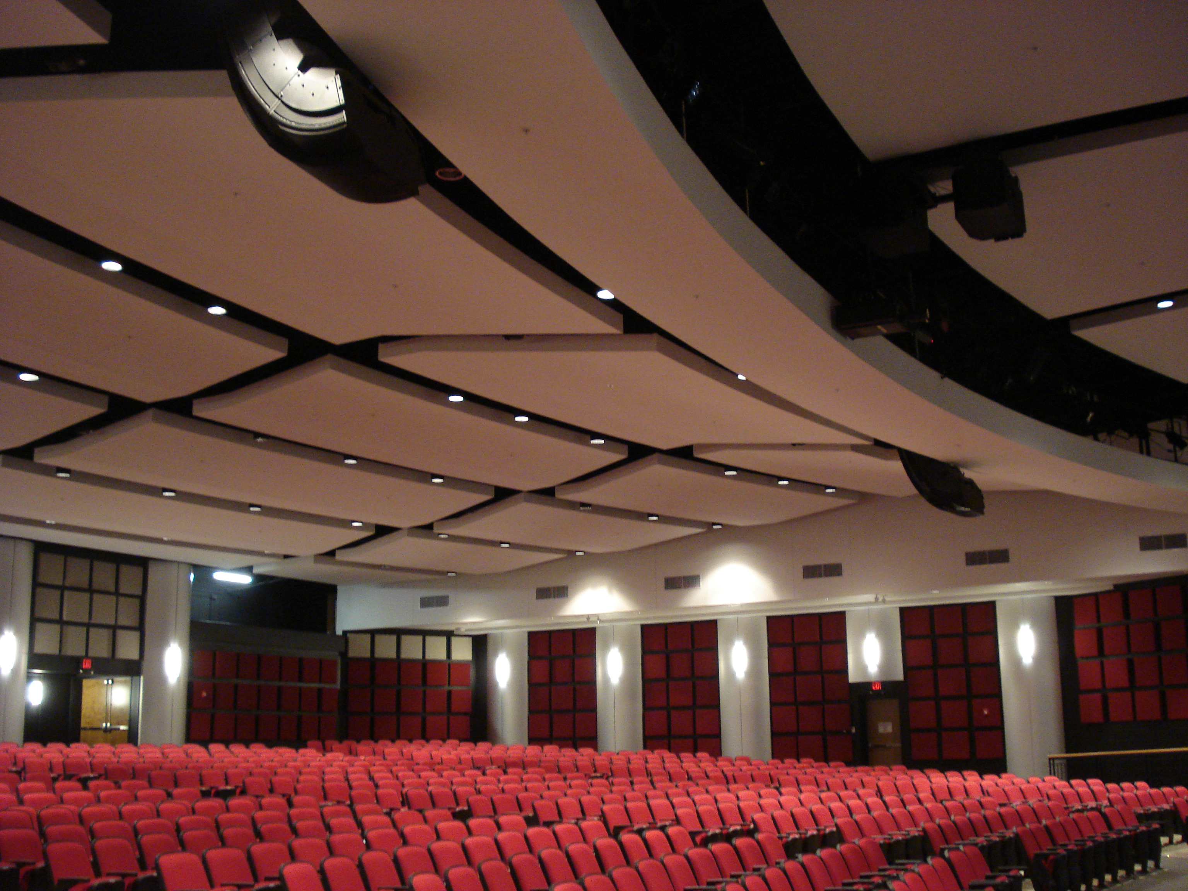

About Bose Corporation
Bose Corporation was founded in 1964 by Dr. Amar G. Bose, professor at the Massachusetts Institute of Technology. Today, the company is primarily known for acoustics; however, its research has resulted in products for non-audio fields. Bose inventions have improved the performance of:
- Loudspeakers
- Home entertainment systems
- Automotive music systems designed for the interior acoustics of each car model (first introduced by Bose)
- Noise reducing headsets for pilots and the public (first introduced by Bose)
- Sound in public spaces
- The production of sound for musicians requiring electronic amplification of their instruments
- Materials testing and durability simulation instruments for biomedical, industrial and commercial applications
- Driver suspension systems for heavy-duty trucks
Bose Contact:
Bose Professional Systems Division
508-614-6441
Bose_Professional_Systems@bose.com

