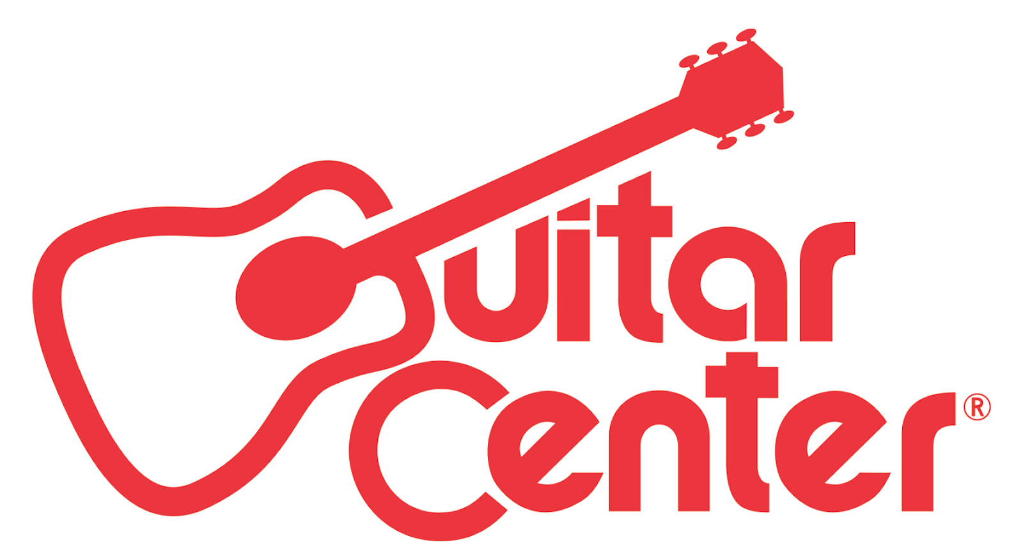

*** MEDIA ALERT FOR JANUARY 14, 2017 ***

Media Contact:
Robert Clyne
Clyne Media Inc.
Robert@clynemedia.com

Legendary Musicians Sheila E., Pete Escovedo and More Will Rock Guitar Center’s 28th Annual Drum-Off, Celebrating the Nation’s Top Drummers

The top five undiscovered drummers in the country compete for the title of Guitar Center’s Drum-Off Champion and a chance to kick-start their career on January 14 at the Novo in Los Angeles, CA

WHAT: Excitement has been building around Guitar Center's 28th Annual Drum-Off, the retailer’s annual search for the top undiscovered drummer. As the retailer’s longest running artist discovery program, Guitar Center’s Drum-Off continues to unearth some of today’s top emerging drum talent and has become one of the most highly anticipated events in the drum community.

Over three months ago, thousands of drummers from across the country began competing at more than 1,000 local competitions at Guitar Center stores nationwide. From a pool of over 5,000 determined drummers, five talented individuals have been chosen to move on to Guitar Center’s Drum-Off Finals on Saturday, January 14, at 7:00 PM at The Novo in Los Angeles, CA.

Past winners have gone on to play with Beyoncé and Prince (Cora Coleman-Dunham), Jay-Z (Tony Royster Jr.) and many more.

WHO: Guitar Center’s Drum-Off, hosted by famed session drummer Gregg Bissonette (David Lee Roth, Ringo Starr), will feature special celebrity moments throughout the evening including:

- A live performance by Sheila E. featuring Pete Escovedo
- Exclusive collaborative performance with Larnell Lewis (of GRAMMY® Award-winning artist Snarky Puppy) and Rashid Williams (John Legend)
- A Rockwalk Induction honoring Legendary James Brown drummers John “Jabo” Starks and Clyde Stubblefield
- After-Party with a special DJ set by Ali Shaheed Muhammad of A Tribe Called Quest (invite only).

Live performances from the following five finalists will cap off the evening, each competing for top prizes including $25,000 in cash, top-of-line drum gear, and more:

- Anthony Burns (Saginaw, MI)
- Kwesi Robinson (Lawrenceville, NJ)
- Fred Boswell (Avondale, AZ)
- Hilario Bell (Miami, FL)
- Mark Pacpaco (West Covina, CA)

The five Drum-off finalists will compete for the winning title in front of a live audience full of fans and industry professionals and a panel of celebrity judges including:

- Venzella Joy (Beyoncé)
- Tony Royster Jr. (Charlie Puth, Jay-Z)
- Queen Cora Dunham (Dave Chappelle, Beyoncé, Prince)
- Aaron Spears (Ariana Grande, Usher)
- Steve Ferrone (Tom Petty, Average White Band)
- Thomas Lang (Paul Gilbert, Educator/Clinician)
- Rich Redmond (Jason Aldean)
- Gil Sharone (Marilyn Manson, Team Sleep)
- Gerald Heyward (Chris Brown)
- Dave Elitch (Antemasque, The Mars Volta)
- Eric Leiderman (Producer of The Seth Meyers Show)
- Hannah Welton (Prince)

WHEN: Saturday, January 14, 2017, at 7:00 PM

Run of Show:
- 6:30 PM - Media check-in
- 7:00 PM - Red Carpet / Doors Open to Public
- 8:00 PM - Show Begins
- 11:00 PM - 1:30 AM - After-Party (Invite-only)

WHERE: The Novo at L.A. Live
800 West Olympic Blvd. Suite A335 Los Angeles, CA 90015

HOW: Advance tickets are available for $25 and can be purchased here: https://tickets.axs.com/shop/#/48c16520-af09-42dc-9456-a1f7d7fac02a

Media attendance welcome. Please RSVP here: Clyne Media, Inc. / gc@clynemedia.com

###

