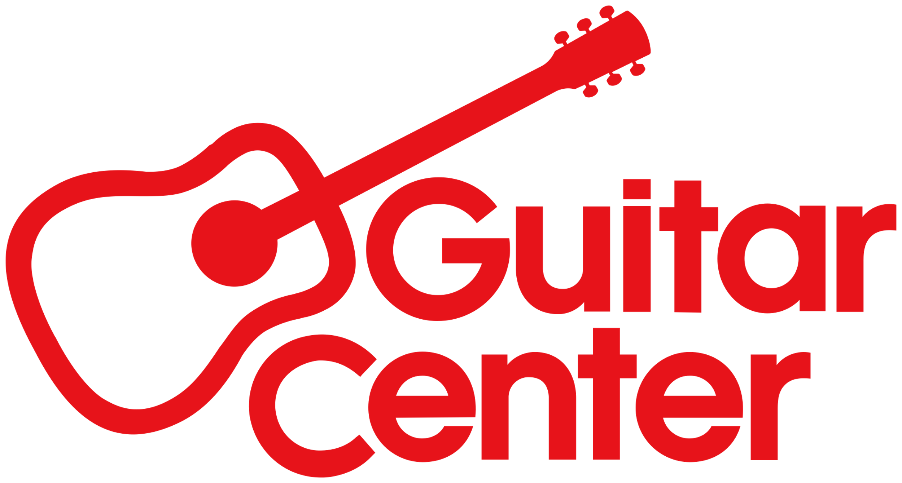

Guitar Center Announces Winners of the Guitar Center Lessons Crossroads Contest

Two winners – Daniel Castillo of Miami, FL, and Max French of Lancaster, PA – will perform as part of the live music at the Guitar Center Village, taking place on Peacock Place at L.A. LIVE, adjacent to the Crypto.com Area (the site of the 2023 Crossroads Guitar Festival) on September 23 and 24

LOS ANGELES, CA (September 21, 2023) — Guitar Center, the world’s largest musical instrument retailer, announces the winners of its GC Lessons Crossroads Contest, held as part of the festivities around the 2023 Crossroads Guitar Festival. Earlier this summer, GC Lessons students nationwide submitted videos showcasing their skills, which were judged by a diverse panel of Guitar Center employees. Two grand prize winners were selected – Daniel Castillo of Miami, FL, and Max French of Lancaster, PA – from a pool of video submissions. The contest was open to all Guitar Center Lessons students who were at least 16 years-old and currently learning guitar at any of the 300 plus lessons locations across the country.

The grand prize includes a free trip (flight and accommodations) for each winning student and one guest to Los Angeles, CA, to perform, accompanied by a band consisting of Guitar Center Lessons Instructors from the Northridge, Calif. store, on a special stage at the Guitar Center Village, located adjacent to the Crypto.com arena (the festival’s main stage site) at L.A. LIVE on Peacock Place and Chick Hearn Court. They will perform on September 23 and 24.

Daniel Castillo is a guitar student at the South Miami Guitar Center store, currently working with instructor Alex Escandon. Castillo credits the work of Eddie Van Halen for striking a chord with him early on and inspiring him to play guitar while listening to Van Halen’s classic songs with his father. He is also inspired by Eric Clapton, Carlos Santana and Stevie Ray Vaughan. He began playing guitar during COVID lockdown and took it very seriously, practicing every day. He remarks, “I realized that the guitar gives me nothing but joy. What keeps me motivated is trying to get better and better and learn new techniques and improve as a musician.” Last year, he auditioned for and was admitted to his high school’s rock ensemble class, and this year he is taking its honors concert band class.

Max French is a guitar student at the Lancaster Guitar Center store, currently working with instructor Jonas Kreitzer. As a 13-year-old in 2018, he began to dig into classic records – first the work of the Beatles, and then his Uncle Mark’s record collection, which ranged from the 60s to the 80s. “These albums helped me learn not just about guitar, but also keyboards, bass, and drums. I relate most to a lot of the artists from the 60s and 70s,” he notes. “All my free time at this point is either practicing, listening to music or talking to my friends who are also greatly interested in music. Everyone I know right now, I would never have met, if I didn’t play guitar.” He plans on applying to Berklee College of Music for Fall 2024.

“These talented students represent the next generation of musicians, and we are beyond proud that they have been able to hone their craft with the amazing instructors within our GC Lessons program,” said Dr. Donny Gruendler, Vice President of Music Education at Guitar Center. “We cannot wait for them to perform at the GC Village and showcasing their talents along with some of the world’s best guitarists, which is the ultimate reward for all their hard work.”

More about the Guitar Center Village:

The Guitar Center Village will host nearly two dozen guitar and gear manufacturers. Village guests will be able to plug in and play the latest guitars, amps, pedals, mics, and specialized audio gear from the world’s best manufacturers. The largest exhibition in the Village will be in the Guitar Center & Legends Collection tent, which will include scores of instruments and extensive selections of gear for guitarists at every skill level and price point, as well as its world-renowned Legends Collection, featuring famous vintage guitars previously owned and played by artists including Eric Clapton and Stevie Ray Vaughan). In addition, Guitar Center will be displaying and selling instruments from the Crossroads 25th Anniversary Collection of limited edition electric and acoustic guitars from the custom shops of Fender, Martin, and PRS/Paul Reed Smith.

For more information and videos featuring the 2023 Crossroads Guitar Festival’s 25th Anniversary Guitar Collection, please visit https://www.guitarcenter.com/Crossroads.gc. For more information about the Crossroads Guitar Festival, please visit crossroadsguitarfestival.com.

###

About Guitar Center

Guitar Center is the leading retailer of musical instruments, lessons, repairs and rentals in the U.S. With more than 300 stores across the U.S. and one of the top direct sales websites in the industry, Guitar Center has helped people make music for more than 50 years. Guitar Center also provides customers with various musician-based services, including Guitar Center Lessons, where musicians of all ages and skill levels can learn to play a variety of instruments in many music genres, GC Repairs, an on-site maintenance and repairs service, and GC Rentals, a program offering easy rentals of instruments and other sound reinforcement gear. Additionally, Guitar Center’s sister brands include Music & Arts, which operates more than 280 stores specializing in band & orchestral instruments for sale and rental, serving teachers, band directors, college professors, parents and students, and Musician’s Friend, a leading direct marketer of musical instruments in the United States. For more information about Guitar Center, please visit guitarcenter.com.

Media Contacts

Clyne Media / Robert Clyne / robert@clynemedia.com

Guitar Center / media@guitarcenter.com

Edelman / GuitarCenter@edelman.com

