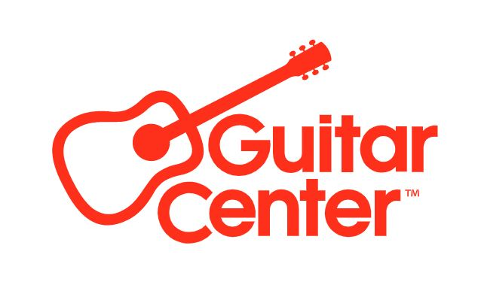

Guitar Center Announces an Exclusive Sweepstakes Opportunity for Two Grand Prize Winners to Attend Eric Clapton’s Crossroads Guitar Festival in Los Angeles

From now through 7/31, anyone of at least 18 years of age can enter a sweepstakes for a chance to win a trip for two to attend Eric Clapton’s Crossroads Guitar Festival in Los Angeles. Two grand prize winners will be selected. The prize includes airfare, hotel accommodations, tickets to attend the festival and more…

LOS ANGELES, CA (July 6, 2023) — In celebration of the upcoming Crossroads Guitar Festival, Guitar Center, a co-sponsor since 2004, is offering an exclusive trip for two grand prize winners and a guest to the Festival via a new sweepstakes! From now through July 31, enter for a chance to win a trip for two to attend Eric Clapton’s Crossroads Guitar Festival in Los Angeles. The Grand Prize includes airfare and hotel accommodations for two, tickets to attend the festival on each day (September 23 and 24), and a $500 Guitar Center gift card.

Eric Clapton and friends along with Guitar Center are gearing up for the 25th anniversary of the Crossroads Guitar Festival. The Festival, which has become legendary in its own right for hosting performances and impromptu collaborations from the world’s most renowned guitar players, will take place over two nights on September 23 and 24 at the Crypto.com Arena in Los Angeles, CA. Clapton will gather the past, present and future of guitar music onto one stage for an unparalleled musical event featuring performances from the who’s-who of guitarists.

Additionally, the lucky winner and a guest will visit the Guitar Center Village, located just outside of the Crypto.com Arena at Xbox Plaza, featuring some of the world’s best and exclusive guitars and check out the latest gear from manufacturers, including Fender, Gibson, Martin, BOSS, D’Angelico, Ernie Ball, Focusrite, Ibanez, Mark Bass, Marshall, Mitchell, PRS, Shure, Yamaha and more.

No purchase necessary to enter or win. Void where prohibited by law. Sweepstakes begins at 12:00:00 AM ET on 6/29/2023, and ends at 11:59:59 PM EDT on 7/31/2023. Limited to legal residents of the 50 United States and the District of Columbia who are at least 18 years of age or older. To enter and view complete details, visit https://www.guitarcenter.com/Crossroads.gc

For more information about the Crossroads Guitar Festival, please visit crossroadsguitarfestival.com.
Photo file 1: 2023_Crossroads_Sweepstakes_Signage.JPG

Photo caption 1: 2023 Crossroads Sweepstakes

About The Crossroads Centre, Antigua

Founded in 1998, Crossroads Centre, Antigua was created to provide treatment and education to chemically and alcohol dependent persons, their families and their significant others. Treatment is provided through residential care, family and aftercare programs. The pathway to recovery is founded on the 12 steps and a change in lifestyle. Crossroads Centre, Antigua also operates a halfway house in Antigua called the Bevon House and facilitates various ongoing recovery initiatives on the island of Antigua and in the Caribbean. For more information visit www.crossroadsantigua.org.

About Guitar Center

Guitar Center is the leading retailer of musical instruments, lessons, repairs and rentals in the U.S. With more than 300 stores across the U.S. and one of the top direct sales websites in the industry, Guitar Center has helped people make music for more than 50 years. Guitar Center also provides customers with various musician-based services, including Guitar Center Lessons, where musicians of all ages and skill levels can learn to play a variety of instruments in many music genres, GC Repairs, an on-site maintenance and repairs service, and GC Rentals, a program offering easy rentals of instruments and other sound reinforcement gear. Additionally, Guitar Center’s sister brands include Music & Arts, which operates more than 280 stores specializing in band & orchestral instruments for sale and rental, serving teachers, band directors, college professors, parents and students, and Musician’s Friend, a leading direct marketer of musical instruments in the United States. For more information about Guitar Center, please visit guitarcenter.com.

Media Contacts

For Eric Clapton:

Kristen Foster / kristen.foster@fullcov.com

For Guitar Center:

Clyne Media / pr@clynemedia.com

Guitar Center / media@guitarcenter.com
Edelman / GuitarCenter@edelman.com

