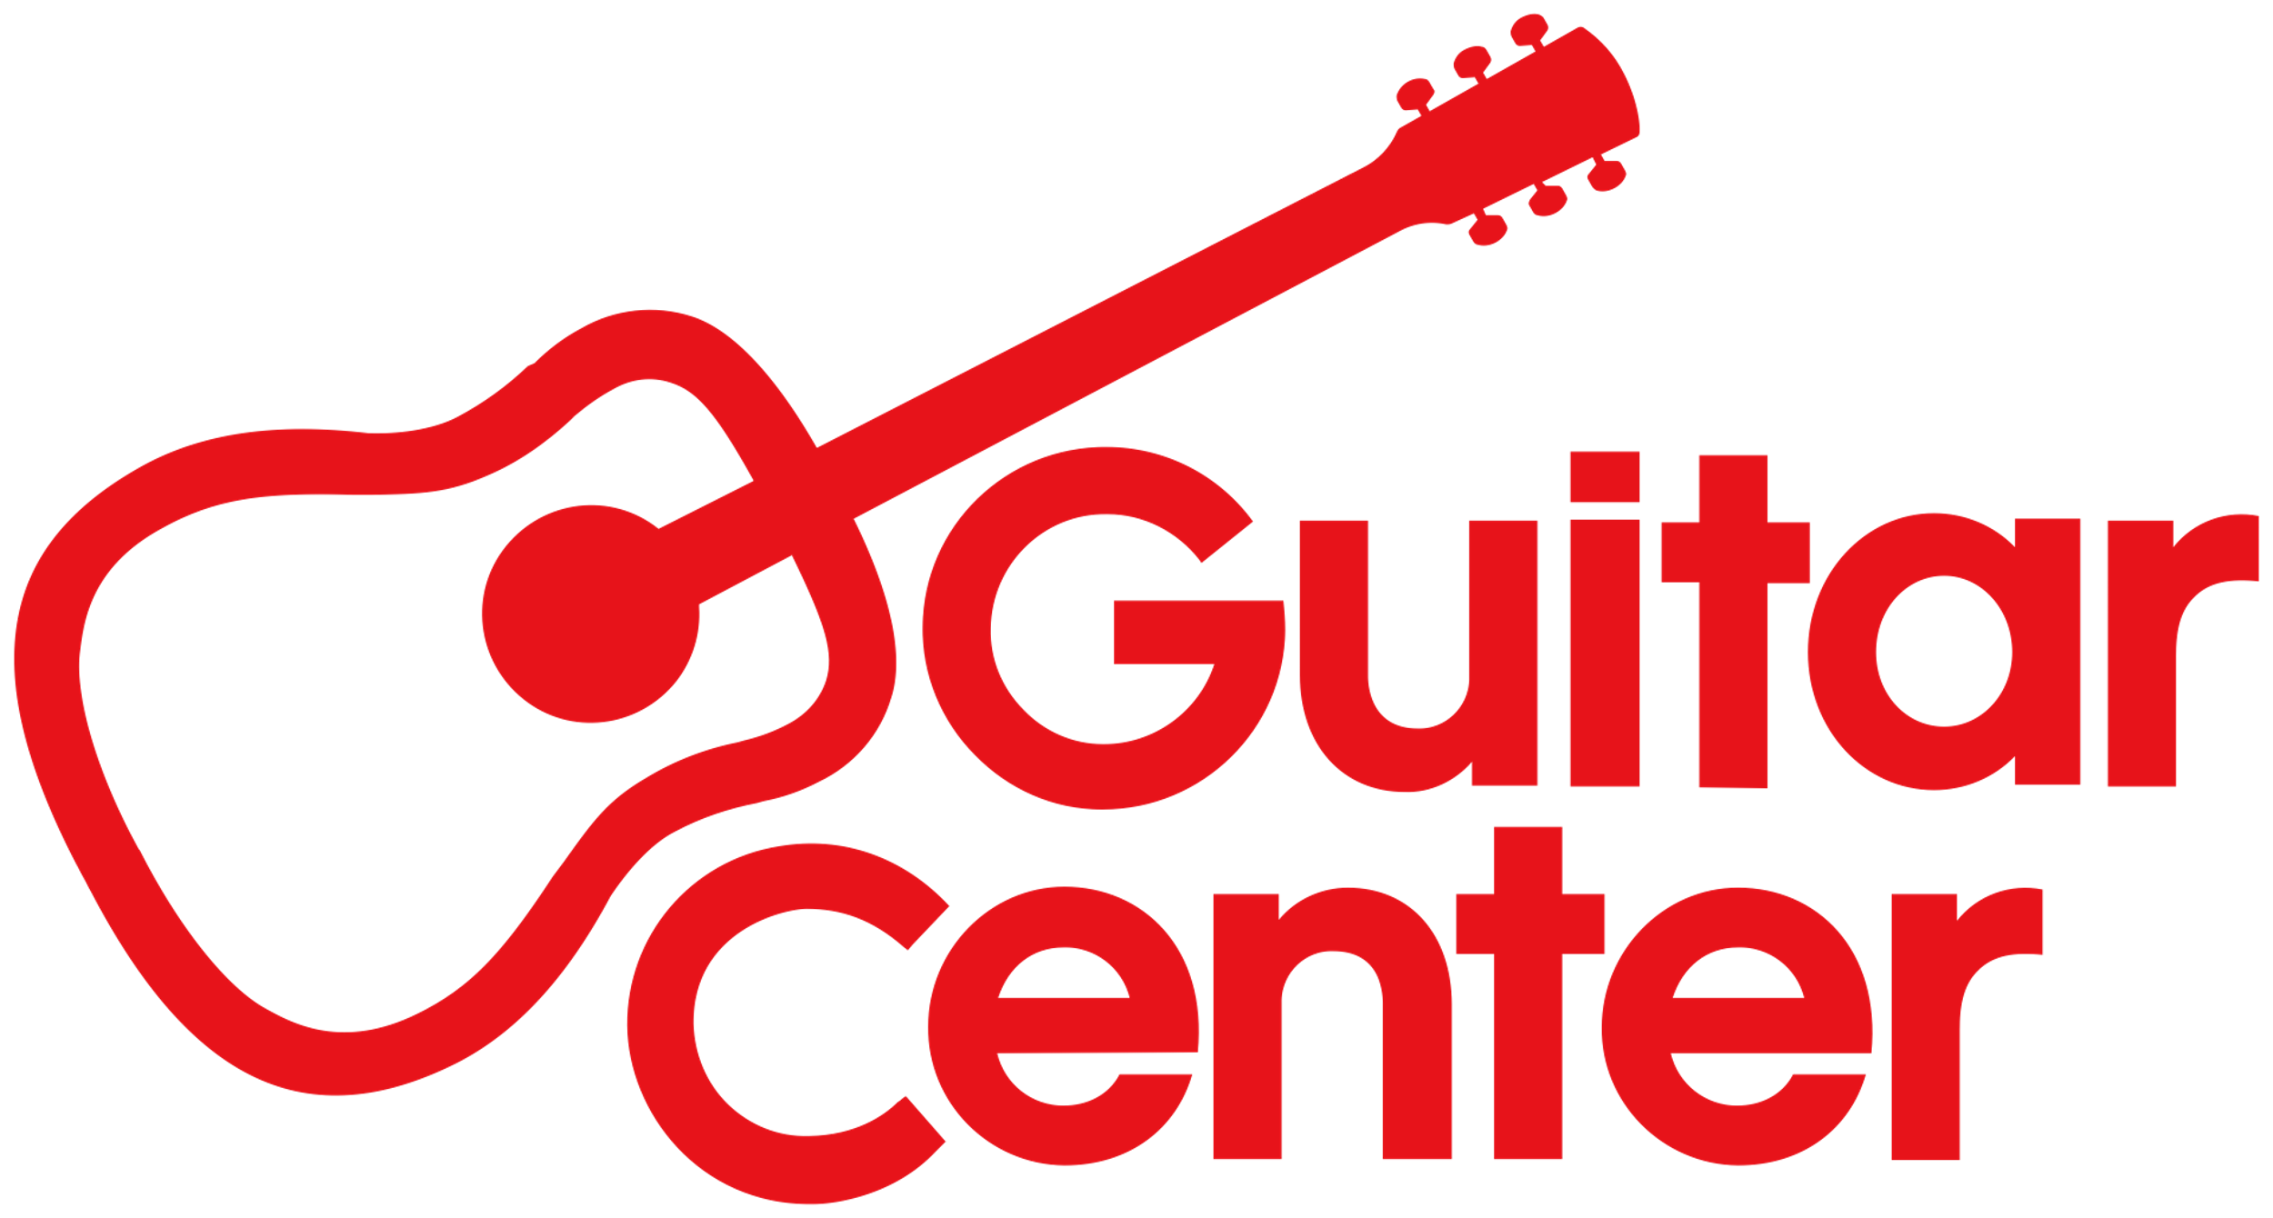

***MEDIA ALERT***

Guitar Center Partners with Drum Workshop for “DW Factory Day” on October 21

Taking place at DW’s headquarters in Oxnard, California,

WHO: Guitar Center, the world’s largest musical instrument retailer, partnering with Drum Workshop, Inc. (DW), one of the world’s preeminent manufacturers of drums and drum hardware.

WHAT: “DW Factory Day,” a day-long event open to the public, featuring one-day-only factory pricing, facility and showroom tours, artist clinics, special events, raffles/giveaways (from DW, PDP, LP, Zildjian, Remo, Vic Firth), local food trucks, and much more! Guitar Center will be serving as the exclusive vendor for all gear purchased through the event, offering special pricing on drums and gear available at the event, in-store and by phone, Oct. 21 only. Guitar Center Lessons personnel will also be on hand to offer free consultation and lesson services. Noted drummer Curt Bisquera (Mick Jagger, Elton John, Tom Petty) will serve as host.

Factory Day attendees can experience the full factory tour, where they will see the entire process of drum making from start to finish, hear about the 50-plus-year history of the company, see how drum hardware is made and visit the showroom of DW drums. On display are legendary drum kits including the last kit Rush drummer Neil Peart ever played. DW created the R40 drum set to celebrate Neil Peart’s 40 years with Rush, and it’s now on permanent display to honor one of the greatest drummers of all time.

A Drum Battle competition will also be held and is open to all comers (sign up from 10 a.m. to noon; 20 spots available), with prizes from DW, Zildjian & Guitar Center. Judges will include notable drummers Satnam Ramgotra, Mario Calire, Joe Travers, Joey Heredia, Curt Bisquera, Kenny Aronoff and Don Lombardi (DW co-founder).

The day will feature performances from legendary drummer Russ Kunkel, who will perform at the “Drum Channel Presents” stage at 11 a.m. and 2:15 p.m., each also including a Q&A session with DW co-founder John Good. (Signups for the 11 a.m. session will be available starting 9:30 a.m. and are first-come, first-served). Other performers throughout the day will include Curt Bisquera and Ray Yslas, as well as Gerald Heyward.

WHERE: DW Headquarters, 3450 Lunar Ct., Oxnard, CA 93030.

WHEN: Saturday, October 21, 2023, from 12 to 5 p.m. PDT (tickets and signups for the specific events including Drum Battle begin as early as 9:30 a.m.).

Visit https://www.guitarcenter.com/DW-Factory-Day.gc for more information and a detailed itinerary.
###

About Guitar Center:
Guitar Center is the leading retailer of musical instruments, lessons, repairs and rentals in the U.S. With more than 300 stores across the U.S. and one of the top direct sales websites in the industry, Guitar Center has helped people make music for more than 50 years. Guitar Center also provides customers with various musician-based services, including Guitar Center Lessons, where musicians of all ages and skill levels can learn to play a variety of instruments in many music genres, GC Repairs, an on-site maintenance and repairs service, and GC Rentals, a program offering easy rentals of instruments and other sound reinforcement gear. Additionally, Guitar Center’s sister brands include Music & Arts, which operates more than 250 stores specializing in band & orchestral instruments for sale and rental, serving teachers, band directors, college professors, parents and students, and Musician’s Friend, a leading direct marketer of musical instruments in the United States. For more information about Guitar Center, please visit guitarcenter.com.

FOR MORE INFORMATION PLEASE CONTACT:
Clyne Media | pr@clynemedia.com
Guitar Center | media@guitarcenter.com

