FOR IMMEDIATE RELEASE
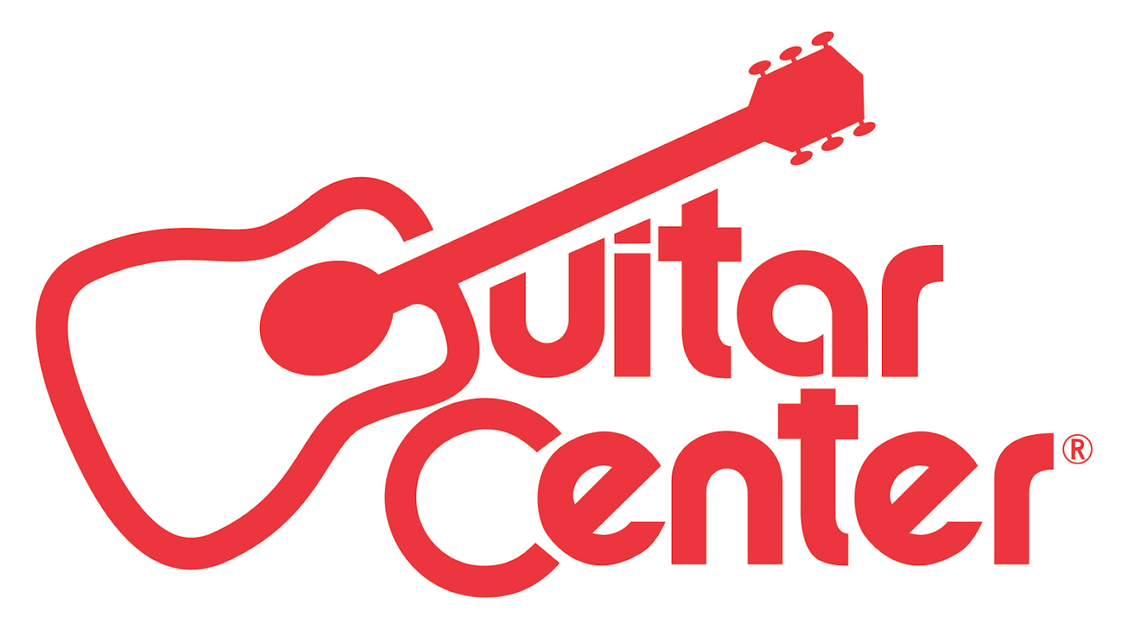

Guitar Center Spotlights the Nation’s Best Drummers in the 28th Annual Drum-Off

ANNOUNCEMENT HIGHLIGHTS:

- Guitar Center kicks off its annual celebration of drums, presenting the world’s premier drum competition
- Past Drum-Off winners have gone on to see successful careers, playing with the likes of Jay-Z, Beyoncé, Prince, The Mars Volta and more
- Drum-Off sign-ups are open now at all Guitar Center locations nationwide

Westlake Village, CA (August 1, 2016) – Guitar Center’s Drum-Off, the world’s premier drum competition, launches its 28th annual search for the top undiscovered drummer. Developed to inspire and support drummers in the pursuit of their musical aspirations, the program provides drummers with an incentive to work on their craft and connect with a larger audience, and has grown into a sought-after launching pad for a career as a professional drummer. Past Drum-Off winners have gone on to play with Beyoncé and Prince (Cora Coleman-Dunham), The Mars Volta and Trash Talk (Thomas Pridgen), Jay-Z (Tony Royster Jr.) and many more. As Guitar Center’s longest running artist discovery program, Drum-Off continues to unearth some of today’s top emerging drum talent and provide an unrivaled platform for exposure.

Starting today, drummers can sign-up for Guitar Center’s Drum-Off at any of the retailer’s locations nationwide. Free and open to drummers across the country, entrants will compete for a chance to win a career-launching grand prize package valued at $50,000 including cash, gear, endorsement deals, and more.

Guitar Center’s Drum-Off Grand Prize Winner Will Receive:

- $25,000 Cash
- Roland Electronic Drum Kit
- High-End Drum Kit by DW, Tama, Pearl, Gretsch or Yamaha (Winner’s Choice)
- Full set up of drum sticks, cymbals, and drumheads (Winner’s Choice)
- Endorsement Deals from the top drum manufacturers (Winner’s Choice)
- VIP Experience at NAMM 2017
- Feature in a Guitar Center Buyer’s Guide

How The Competition Works:
Starting August 1, 2016, drummers from all over the country will be able to sign up at their local GC store for the chance to become Guitar Center’s Drum-Off Champion. The competition breaks down into 2 weeks of store preliminaries at 267 participating stores. The top 3 drummers from each of the prelims will advance on to the store finals at all 267 of those locations. From there each of the store winners will move forward to the 30 quarter finals, and from there the 5 semifinals, culminating with the grand finals at The Novo in Los Angeles on January 14, 2017.

Each contestant will perform on a 5-piece acoustic drum kit complete with hardware, cymbals and percussion. Their performance will be evaluated by a panel of independent and credible judges on the following criteria: skills/technique, style, stage presence, groove, and overall performance.

For more information on rules and regulations, please visit: guitarcenter.com/drumoff.

Watch Guitar Center’s 27th Annual Drum-Off winner Tony Taylor Jr., and his winning performance, here: https://youtu.be/ydlayILLjbo

“Over the past 28 years, Guitar Center’s Drum-Off has become an institution and a highly anticipated event in the drum community,” said Maria Brown, manager of music and entertainment marketing for Guitar Center. “We are excited to create opportunities for drummers to play more, build their craft and shine a light on the emerging talent that we get to see during the competition ”

Drum-Off Competition Dates:
- Store Prelims = September 13 and 20, 2016
- Store Finals = September 27, 2016
- Quarter Finals = October 25, 2016
- Semifinals = November 15, 2016
- Grand Finals = January 14, 2017

In years past, some of the world’s most renowned drummers have participated in and supported Guitar Center’s Drum-Off, including: Terry Bozzio (Frank Zappa, Missing Persons), Aaron Spears (Usher), Dennis Chambers (Parliament/Funkadelic), Chad Smith (Red Hot Chili Peppers), Steve Gadd (Steely Dan), Questlove (The Roots), Travis Barker (Blink-182), Tommy Lee (Motley Crüe), Dave Lombardo (Slayer), Carmine Appice (Ted Nugent, Ozzy Osbourne), John Tempesta (The Cult), Taylor Hawkins (Foo Fighters), Steve Smith (Journey), Josh Freese (Nine Inch Nails, A Perfect Circle), José Pasillas (Incubus), Billy Cobham (Miles Davis), Niko McBrain (Iron Maiden), Stephen Perkins (Jane’s Addiction), Danny Carey (Tool), Brann Dailor (Mastodon), Steve Ferrone (Tom Petty & The Heartbreakers), and more.

Guitar Center Drum-Off is presented by: DW, Pro-Mark, Yamaha, LP, Meinl, Roland, Gretsch, Pearl, Modern Drummer, Vic Firth, Zildjian, GoPro, Sabian, Remo, Tama, Evans and Drum Channel.

Photo file: DrumOff_28.JPG
Photo caption: Guitar Center’s 28th Annual Drum-Off begins August 1, 2016.

About Guitar Center:
Guitar Center is the world’s largest retailer of guitars, amplifiers, drums, keyboards, recording, live sound, DJ, and lighting equipment. With more than 270 stores across the U.S. and one of the top direct sales websites in the industry, Guitar Center has helped people make music for more than 50 years. In addition, Guitar Center’s sister brands include Music & Arts, which operates more than 120 stores specializing in band & orchestral instruments for sale and rental, serving teachers, band directors, college professors and students, and Musician’s Friend, a leading direct marketer of musical instruments in the United States. With an unrivalled in-store experience, an industry-leading online presence and passionate commitment to making gear easy-to-buy, Guitar Center is all about enabling musicians and non-musicians alike to experience the almost indescribable joy that comes from playing an instrument. For more information about Guitar Center, please visit www.guitarcenter.com.

You can visit our press room at http://www.guitarcenter.com/pages/press-room, and send media inquiries to media@guitarcenter.com.

FOR MORE INFORMATION PLEASE CONTACT:
Sarah Chavey | Praytell Agency | 313.407.7571 | sarah@praytellagency.com
Robert Clyne | Clyne Media | 615.662.1616 | pr@clynemedia.com
Syvetril Perryman | Guitar Center | 818.735.8800 x 2979 | media@guitarcenter.com

