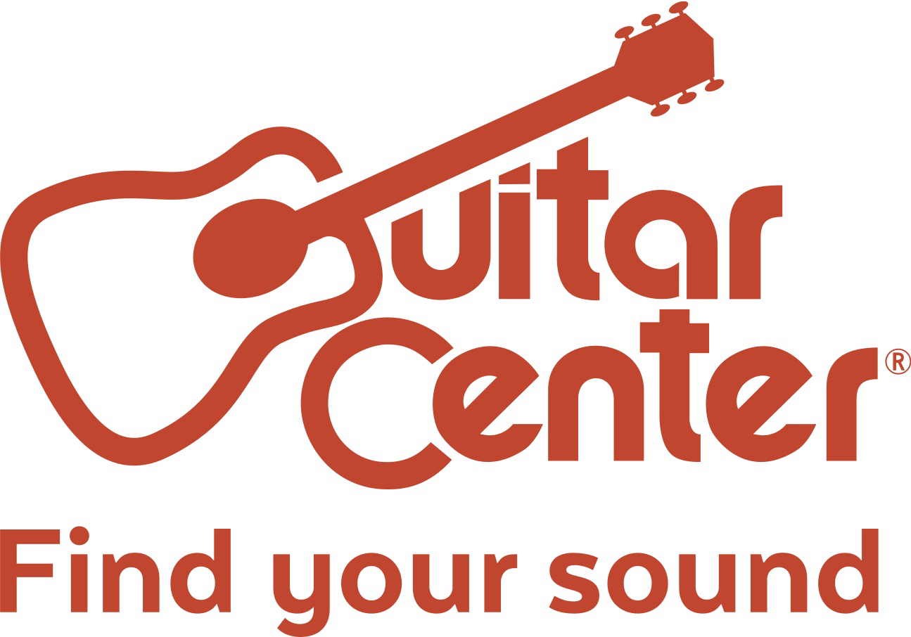

Guitar Center and D’Addario Partner for COVID-Safe Earth Day Recycling / Re-String Event at Locations Nationwide

On Earth Day (April 22), Guitar Center will offer two different D’Addario string promotions for musicians who bring their guitars for setup service, encouraging recycling and responsible green practices

Westlake Village, CA (April 7, 2021) – Guitar Center, the world’s largest musical instrument retailer, is partnering with D’Addario for a special event in celebration of Earth Day. On Thursday, April 22 at Guitar Center locations nationwide, musicians are eligible for one of two promotions encouraging recycling and responsible green practices:

- Nationwide Earth Day offer: Free set of D’Addario strings with the purchase of any guitar setup service that includes a restring and the recycling of the old strings (offer valid on 4/22 at all GC locations)
- Limited five-store acoustic offer: Free acoustic restring with an upgrade to D’Addario XS strings with the recycling of old strings (limited to the first 25 acoustic guitar customers per store – offer valid on 4/22 only at Hollywood, Nashville, NYC Union Square, Las Vegas and Central Houston locations)

This event is part of D’Addario’s Playback String Recycling Program, as well as Guitar Center’s year-round string recycling initiative, which has seen approximately 6 million strings recycled to date making the retailer one of the largest string recycling destinations in the country.

These efforts are accomplished with the help of global recycling leader TerraCycle, which specializes in recycling typically unrecyclable materials and diverting them from the landfill. As musical instrument strings are not recycled through municipal recycling programs, an estimated 1.5 million lbs. of instrument string metal are put into landfills each year (equal to 2.5 Statues of Liberty) – material that is recyclable through TerraCycle’s innovative program with D’Addario.

“It is the responsible choice to recycle, and we encourage all musicians to recycle their used strings whenever and wherever possible, not just on Earth Day,” stated Stacey Spencer, Guitar Center Director – Repairs & Rentals. “We thank all those who regularly turn to their local Guitar Center for recycling their used strings. We are looking forward to serving guitarists with customized setup services with a goal to recycle 8 million strings in 2021.”

To ensure the protection of our customers and associates this year, Guitar Center is requiring social distancing at GC Repair benches and that everyone to wear a face mask or adequate face covering when in our stores. View the full list of our Covid-19 safety guidance here: https://www.guitarcenter.com/pages/COVID-19-Announcements.gc

###

Photo file: GC_EarthDay2021.JPG
Photo caption: Guitar Center and D’Addario have partnered for COVID-safe Earth Day recycling / re-string event at locations nationwide on April 22, 2021

About Guitar Center:
Guitar Center is a leading retailer of musical instruments, lessons, repairs and rentals in the U.S. With nearly 300 stores across the U.S. and one of the top direct sales websites in the industry, Guitar Center has helped people make music for more than 50 years. Guitar Center also provides customers with various musician-based services, including Guitar Center Lessons, where musicians of all ages and skill levels can learn to play a variety of instruments in many music genres; GC Repairs, an on-site maintenance and repairs service; and GC Rentals, a program offering easy rentals of instruments and other sound reinforcement gear. Additionally, Guitar Center’s sister brands include Music & Arts, which operates more than 200 stores specializing in band & orchestral instruments for sale and rental, serving teachers, band directors, college professors and students, and Musician’s Friend, a leading direct marketer of musical instruments in the United States. For more information about Guitar Center, please visit www.guitarcenter.com.

D'Addario & Company, Inc.
D’Addario is the world’s largest manufacturer of musical instrument accessories, marketed under several product brands: D’Addario Fretted, D’Addario Orchestral, D’Addario Woodwinds, Promark Drumsticks, Evans Drumheads, and Puresound Snare Wires. A family-owned and operated business with roots dating back to the 17th century, D’Addario now has over 1,100 employees worldwide, and manufactures 95% of its products in the U.S. while utilizing Toyota's Lean manufacturing principles. D'Addario musical accessories are distributed in 120 countries, serve more than 3,300 U.S. retailers, all major e-commerce sites, and are the preferred choice of musicians worldwide such as, Keith Urban, Zac Brown, Brandi Carlile, Dave Matthews, Gary Clark Jr., Chris Thile, Ry Cooder, Joe Satriani, Julia Fischer, Anderson .Paak, Kacey Musgraves and more.

The D’Addario Foundation believes in the power of music to unlock creativity, boost self-confidence, and enhance academics. D’Addario also reinforces its role as a social and environmental leader with initiatives such as Playback and PlayPlantPreserve.

About TerraCycle
TerraCycle is an innovative waste management company with a mission to eliminate the idea of waste. Operating nationally across 20 countries, TerraCycle partners with leading consumer product companies, retailers and cities to recycle products and packages, from dirty diapers to cigarette butts, that would otherwise end up being landfilled or incinerated. In addition, TerraCycle works with leading consumer product companies to integrate hard to recycle waste streams, such as ocean plastic, into their products and packaging. Its new division, Loop, is the first shopping system that gives consumers a way to shop for their favorite brands in durable, reusable packaging. TerraCycle has won over 200 awards for sustainability and has donated over $44 million to schools and charities since its founding more than 15 years ago and was named #10 in Fortune magazine’s list of 52 companies Changing the World. To learn more about TerraCycle or get involved in its recycling programs, please visit www.terracycle.com.

FOR MORE INFORMATION PLEASE CONTACT:
Clyne Media | 615.662.1616 | pr@clynemedia.com
Guitar Center | 818.735.8800 | media@guitarcenter.com
Edelman | 323.761.6523 | GuitarCenter@edelman.com
D’Addario & Co, Inc. | Natalie Morrison | natalie.morrison@daddario.com

