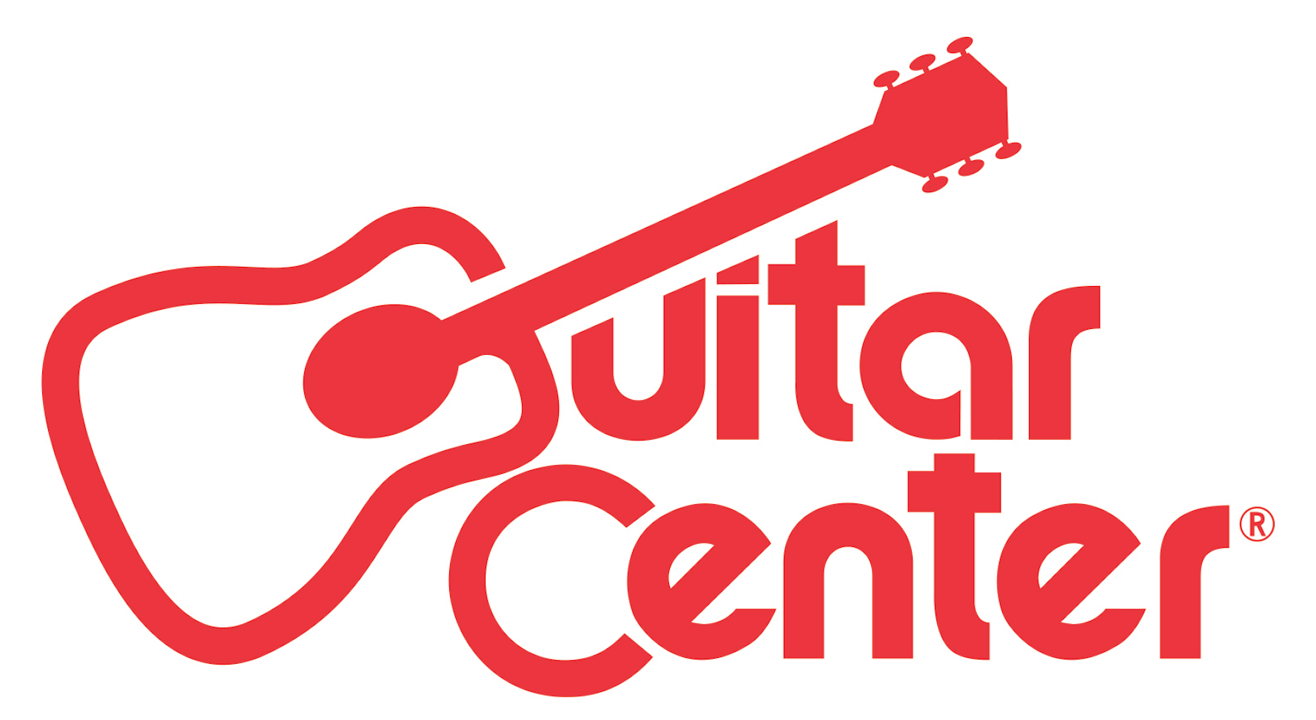

FOR IMMEDIATE RELEASE

Guitar Center Named Exclusive Retail Partner for Moogfest 2016

ANNOUNCEMENT HIGHLIGHTS:
- Guitar Center is now the exclusive retail partner of Moogfest 2016
- Guitar Center will help launch the reintroduction of the Moog Minimoog Model D, one of the most iconic synthesizers of all time
- First 30 Minimoog Model D synthesizers will be built onsite at Moogfest, and Guitar Center will make these instruments available to the world at its “Moog Store by Guitar Center”

Los Angeles, CA (May 19, 2016): Guitar Center, the world’s largest musical instrument retailer, has partnered with Moog Music Inc., to become the official sponsor of the electronic musical instrument store within the Moog Pop-Up Factory during Moogfest 2016. Now in its 12th year, Moogfest celebrates the legacy of Bob Moog, the visionary engineer who pioneered the analog synthesizer and other technology tools used by artists like Stevie Wonder, David Bowie and Kraftwerk. The four-day festival runs from May 19-22 in Durham, North Carolina, and will feature over 250 innovators in music, art and technology – from Gary Numan, GZA, Grimes and Laurie Anderson to virtual reality pioneer Jaron Lanier and transhumanist visionary Dr. Martine Rothblatt.

At Moogfest 2016, the legendary Minimoog Model D will be put back into production for the first time in 35 years, and Guitar Center will make these instruments available to customers at the “Moog Store by Guitar Center” in the Moog Pop-Up Factory where the instruments are being built onsite. As one of the most iconic synthesizers of all time, the original Minimoog Model D was in production from 1970-1981 and is regarded as the prototype from which all modern synthesizer designs are based on. In addition, Funk legend Bernie Worrell, founding keyboardist of Parliament/Funkadelic, and architect of some of the most influential Minimoog bass lines, will be appearing at the Guitar Center Moog Store on Thursday, May 19, and Friday, May 20.

Watch a Minimoog Model D demo at Moogfest here: https://www.facebook.com/GuitarCenter/videos/10154363299494728/.

“The Minimoog Model D is the instrument that set the stage for modern-day synthesizers, and we are honored to be the exclusive retail channel for this launch of the rebirth of this iconic keyboard. Having been chosen to have our Moog Store at Moogfest 2016 represents a truly unique opportunity for keyboard enthusiasts to get their hands on one of the first units produced, and it further underscores GC’s position as the comprehensive resource for all musicians. It should be a great event, and we are proud to be associated with Moogfest 2016.”
– Michael Amkreutz, Guitar Center Executive Vice President, Merchandising, Marketing and E-Commerce

"Guitar Center understood our vision and worked in lockstep with us to design a wonderland of interactive experiences for those who appreciate electronic music and the art of synthesis. This is a unique partnership that enables Guitar Center customers at Moogfest to witness their Minimoog Model D Synthesizer being handcrafted, while some of the greatest and most influential artists to ever play this storied synthesizer, like Bernie Worrell and Gary Numan, look on. We are grateful that Guitar Center's phenomenal collaboration helped us to realize this fantasy."
– Emmy Parker, Moog Music Brand Director

Photo file 1: MoogStore.JPG
Photo caption 1: The Moog Store by Guitar Center at Moogfest 2016

Photo file 2: ModelD.JPG
Photo caption 2: Minimoog Model D

About Moogfest
Moogfest is the synthesis of music, art and technology. Since 2004, Moogfest has brought together artists, futurist thinkers, inventors, entrepreneurs, designers, engineers, scientists and musicians. By day, Moogfest is a platform for conversation and experimentation. By night, Moogfest presents cutting-edge music in venues throughout the city. This mind-expanding conference attracts creative and technology enthusiasts for three days of participatory programming in Durham, North Carolina. Performing artists include early pioneers in electronic music, alongside pop and avant-garde experimentalists of today.

About Moog
Moog Music is the leading producer of analog synthesizers in the world. The employee-owned company and its customers carry on the legacy of its founder, electronic musical instrument pioneer, Dr. Bob Moog. All of Moog’s instruments are hand built in its factory on the edge of downtown Asheville, NC.

About Guitar Center:
Guitar Center is the world’s largest retailer of guitars, amplifiers, drums, keyboards, recording, live sound, DJ, and lighting equipment. With more than 270 stores across the U.S. and one of the top direct sales websites in the industry, Guitar Center has helped people make music for more than 50 years. In addition, Guitar Center’s sister brands includes Music & Arts, which operates more than 140 stores specializing in band & orchestral instruments for sale and rental, serving teachers, band directors, college professors and students, and Musician’s Friend, a leading direct marketer of musical instruments in the United States. With an unrivalled in-store experience, an industry-leading online presence and passionate commitment to making gear easy-to-buy, Guitar Center is all about enabling musicians and non-musicians alike to experience the almost indescribable joy that comes from playing an instrument. For more information about Guitar Center, please visit www.guitarcenter.com.

You can visit our press room at http://www.guitarcenter.com/pages/press-room and send media inquiries to media@guitarcenter.com.

FOR MORE INFORMATION PLEASE CONTACT:
Brad Gibson | Clyne Media, Inc. | 615.662.1616 | brad@clynemedia.com
Sarah Chavey | Praytell Agency | 313.407.7571| GCPR@praytellstrategy.com
Syvetril Perryman | Guitar Center | 818.735.8800 | media@guitarcenter.com

