FOR IMMEDIATE RELEASE
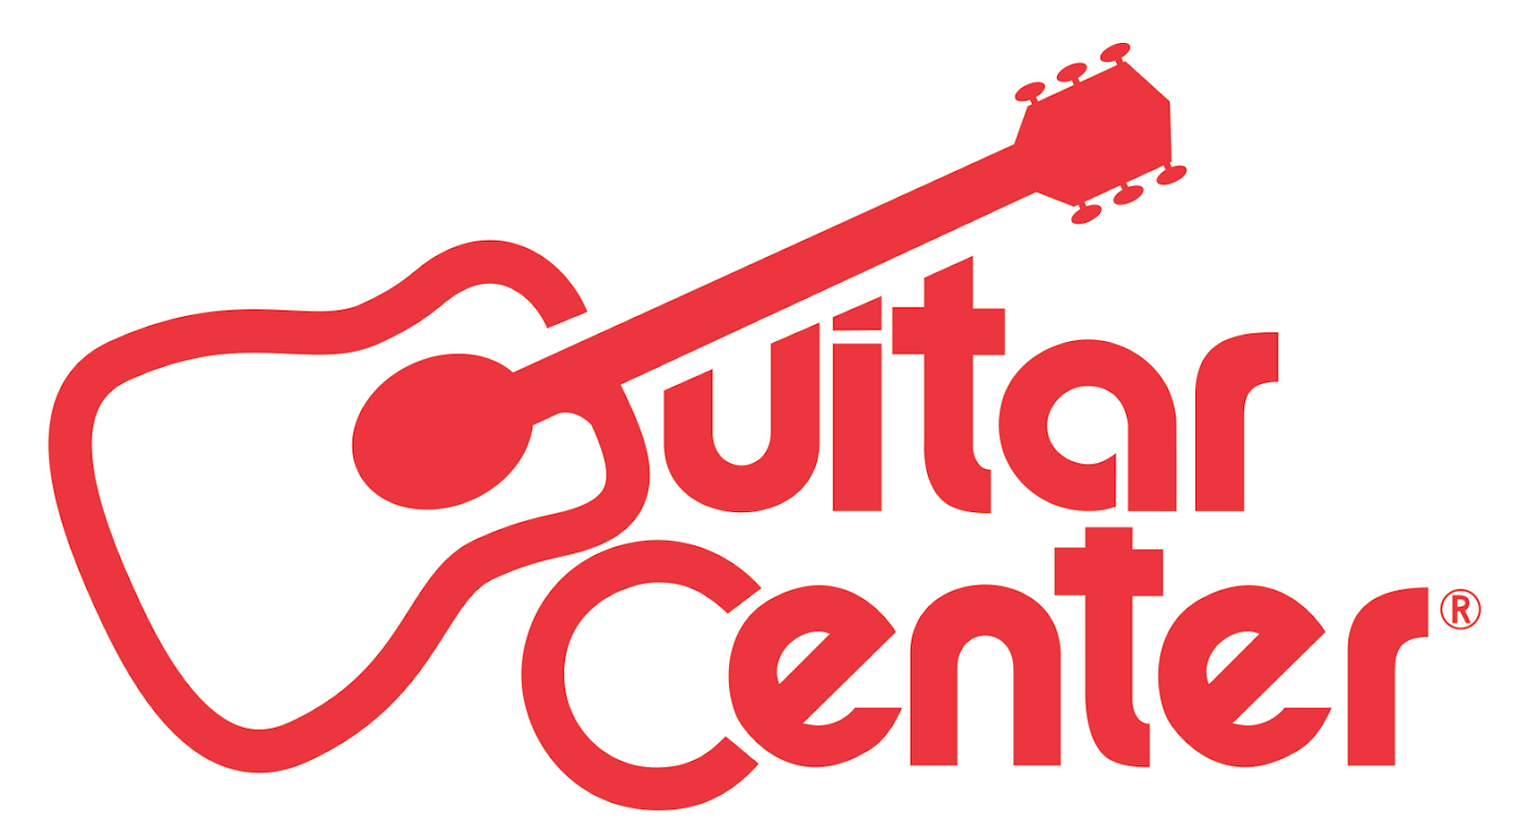

Guitar Center Expands National Presence with New Store Grand Openings

The new locations in Orem, UT, Cary, NC, and Norman, OK, give area residents one-stop shops for all of their music needs, from instruments and on-site lessons to guitar repairs and rental services

Los Angeles, CA (August 18, 2016) – Guitar Center, the world’s largest instrument retailer, has been expanding its presence nationwide with recent store grand openings in Orem, Utah (June 30); Cary, North Carolina (July 14); and Norman, Oklahoma (August 11). These three grand openings further underscore Guitar Center’s ongoing expansion and its commitment to serving growing music communities across the country.

The Orem store, covering 8,843 square feet, can be found at 64 E. 1300 South, Orem, UT 84058. The Cary store, a 10,000-square-foot facility, is located at 7123 O’Kelly Chapel Road, Cary, NC 27519. The Norman store covers 8,000 square feet and is located at 2202 24th Ave., Norman, OK. To celebrate the new stores, GC recently held three Grand Opening weekend events.

All three stores feature modern showrooms equipped with the latest products for musicians — from guitars, amplifiers, percussion instruments and keyboards to live sound, DJ, lighting and recording equipment. Customer services include Guitar Center Lessons, an in-house, state-of-the-art music academy for players of all ages and skill levels, GC Repairs, an on-site maintenance and repairs service, GC Rentals, easy rentals of instruments and other gear, and Guitar Center Workshops, offering free introductory classes and instruction on guitar, ukulele, and recording.

Shoppers at these locations are also able to enjoy Guitar Center’s multi-channel “endless aisle,” which gives customers the ability to combine in-store, online and phone options to purchase music equipment from anywhere.

Guitar Center Orem Store and Lessons Hours:
Monday – Friday 10am - 9pm
Saturday 10am - 8pm
Sunday 11am - 7pm

Guitar Center Cary Store and Lessons Hours:
Monday – Friday 10am - 9pm
Saturday 10am - 8pm
Sunday 11am - 7pm

Guitar Center Norman Store and Lessons Hours:
Monday – Friday 10am - 9pm
Saturday 10am - 8pm
Sunday 11am - 7pm

Photo file 1: GC_Orem_Storefront.JPG
Photo caption 1: The storefront of Guitar Center’s new retail location in Orem, Utah.

Photo file 2: GC_Orem_Employees.JPG
Photo caption 2: The employee team at Guitar Center’s new retail location in Orem, Utah.

Photo file 3: GC_Orem_Showroom.JPG
Photo caption 3: The showroom of Guitar Center’s new retail location in Orem, Utah.

Photo file 4: GC_Norman_Storefront.JPG
Photo caption 4: The storefront of Guitar Center’s new retail location in Norman, Oklahoma.

Photo file 5: GC_Norman_Employees.JPG
Photo caption 5: The employee team at Guitar Center’s new retail location in Norman, Oklahoma.

Photo file 6: GC_Norman_Showroom.JPG
Photo caption 6: The showroom of Guitar Center’s new retail location in Norman, Oklahoma.

About Guitar Center:
Guitar Center is the world’s largest retailer of guitars, amplifiers, drums, keyboards, recording, live sound, DJ, and lighting equipment. With more than 270 stores across the U.S. and one of the top direct sales websites in the industry, Guitar Center has helped people make music for more than 50 years. In addition, Guitar Center’s sister brands include Music & Arts, which operates more than 120 stores specializing in band & orchestral instruments for sale and rental, serving teachers, band directors, college professors and students, and Musician’s Friend, a leading direct marketer of musical instruments in the United States. With an unrivalled in-store experience, an industry-leading online presence and passionate commitment to making gear easy-to-buy, Guitar Center is all about enabling musicians and non-musicians alike to experience the almost indescribable joy that comes from playing an instrument. For more information about Guitar Center, please visit www.guitarcenter.com.

You can visit our press room at http://www.guitarcenter.com/pages/press-room, and send media inquiries to media@guitarcenter.com.

FOR MORE INFORMATION PLEASE CONTACT:
Sarah Chavey | Praytell Agency | 313.407.7571 | sarah@praytellagency.com
Robert Clyne | Clyne Media | 615.662.1616 | pr@clynemedia.com
Syvetril Perryman | Guitar Center | 818.735.8800 x 2979 | media@guitarcenter.com

