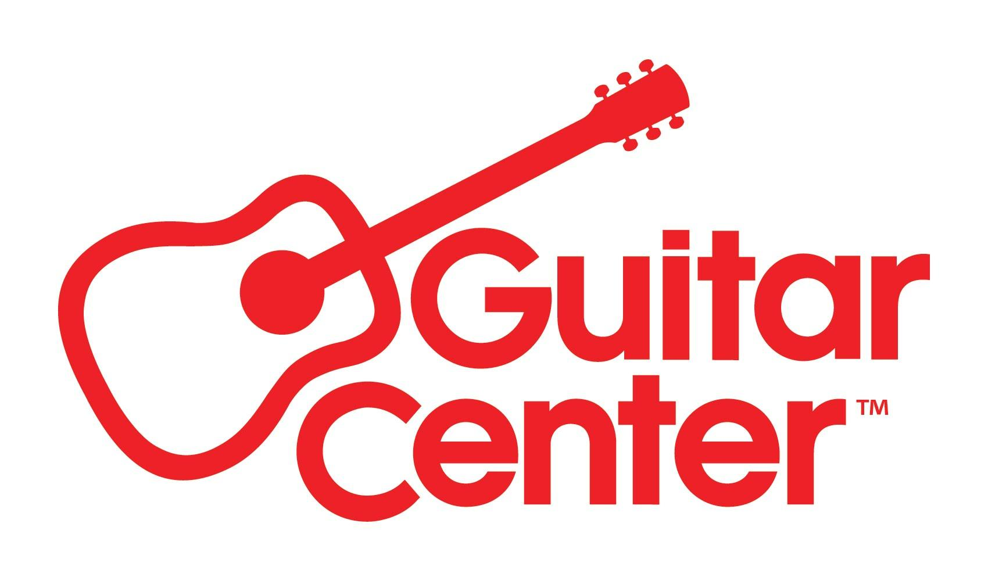

FOR IMMEDIATE RELEASE

Guitar Center Amplifies the Voices of LGBTQ Musicians with “Playing with Pride” Campaign

Guitar Center to celebrate Pride Month with charity auction, video content and more, all in support and celebration of the LGBTQ community

One-hundred percent of the auction proceeds will go to support The Trevor Project, with Guitar Center matching auction proceeds up to $50,000 as an additional donation

Westlake Village, CA, June 1, 2022 – Celebrated annually in June, Pride Month is a celebration of the history and achievements of the LGBTQ community, while also commemorating the ongoing pursuit of civil rights and equal justice under the law. In keeping with the celebration of diversity and inclusion, and in support of LGBTQ musicians and youth, Guitar Center announces its first “Playing with Pride” series of initiatives, coinciding with 2022 Pride Month (June 1 – 30, 2022).

The centerpiece of the retailer’s Pride campaign is an online charity auction featuring exclusive and unique gear from more than 30 top manufacturers of musical instruments and professional audio products. One-hundred percent of the auction’s proceeds will go to support The Trevor Project, the world’s largest suicide prevention and mental health organization for LGBTQ (lesbian, gay, bisexual, transgender, queer, and questioning) young people. The Trevor Project works to save young lives by providing support through free and confidential suicide prevention and crisis intervention services on platforms where young people spend their time: a 24/7 phone lifeline, chat, and text. The organization also runs TrevorSpace, the world’s largest safe space peer support platform for LGBTQ youth, and operates innovative education, research, and advocacy programs.

The auction, running from June 1 – 29, and accessible at GuitarCenter.com/Play-With-Pride.gc, features more than 70 specialty and/or one-of-a-kind products from manufacturers such as PRS, D’Angelico, Taylor, Electro-Voice, Zildjian/Vic Firth, D'Addario, and more. Much of the gear available for auction has been signed by the creators or top artists who have pledged their support for this campaign. A particular highlight is the PRS Custom Shop Rainbow Guitar (U.S. MSRP $11,890), which features a bold rainbow color pattern, curly maple top, figured mahogany back and neck, Brazilian rosewood fretboard, and darkside cross fade – one of only seven made in the world.

Other auction items include:
- IK Multimedia iRig HD 2 signed by Slash
- Vox Amplifier signed by Brian May
- Taylor Builder's Edition 717 Grand Pacific Dreadnought Acoustic Guitar Wild Honey Burst – signed by Linda Perry
- Electro-Voice EVOLVE 30M line array signed by Cory Wong
- Zildjian Gong (signed at the 2006 NAMM Show by over 30 famous drummers including Steve Smith, Matt Sorum, Peter Erskine, Mick Fleetwood, and more)
- Zildjian Vintage A cymbals, hand-selected from Armand Zildjian’s personal collection
- A year of Guitar Center Lessons, and much more!

Additionally, Guitar Center will match all auction proceeds up to $50,000 as an additional donation to support The Trevor Project’s mission to end suicide among LGBTQ young people.

Other activities during the month-long celebration will include Sounds of Pride (a content series spotlighting LGBTQ artists, on Guitar Center’s Riffs blog and social media channels), celebrating the unique musical contributions and legacy of the LGBTQ community.

“Guitar Center has been a long-time supporter of grassroots efforts that uplift and showcase musicians within diverse communities; however, this year, our employees and customers have expressed a desire for us to do even more. We are therefore making a commitment to more meaningful activations in support of Pride, to demonstrate our allyship in an even bigger way,” said Jeannine D’Addario, SVP, Chief Marketing & Communications Officer at Guitar Center. “For more than two decades now, The Trevor Project has served as a beacon of hope for so many young people in need of support. Guitar Center is proud to partner with The Trevor Project to encourage LGBTQ youth to tap into the healing and therapeutic powers that making music may bring.”

“We are so incredibly grateful for this generous donation from Guitar Center and the work they are doing to uplift and celebrate the voices of LGBTQ young people,” said Sofi Goode (she/her), Corporate Partnerships Manager at The Trevor Project. “While LGBTQ youth experience a number of unique challenges, our research shows that music is one of the ways in which they find joy and strength in their lives. In addition to helping The Trevor Project expand our free, 24/7 life-saving crisis services, Guitar Center’s campaign sends a powerful message of acceptance and inclusion to LGBTQ young people within the music community and beyond.”

For more information, visit GuitarCenter.com or Guitar Center on Facebook, Twitter, Instagram and YouTube.

Additional photos available here.

###

Photo file 1: PRS_Rainbow_Photo1.JPG
Photo caption 1: PRS Custom Shop Rainbow Guitar

Photo file 2: PRS_Rainbow_Photo2.JPG
Photo caption 2: PRS Custom Shop Rainbow Guitar

About The Trevor Project:
The Trevor Project is the world’s largest suicide prevention and mental health organization for lesbian, gay, bisexual, transgender, queer & questioning (LGBTQ) young people. The Trevor Project offers a suite of 24/7 crisis intervention and suicide prevention programs, including TrevorLifeline, TrevorText, and TrevorChat as well as the world’s largest safe space social networking site for LGBTQ youth, TrevorSpace. Trevor also operates an education program with resources for youth-serving adults and organizations, an advocacy department fighting for pro-LGBTQ legislation and against anti-LGBTQ rhetoric/policy positions, and a research team to discover the most effective means to help young LGBTQ people in crisis and end suicide. If you or someone you know is feeling hopeless or suicidal, our trained crisis counselors are available 24/7 at 1-866-488-7386, via chat TheTrevorProject.org/Help, or by texting 678678.

About Guitar Center:
Guitar Center is a leading retailer of musical instruments, lessons, repairs and rentals in the U.S. With nearly 300 stores across the U.S. and one of the top direct sales websites in the industry, Guitar Center has helped people make music for more than 50 years. Guitar Center also provides customers with various musician-based services, including Guitar Center Lessons, where musicians of all ages and skill levels can learn to play a variety of instruments in many music genres; GC Repairs, an on-site maintenance and repairs service; and GC Rentals, a program offering easy rentals of instruments and other sound reinforcement gear. Additionally, Guitar Center’s sister brands include Music & Arts, which operates more than 200 stores specializing in band & orchestral instruments for sale and rental, serving teachers, band directors, college professors and students, and Musician’s Friend, a leading direct marketer of musical instruments in the United States. For more information about Guitar Center, please visit www.guitarcenter.com.

FOR MORE INFORMATION PLEASE CONTACT:
Clyne Media | pr@clynemedia.com
Guitar Center| media@guitarcenter.com
Edelman | GuitarCenter@edelman.com

