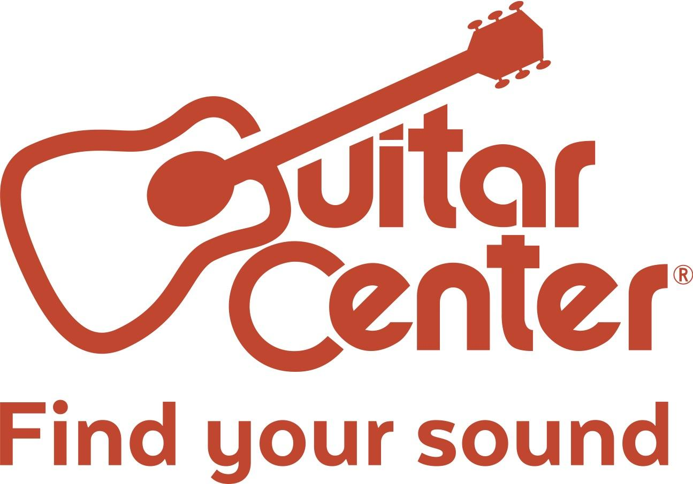

RedOne Names John Russell Winner of Guitar Center’s Sixth Annual Singer-Songwriter Competition

John Russell receives a grand prize that includes an EP produced by GRAMMY® Award winner RedOne, one-on-one mentorship with Cody Simpson and a performance slot on Jimmy Kimmel Live!

Westlake Village, CA (March 29, 2017) – Guitar Center, the world’s largest instrument retailer, in partnership with legendary producer RedOne (Lady Gaga, Jennifer Lopez, Usher), named John Russell from Savannah, GA, winner of Guitar Center's Sixth Annual Singer-Songwriter competition at the Grand Finale on Friday, March 24, 2017, at the Troubadour in Los Angeles, Calif.

Nearly 10,000 undiscovered songwriters from across the country sent in their submissions to Guitar Center's Singer-Songwriter for a chance to win a once-in-a-lifetime opportunity to produce their own EP with RedOne and Australian singer-songwriter Cody Simpson, who will serve as mentor to help kick start their career. The top five aspiring artists were hand-selected by RedOne to compete onstage at the Grand Finale, where John Russell was ultimately crowned.

Hosted by YouTube musical sensation Clara C, the night featured an opening collaborative performance with Kate Brady (last year's winner of Singer-Songwriter) and Streetlight Cadence, followed by a special performance by Australian singer-songwriter Cody Simpson. RedOne watched as each of the five finalists took the stage to perform their final showcase of songs before announcing John as the grand prize-winner.

Watch John’s winning performance HERE.

As the winner of Guitar Center’s Sixth Annual Singer-Songwriter John will receive:
- $25,000 Cash
- 4-song EP produced by RedOne
- One-on-One Mentorship with Cody Simpson
- Performance slot on Jimmy Kimmel Live!
- Showcase performance at the 2018 NAMM Show in Anaheim
- New gear from top instrument retailers
- A feature in American Songwriter magazine
- Global distribution through AWAL

John is a professional singer-songwriter residing in Savannah, Georgia, with his wife. Before winning Singer-Songwriter, John composed songs for commercials and TV, while maintaining his passion for creating original material for his own pursuits, which ultimately led to him earning the winning title of the 6th annual talent search. Driven by big, sweeping hooks, John marries a strategic songwriting process with his unique artistic flow to craft each song. Through his raw vocal talent and extensive proficiency in nine different instruments, John’s sound straddles pop, rock, funk, and jazz to create a genre all his own. He looks forward to growing as an artist through the guidance of RedOne and Cody Simpson and support of Guitar Center.

"I am overwhelmed with emotion to have won Guitar Center's Singer-Songwriter program. After my wife losing her job and friends and family encouraging me to do it, I took a leap of faith. It felt like the right time. I entered the competition because I wanted to share my story with people. Music was always a hobby of mine, but they pushed to me to pursue it. Now, the only way to go is up – to make music with RedOne that brings hope to people. Not everyone gets this chance, and I'm eternally grateful to Guitar Center for this opportunity." – John Russell, winner of Guitar Center’s 6th annual Singer-Songwriter program.

"From the moment he strummed the first chord, John Russell instantly stood out to me. He owned the stage and brought a unique sound and style matched with outstanding guitar and songwriting skills. He had that authentic star quality. I am so thrilled to partner with Guitar Center to help John start on his musical journey and can't wait to see where his gift will take him." – RedOne, GRAMMY® award winning producer and judge of the 6th annual Singer-Songwriter program.

“Guitar Center Singer-Songwriter has become a yearly highlight for our organization, as we provide a platform for talented unsigned artists to showcase their craft. We are so proud of all of the contestants, and each of them deserves to be heard and celebrated. Our five finalists are all winners in their own right, but tonight John Russell had his special moment as the latest winner of our Singer-Songwriter program. All of us at Guitar Center are thrilled to be able to support undiscovered artists while partnering with producers and artists as respected and renowned as RedOne and Cody Simpson. We congratulate this year’s finalists and grand prize winner, and we wish them all good luck with their careers. Also, a special thanks goes out to our sponsors, without whom this event could not take place.” – Jake Cheung, manager of music marketing and artist relations for Guitar Center

Guitar Center Singer-Songwriter 6 is sponsored by: Acoustic, American Songwriter, ASCAP, AWAL, D’Addario, Dunlop, Fishman, Gibson Memphis, Jimmy Kimmel Live!, Keep A Breast Foundation, Martin Guitar, Music Saves Lives, NAMM, Roland, Shure Microphones, Sunset Marquis, TC-Helicon and the Troubadour.

Photo file 1: SSW6_Group.JPG
Photo caption 1: Finalists and organizers of Guitar Center’s Sixth Annual Singer-Songwriter gathered at the competition’s Grand Finale on Friday, March 24, 2017, at the Troubadour in Los Angeles, Calif. Pictured L-R: Jake Cheung, manager of music marketing and artist relations for Guitar Center; Australian singer-songwriter Cody Simpson; John Russell, winner of Guitar Center’s Sixth Annual Singer-Songwriter; finalist Edwina Maben; finalist Kailey Abel; GRAMMY®-nominated producer RedOne; finalist Rachel Wong; finalist James Jannetty; Frank Crowson, Guitar Center Senior Vice President of Marketing; and Brian Berman, Guitar Center Vice President of Marketing. Photo credit: Guitar Center/Briand Guzman.

Photo file 2: SSW6_JohnRussell.JPG
Photo caption 2: John Russell, winner of Guitar Center’s Sixth Annual Singer-Songwriter, pictured at the competition’s Grand Finale on Friday, March 24, 2017, at the Troubadour in Los Angeles, Calif. Photo credit: Guitar Center/Briand Guzman.

Photo file 3: SSW6_JohnRussell_RedOne.JPG
Photo caption 3: Pictured L-R: John Russell, winner of Guitar Center’s Sixth Annual Singer-Songwriter, and GRAMMY®-nominated producer RedOne, pictured at the competition’s Grand Finale on Friday, March 24, 2017, at the Troubadour in Los Angeles, Calif. Photo credit: Guitar Center/Briand Guzman.

About Guitar Center: Guitar Center is the world’s largest retailer of guitars, amplifiers, drums, keyboards, recording, live sound, DJ, and lighting equipment. With more than 280 stores across the U.S. and one of the top direct sales websites in the industry, Guitar Center has helped people make music for more than 50 years. In addition, Guitar Center’s sister brands include Music & Arts, which operates more than 140 stores specializing in band & orchestral instruments for sale and rental, serving teachers, band directors, college professors and students, and Musician’s Friend, a leading direct marketer of musical instruments in the United States. With an unrivalled in-store experience, an industry-leading online presence and passionate commitment to making gear easy-to-buy, Guitar Center is all about enabling musicians and non-musicians alike to experience the almost indescribable joy that comes from playing an instrument. For more information about Guitar Center, please visit www.guitarcenter.com.
You can visit our press room at http://www.guitarcenter.com/pages/press-room, and send media inquiries to media@guitarcenter.com.

FOR MORE INFORMATION PLEASE CONTACT:
Robert Clyne | Clyne Media | 615.662.1616 | pr@clynemedia.com
Sarah Chavey | Praytell Agency | 313.407.7571 | GCPR@praytellagency.com
Syvetril Perryman | Guitar Center | 818.735.8800 x 2979 | media@guitarcenter.com

###

