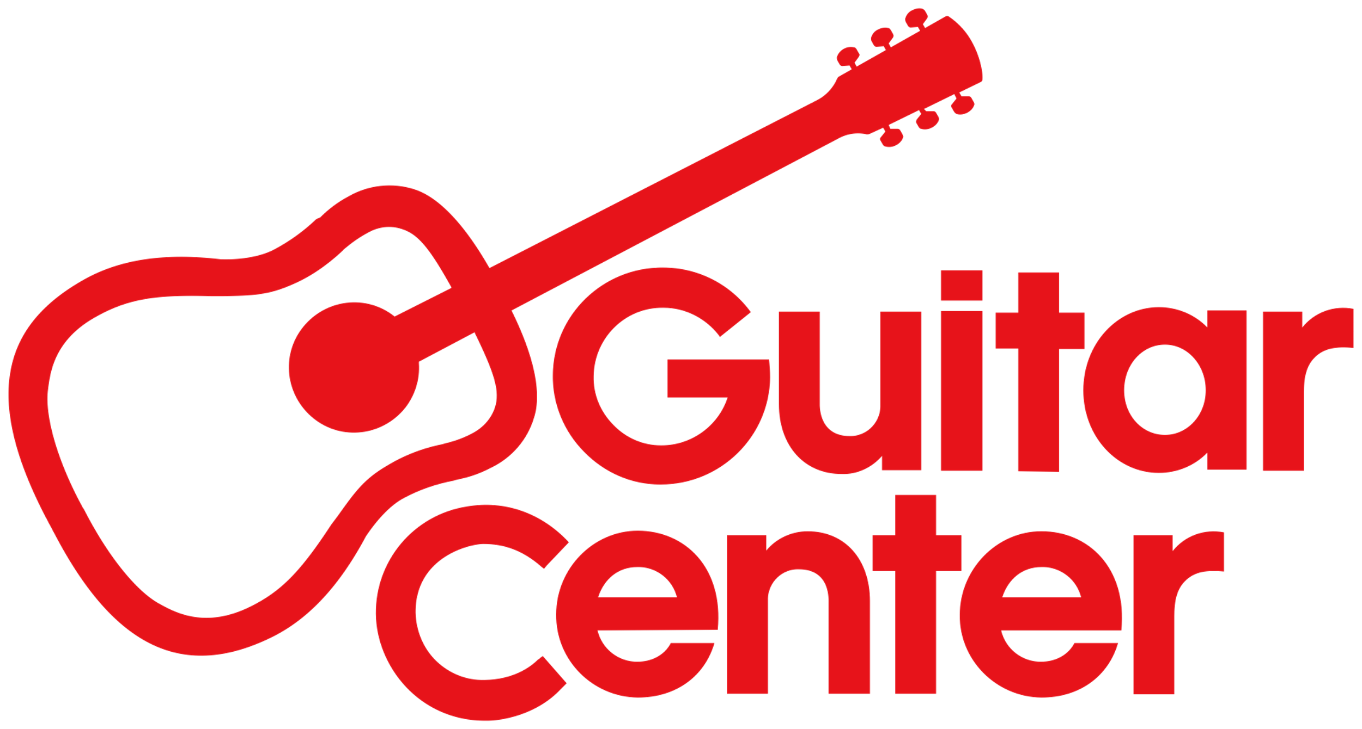

***MEDIA ALERT***

Ernie Ball Music Man Presents in-store session with Animals As Leaders founder and guitarist Tosin Abasi on Saturday, Oct. 7, at Guitar Center Hollywood

WHO: Ernie Ball Music Man presents an exclusive in-store event with guitarist Tosin Abasi at GUITAR CENTER HOLLYWOOD.

WHAT: Mark your calendar for a special in-store event with Tosin Abasi. The self-taught guitarist is best known as the founder and guitarist for progressive metal band Animals As Leaders, and has performed with other luminary guitarists, such as Steve Vai, Joe Satriani and Yngwie Malmsteen. Join us as Abasi talks gear, takes questions and goes over the equipment he won’t play without.

WHEN: Saturday, October 7, 2023, 1:00 p.m. PDT

WHERE: Guitar Center Hollywood
7425 Sunset Blvd.
Los Angeles, CA 90046
Store phone number: 323-874-1060
###

Photo file 1: GC_TosinAbasi_InStoreEvent.JPG

Photo caption 1: Ernie Ball Music Man Presents in-store session with Animals As Leaders founder and guitarist Tosin Abasi on Saturday, Oct. 7, at Guitar Center Hollywood

Photo file 2: TosinAbasi.JPG

Photo caption 2: Tosin Abasi

About Guitar Center:
Guitar Center is the leading retailer of musical instruments, lessons, repairs and rentals in the U.S. With more than 300 stores across the U.S. and one of the top direct sales websites in the industry, Guitar Center has helped people make music for more than 50 years. Guitar Center also provides customers with various musician-based services, including Guitar Center Lessons, where musicians of all ages and skill levels can learn to play a variety of instruments in many music genres, GC Repairs, an on-site maintenance and repairs service, and GC Rentals, a program offering easy rentals of instruments and other sound reinforcement gear. Additionally, Guitar Center’s sister brands include Music & Arts, which operates more than 250 stores specializing in band & orchestral instruments for sale and rental, serving teachers, band directors, college professors, parents and students, and Musician’s Friend, a leading direct marketer of musical instruments in the United States. For more information about Guitar Center, please visit guitarcenter.com.

FOR MORE INFORMATION PLEASE CONTACT:
Clyne Media | pr@clynemedia.com
Guitar Center | media@guitarcenter.com

