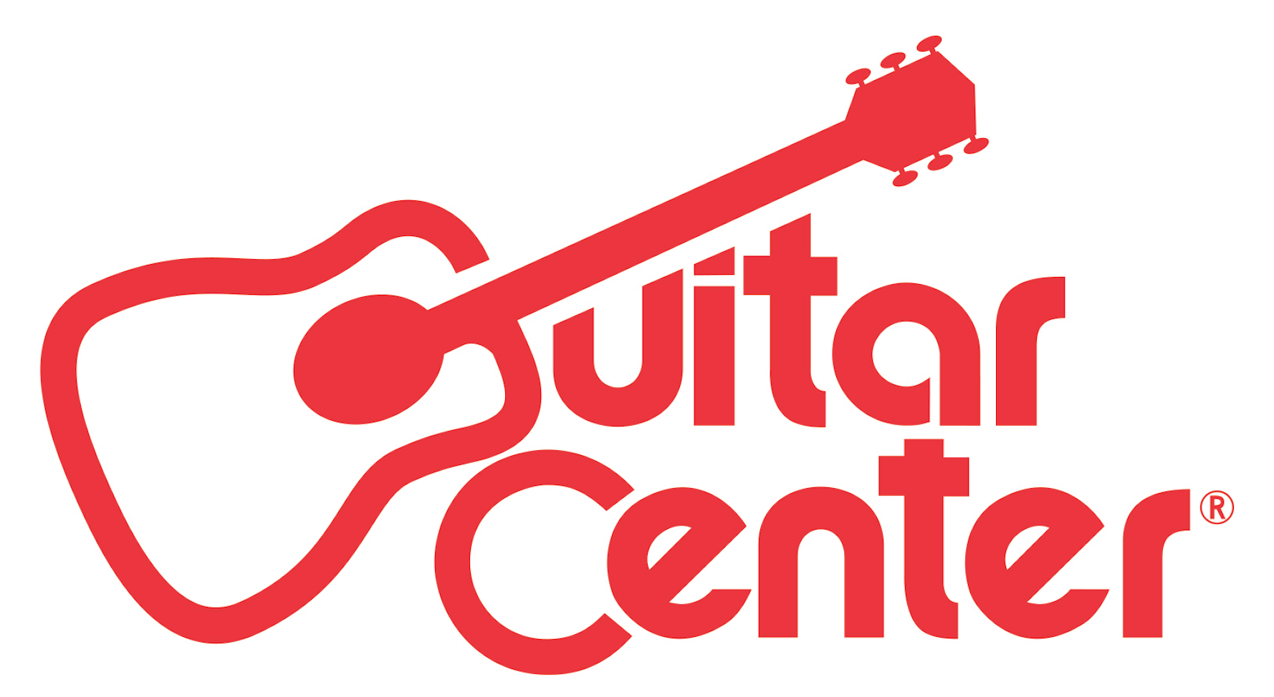

FOR IMMEDIATE RELEASE

Guitar Center To Promote Ron Japinga to Chief Executive Officer

ANNOUNCEMENT HIGHLIGHTS:
- Ron Japinga to assume Chief Executive Officer role
- Promotion to provide continuity of strategy following retirement of Darrell Webb

Los Angeles, CA (August 9, 2016): Guitar Center, the world’s largest musical instrument retailer, announced today that Darrell Webb will retire from his positions with the company, effective upon the naming of his successor as Chief Executive Officer. Guitar Center expects to finalize the promotion of Ron Japinga as Webb’s successor in the coming days.

Japinga’s promotion to CEO will follow his recent promotion to President of Guitar Center. In his new role, Japinga will expand his responsibilities to include the entire Guitar Center enterprise. Japinga’s promotion will provide Guitar Center with the opportunity to continue building on the company’s strategic initiatives.

“I’ve thoroughly enjoyed my time at Guitar Center and am proud of the financial and operational successes that we’ve achieved in the past year and a half,” stated Webb. “The company is in a solid position and I have tremendous confidence in Ron’s ability to guide the company. I look forward to seeing what Ron and the team will accomplish in the future.”

Before joining the team at Guitar Center, Japinga had an impressive 8-year career at West Marine where he was the Executive Vice President of Merchandising, Planning and Logistics. Prior to that, Japinga was a VP-level executive with Kohl’s Department Stores. At Guitar Center as Executive Vice President for Supply Chain and Private Brands, Japinga shared his vast knowledge of retailing throughout the company to positively influence Guitar Center’s overall performance.

“I’m excited about this opportunity, on both a personal and professional level,” said Japinga. “One of the key reasons I joined the team here at Guitar Center was due to its great prospects for success. We have accomplished so much since then, yet we have more to accomplish. I remain enthusiastic about the company and look forward to contributing to the strategic direction that we’ve established in order to continue that success.”

About Guitar Center:
Guitar Center is the world’s largest retailer of guitars, amplifiers, drums, keyboards, recording, live sound, DJ, and lighting equipment. With more than 270 stores across the U.S. and one of the top direct sales websites in the industry, Guitar Center has helped people make music for more than 50 years. In addition, Guitar Center’s sister brands includes Music & Arts, which operates more than 140 stores specializing in band & orchestral instruments for sale and rental, serving teachers, band directors, college professors and students, and Musician’s Friend, a leading direct marketer of musical instruments in the United States. With an unrivalled in-store experience, an industry-leading online presence and passionate commitment to making gear easy-to-buy, Guitar Center is all about enabling musicians and non-musicians alike to experience the almost indescribable joy that comes from playing an instrument. For more information about Guitar Center, please visit www.guitarcenter.com.

You can visit our press room at http://www.guitarcenter.com/pages/press-room and send media inquiries to media@guitarcenter.com.

FOR MORE INFORMATION PLEASE CONTACT:
Robert Clyne | Clyne Media, Inc. | 615.662.1616 | robert@clynemedia.com
Sarah Chavey | Praytell Agency | 313.407.7571| GCPR@praytellstrategy.com
Syvetril Perryman | Guitar Center | 818.735.8800 | media@guitarcenter.com

