FOR IMMEDIATE RELEASE
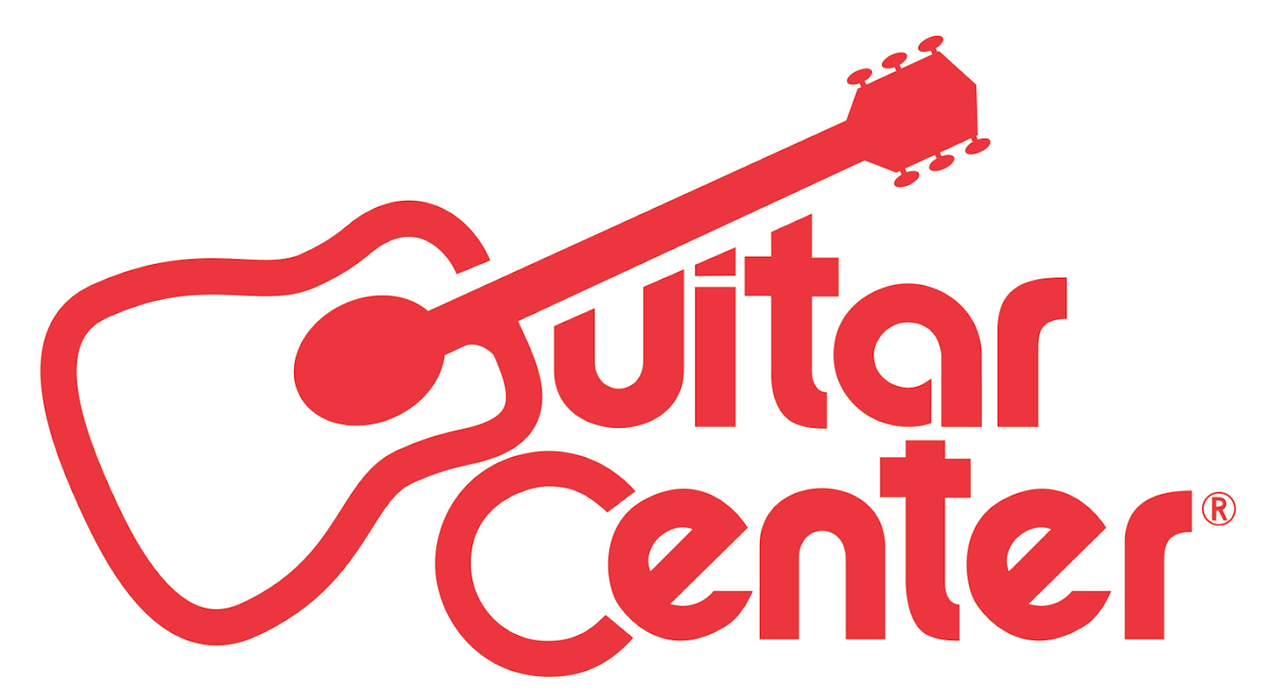

Guitar Center Expands East Coast Presence with New Store Grand Openings

The new locations in Spartanburg, SC, and West Springfield, MA, give area residents one-stop shops for all of their music needs, from instruments and on-site lessons to guitar repairs and rental services

Los Angeles, CA (June 29, 2016) – Guitar Center, the world’s largest instrument retailer, has been expanding its footprint on the East Coast with recent store grand openings in Spartanburg, South Carolina, and West Springfield, Massachusetts. These two grand openings further underscore Guitar Center’s ongoing expansion and its commitment to serving growing music communities nationwide. The Spartanburg store, covering 10,000 square feet, can be found at 1487 W. O. Ezell Blvd, Spartanburg, SC 29301. The West Springfield store, a 12,000-square-foot facility, is located at 935 Riverdale St., West Springfield, MA 01089. To celebrate the new stores, GC recently held two Grand Opening weekend events.

Both stores feature modern showrooms equipped with the latest products for musicians — from guitars, amplifiers, percussion instruments and keyboards to live sound, DJ, lighting and recording equipment. Customer services include Guitar Center Lessons, an in-house, state-of-the-art music academy for players of all ages and skill levels, GC Repairs, an on-site maintenance and repairs service, GC Rentals, easy rentals of instruments and other gear, and Guitar Center Workshops, offering free introductory classes and instruction on guitar, ukulele, and recording.

As part of Guitar Center’s initiatives designed to educate and inspire artists nationwide, both new stores will offer unique opportunities for musicians to craft their skills, maintain their instruments and experience many other aspects of the music industry first-hand. Guitar Center offers nationwide programs designed to spearhead creativity and highlight the nation’s most promising undiscovered talent. Spartanburg residents will now be able to participate in programs including Guitar Center Singer-Songwriter, Guitar Center’s Drum-Off, Guitar Center’s Cover Me and more.

West Springfield and Spartanburg shoppers are also able to enjoy Guitar Center’s multi-channel “endless aisle,” which gives customers the ability to combine in-store, online and phone options to purchase music equipment from anywhere.

Guitar Center Spartanburg Store and Lessons Hours:
Monday 10:00am – 6:00pm (lessons until 9:00pm)
Tuesday – Friday 10:00am – 9:00pm
Saturday 10:00am – 8:00pm
Sunday 11:00am – 7:00pm

Guitar Center West Springfield Store and Lessons Hours:
Monday 10:00am – 6:00pm (lessons until 9:00pm)
Tuesday – Friday 10:00am – 9:00pm
Saturday 10:00am – 8:00pm
Sunday 11:00am – 7:00pm

Photo file 1: GC_Spartanburg_Storefront.JPG
Photo caption 1: The storefront of Guitar Center’s new retail location in Spartanburg, South Carolina.

Photo file 2: GC_Spartanburg_Employees.JPG
Photo caption 2: The employee team at Guitar Center’s new retail location in Spartanburg, South Carolina.

Photo file 3: GC_Spartanburg_Showroom.JPG
Photo caption 3: The showroom of Guitar Center’s new retail location in Spartanburg, South Carolina.

Photo file 4: GC_WestSpringfield_Storefront.JPG
Photo caption 4: The storefront of Guitar Center’s new retail location in West Springfield, Massachusetts.

Photo file 5: GC_WestSpringfield_Employees.JPG
Photo caption 5: The employee team at Guitar Center’s new retail location in West Springfield, Massachusetts.

Photo file 6: GC_WestSpringfield_Showroom.JPG
Photo caption 6: The showroom of Guitar Center’s new retail location in West Springfield, Massachusetts.

About Guitar Center:
Guitar Center is the world’s largest retailer of guitars, amplifiers, drums, keyboards, recording, live sound, DJ, and lighting equipment. With more than 270 stores across the U.S. and one of the top direct sales websites in the industry, Guitar Center has helped people make music for more than 50 years. In addition, Guitar Center’s sister brands include Music & Arts, which operates more than 120 stores specializing in band & orchestral instruments for sale and rental, serving teachers, band directors, college professors and students, and Musician’s Friend, a leading direct marketer of musical instruments in the United States. With an unrivalled in-store experience, an industry-leading online presence and passionate commitment to making gear easy-to-buy, Guitar Center is all about enabling musicians and non-musicians alike to experience the almost indescribable joy that comes from playing an instrument. For more information about Guitar Center, please visit www.guitarcenter.com.

You can visit our press room at http://www.guitarcenter.com/pages/press-room, and send media inquiries to media@guitarcenter.com.

FOR MORE INFORMATION PLEASE CONTACT:
Sarah Chavey | Praytell Agency | 313.407.7571 | sarah@praytellagency.com
Robert Clyne | Clyne Media | 615.662.1616 | pr@clynemedia.com
Syvetril Perryman | Guitar Center | 818.735.8800 x 2979 | media@guitarcenter.com

