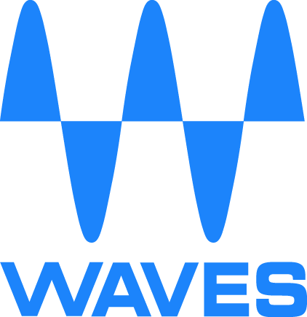

Maxx Technologies by Waves Audio to Have Strong Presence at 2018 Consumer Electronics Show

Waves Audio will be demonstrating a range of its groundbreaking DSP technology, including the Waves & Realtek co-developed WNX7000 (the world’s first Integrated Circuit with embedded Waves Nx Virtual Reality Audio Technology) and Waves MaxxProtect Technology

CES 2018, LAS VEGAS, NV, January 9, 2018 – As the preeminent provider of intelligent audio in consumer electronics, Waves Audio, a global leader in audio DSP technologies, will be demonstrating several of its audio solutions at this year’s Consumer Electronics Show. Waves will be showcasing the WNX7000 – its first-ever integrated circuit (IC) with embedded Waves Nx Virtual Reality Audio capabilities, and which has recently been adopted by leading consumer electronics firms Acer and 1More. Waves will also be highlighting the Nuvoton NAU8331 Amplifier and Waves MaxxProtect technology, which will be demonstrated together as part of an integrated audio speaker by leading acoustics manufacturing company Bujeon.

The WNX7000 – a High-Definition Audio DSP embedded with Waves Nx technology:
Waves co-developed the WNX7000 in partnership with Realtek Semiconductor Corp. (Taiwan Stock Exchange: 2379.TW), one of the world’s leading network and multimedia IC providers. The WNX7000 combines Realtek’s market-leading audio codec technology and Waves’ professional audio algorithmic capabilities, making it the ideal solution for any manufacturer interested in developing headphones or headsets capable of providing the best virtual reality audio experiences for customers.

The WNX7000 is designed to meet the evolving VR/AR needs of the consumer electronics market, bringing the virtual reality audio experience to end users over headphones. WNX7000 is a complete Low Power DSP & Codec Hub audio solution with an integrated headphone amplifier. The high-quality components provided by Realtek, coupled with Waves’ state-of-the-art Nx virtual audio processor, will enable any device to faithfully reproduce 5.1 and 7.1 surround and virtual-reality audio content over headphones, with increased intelligibility reducing listening fatigue. Waves Nx on WNX7000 is an efficient, all-in-one solution that reduces the processing load on devices’ main processors.

The Nuvoton NAU8331 Amplifier:
The mono Nuvoton NAU8331 Amplifier, when combined with Waves’ advanced MaxxProtect technology, offers full speaker protection. This solution brings consumers unparalleled audio performance and is suited for most applications including smart speakers, smartphones, laptops, tablets, mobile devices and Bluetooth®-enabled devices. Additionally, this paring will be utilized by leading acoustics manufacturing company Bujeon, as part of an integrated audio speaker solution.

“Waves Audio continues to develop technologies that are being embraced by the leading manufacturers of consumer devices who are all looking to provide end users with an enhanced audio experience,” stated Tomer Elbaz, EVP & GM, Consumer Electronics Division of Waves Audio. “For over 25 years, Waves has been the trusted name and leading developer of audio DSP solutions for professional and the consumer electronics audio markets. In addition to Realtek, Nuvoton and Bujeon, it’s no wonder that Waves technologies are being employed by top leading consumer electronics companies.”

Waves Audio is exhibiting at the Westgate Hospitality Suites (2610) at the 2018 International CES in Las Vegas, NV.

About Waves Audio
Waves is the world-leading developer of audio DSP technologies and the driving power behind hit records, major motion pictures and popular video games the world over. A recipient of a Technical GRAMMY® Award, Waves is acclaimed by top professional and prosumer users worldwide. More than 400,000 recording studios, mixing and mastering facilities use Waves' portfolio of cutting edge technologies on a daily basis to create top-selling music, movies and games. Waves' professional technologies, 25 years of expertise, and passion for sound are now utilized for all premium audio experiences on consumer electronics devices.

For more information, please visit http://www.waves.com or connect with us on Twitter @WavesAudioLtd

Waves Audio PR Contact:
Robert Clyne, Clyne Media, Inc.
C: 615-300-4666
E: Robert@clynemedia.com

# # #

