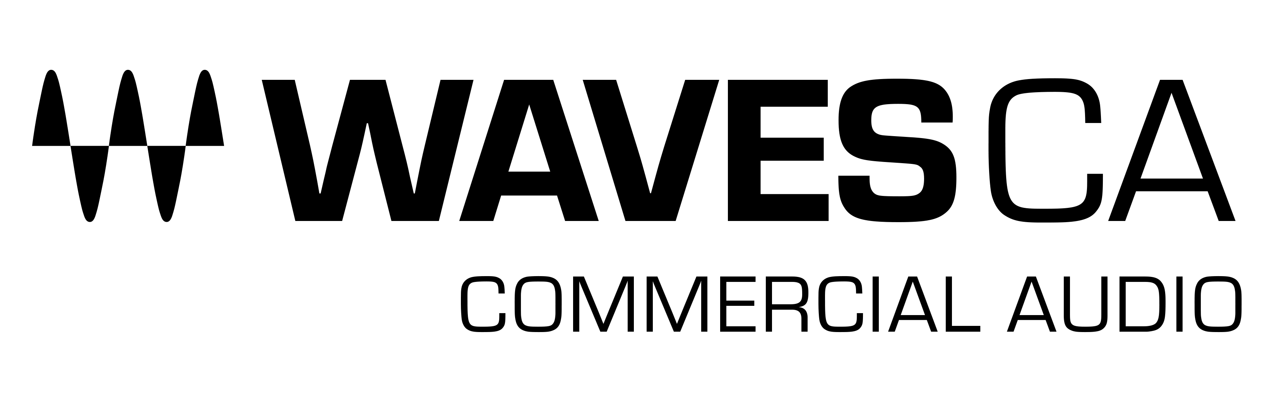
PRESS RELEASE
Contact: Clyne Media, Inc.
Tel: (615) 662-1616

FOR IMMEDIATE RELEASE

Waves Announces Cloud MX Audio Mixer, a Broadcast-Ready Cloud-Based Audio Mixer with Superior Sound Quality

Knoxville, TN, June 7, 2022 — Waves Audio, the world’s leading developer of professional audio signal processing technologies and plugins, announces Cloud MX Audio Mixer, a 100% cloud-based audio mixer with superior sound quality for cloud broadcast environments. Cloud MX Audio Mixer delivers pristine audio, high-precision mix control, and creative processing capabilities with full Waves plugin integration – all in a scalable, remotely operated, broadcast-ready cloud workflow.

Broadcasters and media organizations can now add state-of-the-art audio mixing and processing to their flexible professional cloud-based workflows, thanks to Cloud MX Audio Mixer’s crystal-clear double-precision 32-bit-float mixing engine, augmented by Waves’ industry-leading arsenal of cloud-licensed audio plugins.

Waves’ Cloud MX Audio Mixer is NDI-compatible, fitting easily into NDI-based environments, with easy patching and routing of NDI audio streams. It is also easily deployed on AWS, making integration with your cloud production systems a breeze. Cloud MX Audio Mixer makes it easy to scale productions with any number of audio mixers, without the operational costs involved in shipping, maintaining, or scheduling on-premise gear and personnel.

Cloud MX Audio Mixer opens your live production workflows to more creative possibilities, with finer control over your audio streams. You can run chains of up to eight cloud-licensed plugins directly on any channel inside the mixer itself – helping you mix any event, in the cloud, with unmatched processing power.

All Waves Cloud MX Audio Mixer packages come with the powerful cloud-licensed Waves eMo plugins (eMo D5 Dynamics, eMo F2 Filter, and eMo Q4 Equalizer), which form the mixer’s channel strip for a fast, efficient workflow. You can expand your audio capabilities even further by upgrading to Cloud MX Audio Mixer Plus, with 11 extra cloud-licensed plugins such as the Primary Source Expander for automatic mic bleed elimination, the legendary Renaissance Vox vocal compressor, the surgical F6 Floating-Band Dynamic EQ, MaxxBass, the L2 UltraMaximizer and more; or to, Cloud MX Audio Mixer Premium which adds over 150 cloud-licensed plugins covering every audio need, including the Dugan Speech plugin for real-time automatic mixing of multiple mics.

Cloud MX Audio Mixer’s control options include multiple touchscreen support, plus tactile mixing with the Waves FIT controller and/or Mackie/MIDI controllers.

With Cloud MX Audio Mixer, you and your team can bring a new level of audio fidelity, flexibility, and control to your broadcast production—with easy deployment and superior uncompromising sound quality.

Cloud MX Audio Mixer features:
- 100% cloud-based audio mixing solution
- Easily scalable to any broadcast requirement
- NDI-compatible with easy routing of NDI audio for all ingress/egress streams
- Easy deployment on AWS
- 32-bit floating point mix engine; up to 96 kHz sample rate
- 64 stereo/mono input channels, 44 bus/return channels
- 16 monitor auxes and 8 FX auxes (stereo/mono), 8 audio groups, L/R/C/Mono, 8 matrixes (stereo/mono)
- 16 DCA faders, 8 mute groups, 8 user-assignable shortcut keys
- Cloud-licensed channel strip eMo plugins (dynamics, filter, EQ) included in all Cloud MX Audio Mixer packages)
- Also available: Cloud MX Audio Mixer Plus with 11 additional cloud-licensed plugins; and Cloud MX Audio Mixer Premium with over 150 cloud-licensed plugins
- Full operator-control with the tactile Waves FIT controller and/or up to 4 touchscreens connected via industry-standard remote protocols

Waves Cloud MX Audio Mixer audio mixer ensures superior audio quality and an advanced mixing workflow without compromise, in a professional cloud environment.

To learn more, click here.

…ends 543 words

Photo file 1: CloudMX_AudioMixer.JPG
Photo caption 1: Waves Cloud MX Audio Mixer

About Waves Audio Ltd.:
Waves is the world’s leading developer of audio DSP solutions for music production, recording, mixing, mastering, sound design, post-production, live sound, broadcast, commercial and consumer electronics audio markets. Since its start in the early '90s, Waves has developed a comprehensive line of over 250 audio plugins and numerous hardware devices. For its accomplishments, Waves received a Technical GRAMMY® Award in 2011, and its early flagship plugin, the Q10 equalizer, was selected as an inductee into the TECnology Hall of Fame.

Increasingly leveraging pioneering techniques in artificial intelligence, neural networks and machine learning, as well as the company’s three decades of accumulated expertise in psychoacoustics, Waves technologies are being used to improve sound quality in a growing number of market sectors. Around the world, Waves’ award-winning plugins are utilized in the creation of hit records, major motion pictures, and top-selling video games. Additionally, Waves now offers hardware-plus-software solutions (including the revolutionary eMotion LV1 mixer) for professional audio markets. The company’s WavesLive division is a leader in the live sound sector, spearheading the development of solutions for all live platforms. Products from Waves Commercial Audio enable A/V system integrators and installers to deliver superior sound quality for corporate, commercial, government, educational, entertainment, sports and house-of-worship applications. Under its Maxx brand, Waves offers semiconductor and licensable algorithms for consumer electronics applications, used in laptops, smartphones, smart speakers, gaming headsets, TVs and more from industry leaders such as Dell, Google, Fitbit, Acer, Asus, Hisense and others.

North America Offices:
Waves, Inc., 2800 Merchants Drive, Knoxville, TN 37912;
Tel: 865-909-9200, Fax: 865-909-9245, Email: info@waves.com,
Web: http://www.waves.com

Corporate Headquarters Israel:
Waves Ltd., Azrieli Center, The Triangle Tower, 32nd Floor, Tel Aviv 67023, Israel;
Tel: 972-3-608-4000, Fax: 972-3-608-4056, Email: info@waves.com,
Web: http://www.waves.com

Waves Public Relations:
Clyne Media, Inc., 169-B Belle Forest Circle, Nashville, TN 37221;
Tel: 615-662-1616, Email: robert@clynemedia.com,
Web: http://www.clynemedia.com

