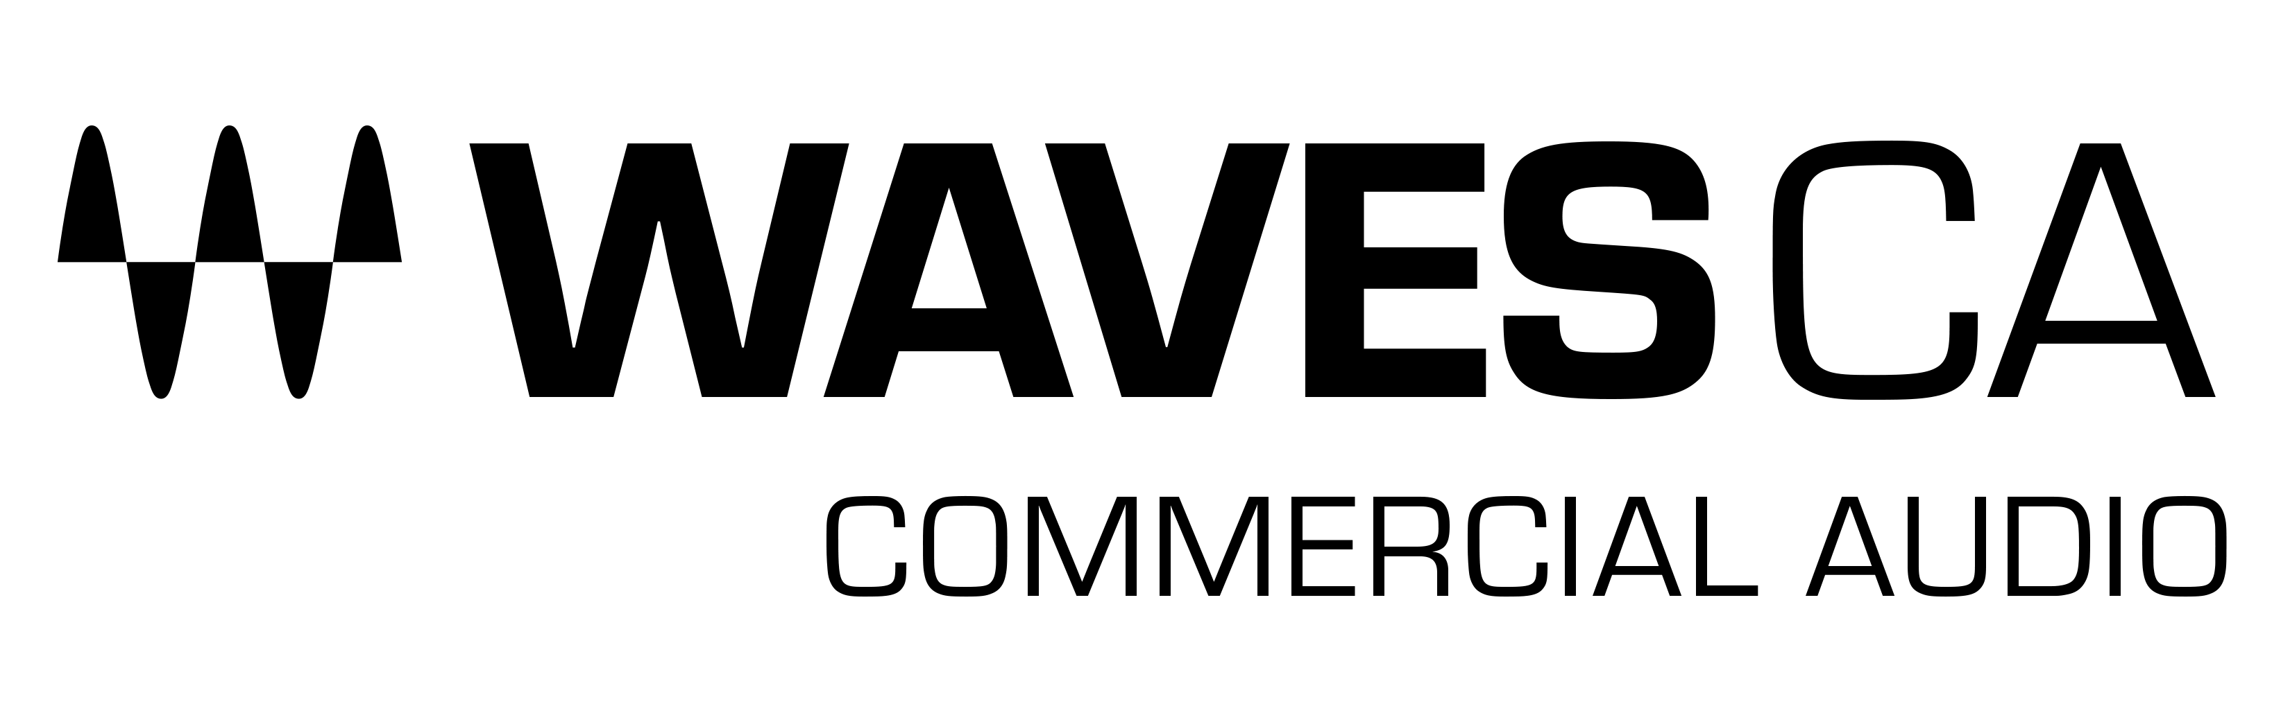
PRESS RELEASE
Contact: Clyne Media, Inc.
Tel: (615) 662-1616

FOR IMMEDIATE RELEASE

NTA Chooses Waves Commercial Audio for Quality and Versatility at Todd English’s Olives at Virgin Hotels Las Vegas

Knoxville, TN, January 6, 2022 – National Technology Associates (NTA), a leading AV integration, design and engineering company, has chosen Waves Commercial Audio solutions for Todd English’s Olives, a new fine-dining venue in Las Vegas, Nevada. NTA installed the Waves CA1000 Commercial Audio DSP Engine to deliver stellar audio quality for live entertainers and diners at the venue, which is located at Virgin Hotels Las Vegas.

NTA specializes in providing advanced AV solutions for the gaming and hospitality industries. For this new design and installation project, NTA worked with the venue to provide a multi-zone audio system for the restaurant and lounge areas that would be both aesthetically and acoustically pleasing to the patrons and live performers.

“As this installation was a relatively small area in a fine-dining venue,” says Joe Garcia Miranda, Senior Design Engineer at NTA, “we needed an intelligent way to automate audio processing for the performer, without physically having an engineer in the space. Small designs, such as the restaurant and lounge at Todd English’s Olives, will often have smaller budgets than some of the larger venues we design. It’s always important that we spec products that have the best performance and versatility to fit within the specified budget.”

NTA installed the Waves CA1000 DSP Engine to process the microphone, instrument, and playback audio sources in the venue. Choosing the Waves CA1000 at the beginning of the project allowed NTA to adapt quickly to changes requested during the deployment. Garcia explains that the system needed to be versatile to support a variety of performers and instruments used at the venue on any given night: “The venue had initially asked to support only an acoustic piano and a singer in the lounge. The entertainment that was eventually hired turned out to be more complex, however, with a varying cast performing everything from standards to modern pop. The typical setup is a digital piano in a baby grand shell, backing tracks, and two singers; but this setup can vary. The versatility of the Waves CA1000 platform made it easy to adapt to all the variations thrown at us for successful deployment.”

Fast Integration with Dante®
The restaurant/lounge installation was implemented using a Dante® network architecture. Garcia was able to quickly integrate the Waves CA1000 within the Dante network: “I love the simplicity of using Waves with Dante without having to incorporate additional hardware. Dante is the standard AoIP transport we use as designers working in a hybrid industry that merges commercial, hospitality and entertainment requirements. The CA1000’s easy integration with Dante was therefore a must-have feature for us.”

Renowned Audio Quality with Customized Presets
Garcia and NTA have been using Waves plugins for recording and production, as well as including Waves SuperRack in designs for larger installation projects. This experience helped Garcia adjust the factory-installed Waves CA presets and customize them to the exact needs of the venue. “When you mention Waves is ‘under the hood,’ many musicians just light up,” he explains, “because they know it guarantees top audio quality for the venue. For this installation, I created my own processing chains using the presets as a starting point. On vocal mics I set up a plugin chain with the Primary Source Expander (PSE), Vocal Rider, F6 Floating Band Dynamic EQ, Sibilance, C6 Multiband Compressor and IR-Live Convolution Reverb. For keys I set up a chain with the F6 and MV2 plugins, and on the entertainer’s playback track I use the Playlist Rider and F6 plugins.”

NTA and the client are pleased with the installation and the resulting audio quality. “What’s most important,” Garcia summarizes, is that with the CA1000 in place, our client is always happy with the quality of the sound, night after night.”

More information about Waves CA products can be found at waves.com/commercial-audio.

…ends 624 words

Photo file: WavesCA_CA1000_Olives.JPG
Photo caption: National Technology Associates (NTA) has chosen the Waves CA1000 Commercial Audio DSP Engine for Todd English’s Olives, a new fine-dining venue in Las Vegas, Nevada

About Waves Audio Ltd.:
Waves is the world’s leading developer of audio DSP solutions for the professional, broadcast, and consumer electronics audio markets. Since its start in the early '90s with the introduction of the Q10 equalizer plugin, Waves has gone on to develop a comprehensive line of over 150 audio plugins, including industry standards like the L1 and L2 Ultramaximizers, popular vintage console models, and innovative mixing tools like Vocal Rider and the Artist Signature Series. For its accomplishments, Waves received a Technical GRAMMY® Award in 2011, and the Q10 was selected as an inductee into the TECnology Hall of Fame. In 2016, Waves released the eMotion LV1 mixer, a revolutionary live digital mixing console that provides real-time audio mixing for front-of-house, monitor, studio and broadcast engineers. Waves technologies are now used to improve sound quality in virtually every sector of the audio market, from recording, mixing, mastering and post-production to broadcast, live sound, and consumer electronics. Waves has over 25 years of expertise in the development of psychoacoustic signal processing algorithms that leverage knowledge of human auditory perception to radically improve perceived sound quality. Waves’ award-winning processors are utilized to improve sound quality in the creation of hit records, major motion pictures, and top-selling video games worldwide. Waves offers computer software and hardware-plus-software solutions for the professional and broadcast markets. The company’s WavesLive division is a market leader in all live sound sectors, spearheading the development of solutions for all live platforms. Under its Maxx brand, Waves offers semiconductor and licensable algorithms for consumer electronics applications. Waves technologies dramatically enhance audio performance and are used by industry leaders such as Dell, Google, Fitbit, Acer, Asus, Hisense and more.

North America Offices:
Waves, Inc., 2800 Merchants Drive, Knoxville, TN 37912;
Tel: 865-909-9200, Fax: 865-909-9245, Email: info@waves.com,
Web: http://www.waves.com

Corporate Headquarters Israel:
Waves Ltd., Azrieli Center, The Triangle Tower, 32nd Floor, Tel Aviv 67023, Israel;
Tel: 972-3-608-4000, Fax: 972-3-608-4056, Email: info@waves.com,
Web: http://www.waves.com

Waves Public Relations:
Clyne Media, Inc., 169-B Belle Forest Circle, Nashville, TN 37221;
Tel: 615-662-1616, Email: robert@clynemedia.com,
Web: http://www.clynemedia.com

