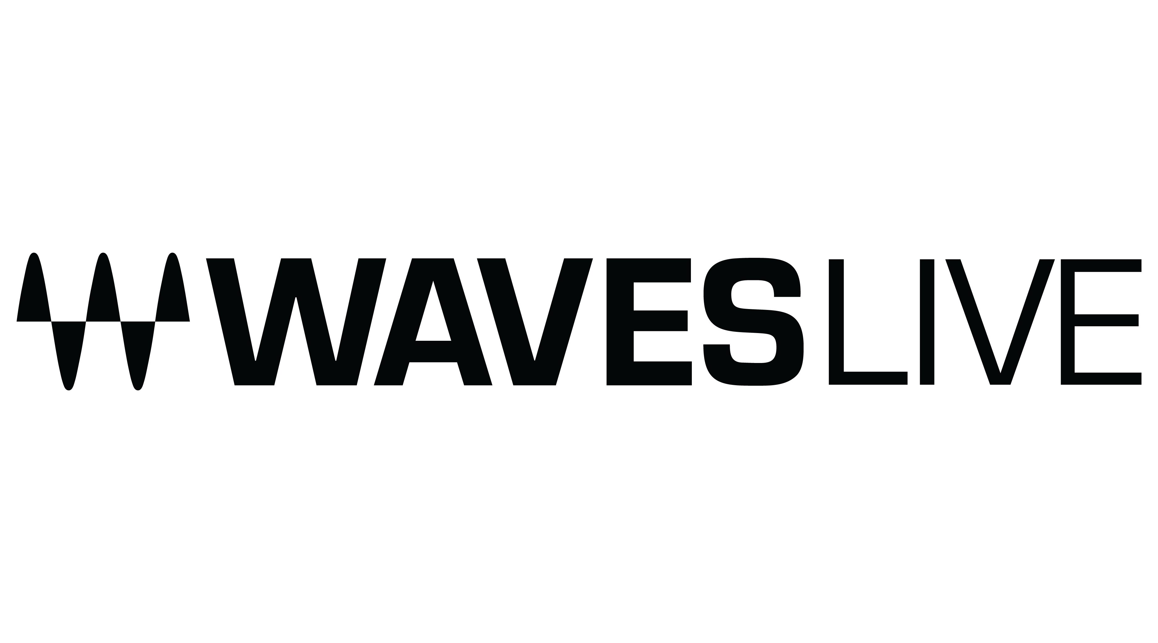
PRESS RELEASE
Contact: Clyne Media, Inc.
Tel: (615) 662-1616

FOR IMMEDIATE RELEASE

Waves and Avid Announce Compatibility of Waves V14 Plugins with Avid VENUE™ | S6L Consoles

Knoxville, TN, September 13, 2022 — Waves Audio, the world’s leading developer of professional audio signal processing technologies and plugins, announces that Avid VENUE™ | S6L consoles are now fully compatible with the latest version of Waves plugins (V14). All Waves V14 SoundGrid-compatible plugins can now run within Avid VENUE | S6L consoles via the Waves SoundGrid Rack for VENUE software rack (which has also been updated to V14).

This release continues and expands the seamless integration of Waves plugins within Avid VENUE | S6L consoles: Waves plugins run directly within the S6L console, with tactile control of the plugins from within the console’s control surface, and no need for an added host computer.

The V14 release expands this seamless integration, adding navigation between Waves plugins directly from the S6L control surface, plus other workflow enhancements. This release also adds official Waves support for Avid I/O sharing.

“The Live Sound Team at Avid is delighted to double down on our relationship with Waves,” says Robb Allan, Avid’s Senior Principal Product Manager, Live Sound. “Avid and Waves are committed to keeping the software development of our products in step with each other. This partnership is great news for all the audio enthusiasts who already use these two products in their day-to-day workflows. Combining the pristine audio of Avid VENUE™ | S6L with the expansive library of Waves plugins gives audio engineers the best tools to craft beautiful sound for any job.”

Allan adds, “Providing tight integration without requiring an extra control computer, including all the tactile control directly on the console, makes for a wonderfully streamlined workflow. Mixing engineers can concentrate on the audio facing forward, accessing all the parameters of a vast suite of creative tools at their fingertips. The ability to store all Waves parameters within the 1000 snapshots available on the S6L means that live sound engineers can program their shows with incredible detail and precision. The massive offering includes 128 voices, with each one supporting a chain of up to eight plugins, which means there is always enough processing power even for the most demanding shows. The ultra-low latency between Avid products integrates with the automatic delay compensation in VENUE software, including bus fed plugins. No matter how complicated a show file and routing scheme are, the audio is always perfectly time-aligned.”

This formidable Waves / S6L combination is currently powering many of today’s biggest live acts, mixed by leading front-of-house engineers including Sean “Sully” Sullivan (Rage Against the Machine), Andrew Newton (Harry Styles), Greg Price (Black Sabbath), Lance Reynolds (alt-J), and Bryan “Froggy” Cross (Doobie Brothers), as well as by the audio teams in leading houses of worship, such as Christ Church of the Valley directed by lead engineer Blair Drake.

“Waves is delighted with the new compatibility of Waves V14 Plugins with Avid VENUE | S6L consoles,” says Mick Olesh, Waves Managing Director and EVP of Sales. “In line with Waves’ ongoing support for the live community, we are gratified to be able to provide professional excellence and significantly enhance the workflow of FOH engineers using S6L consoles.”

To learn more: https://www.waves.com/live-sound/venue.
…ends 507 words

Photo file 1: Avid_V14update.JPG
Photo caption 1: Waves Audio has announced that Avid VENUE | S6L consoles are now fully compatible with the latest version of Waves plugins (V14).

About Waves Audio Ltd.:
Waves is the world’s leading developer of audio DSP solutions for music production, recording, mixing, mastering, sound design, post-production, live sound, broadcast, commercial and consumer electronics audio markets. Since its start in the early '90s, Waves has developed a comprehensive line of over 250 audio plugins and numerous hardware devices. For its accomplishments, Waves received a Technical GRAMMY® Award in 2011, and its early flagship plugin, the Q10 equalizer, was selected as an inductee into the TECnology Hall of Fame.

Increasingly leveraging pioneering techniques in artificial intelligence, neural networks and machine learning, as well as the company’s three decades of accumulated expertise in psychoacoustics, Waves technologies are being used to improve sound quality in a growing number of market sectors. Around the world, Waves’ award-winning plugins are utilized in the creation of hit records, major motion pictures, and top-selling video games. Additionally, Waves now offers hardware-plus-software solutions (including the revolutionary eMotion LV1 mixer) for professional audio markets. The company’s WavesLive division is a leader in the live sound sector, spearheading the development of solutions for all live platforms. Products from Waves Commercial Audio enable A/V system integrators and installers to deliver superior sound quality for corporate, commercial, government, educational, entertainment, sports and house-of-worship applications. Under its Maxx brand, Waves offers semiconductor and licensable algorithms for consumer electronics applications, used in laptops, smartphones, smart speakers, gaming headsets, TVs and more from industry leaders such as Dell, Google, Fitbit, Acer, Asus, Hisense and others.

North America Offices:
Waves, Inc., 2800 Merchants Drive, Knoxville, TN 37912;
Tel: 865-909-9200, Fax: 865-909-9245, Email: info@waves.com,
Web: http://www.waves.com

Corporate Headquarters Israel:
Waves Ltd., Azrieli Center, The Triangle Tower, 32nd Floor, Tel Aviv 67023, Israel;
Tel: 972-3-608-4000, Fax: 972-3-608-4056, Email: info@waves.com,
Web: http://www.waves.com

Waves Public Relations:
Clyne Media, Inc., 169-B Belle Forest Circle, Nashville, TN 37221;
Tel: 615-662-1616, Email: robert@clynemedia.com,
Web: http://www.clynemedia.com

