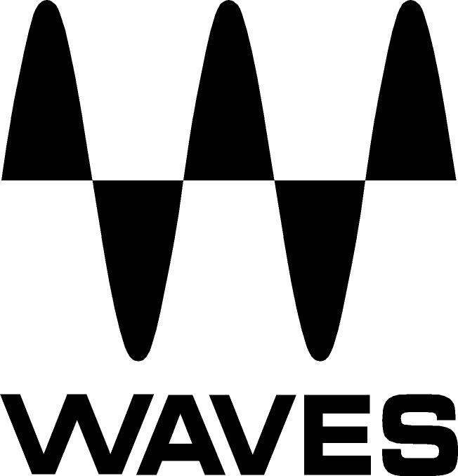
PRESS RELEASE
Contact: Clyne Media, Inc.
Tel: (615) 662-1616
Fax: (615) 662-1636

FOR IMMEDIATE RELEASE

Waves Now Shipping the New SSL EV2 Channel Plugin

Knoxville, TN, November 15, 2021 — Waves Audio, the world’s leading developer of professional audio signal processing technologies and plugins, is now shipping the SSL EV2 Channel plugin – Waves’ all-new modeling of the classic SSL sound.

Authorized by Solid State Logic, the Waves SSL EV2 Channel plugin is a brand-new recreation of the legendary SSL 4000E console channel strip. With new features, including the original SSL “O2” Brown EQ and the console’s richly saturated mic pre and line inputs, SSL EV2 Channel delivers a new level of analog depth and detail – an elevated take on the timeless SSL sound.

Recreated from the ground up using Waves’ new Precision Analog Component® technology, the Waves SSL EV2 Channel has been modeled component-by-component from a meticulously maintained reference console, carefully selected by Solid State Logic.

Alongside the classic dynamics and EQ controls, the SSL EV2 Channel plugin introduces versatile new features. You can now switch between two iconic SSL EQ flavors: the Black Knob (242), delivering the SSL’s famous clean punch; and the original Brown Knob (O2) – the first EQ developed for SSL E-Series consoles – which delivers a crunchy, gritty sound rich with character.

The newly modeled Line and Mic preamp input section gives you rich harmonic distortion options, from gentle saturation to an aggressive drive. You can engage THD (Total Harmonic Distortion) with the Analog switch – a key element in recreating the saturated analog console sound – or you can turn Analog off for a clean input.

The Dynamics section includes a soft-knee compressor/limiter and a gate/expander. You can place it before or after the EQ in your chain for more creativity and precision. As in the original hardware, makeup gain is applied automatically.

The Waves SSL EV2 Channel comes loaded with over 600 presets – including hundreds of presets by GRAMMY®-winning producers and mix engineers Jacquire King, Stuart White, Joe Barresi, Lu Diaz, Dave Pensado, Rich Costey, Jack Joseph Puig, and many more.

SSL EV2 Channel at a glance:
- Brand new modeling of the classic SSL 4000E console channel strip
- Authorized by Solid State Logic
- New level of analog depth, richness and detail
- New: Switch between the iconic Brown (O2) and Black (242) EQ knobs
- New mic pre/line section for rich harmonic saturation, with Analog THD
- Place Dynamics before or after EQ for more creativity and control
- Over 600 presets by GRAMMY®-winning producers and mixers: Jacquire King, Stuart White, Joe Barresi, Dave Pensado, Lu Diaz, many more

From George Martin to Dr. Dre, David Bowie to Kendrick Lamar, the SSL sound is a cornerstone of the music industry. The Waves SSL EV2 Channel brings you that legendary sound, elevated.

The Waves SSL EV2 is available separately and also as part of the Waves SSL 4000 Collection and Waves Studio Classics Collection.

Videos:
- NEW! Waves SSL EV2 Channel – The SSL Sound. Elevated.: https://youtu.be/0iYgAkfkuis
- Waves SSL EV2 Channel – See the All-New Features: https://youtu.be/lKad3YZiBtg

…ends 479 words

Photo file 1: SSL_EV2.JPG
Photo caption 1: Waves SSL EV2 Channel plugin

About Waves Audio Ltd.:
Waves is the world’s leading developer of audio DSP solutions for music production, recording, mixing, mastering, sound design, post-production, live sound, broadcast, commercial and consumer electronics audio markets. Since its start in the early '90s, Waves has developed a comprehensive line of over 250 audio plugins and numerous hardware devices. For its accomplishments, Waves received a Technical GRAMMY® Award in 2011, and its early flagship plugin, the Q10 equalizer, was selected as an inductee into the TECnology Hall of Fame.

Increasingly leveraging pioneering techniques in artificial intelligence, neural networks and machine learning, as well as the company’s three decades of accumulated expertise in psychoacoustics, Waves technologies are being used to improve sound quality in a growing number of market sectors. Around the world, Waves’ award-winning plugins are utilized in the creation of hit records, major motion pictures, and top-selling video games. Additionally, Waves now offers hardware-plus-software solutions (including the revolutionary eMotion LV1 mixer) for professional audio markets. The company’s WavesLive division is a leader in the live sound sector, spearheading the development of solutions for all live platforms. Products from Waves Commercial Audio enable A/V system integrators and installers to deliver superior sound quality for corporate, commercial, government, educational, entertainment, sports and house-of-worship applications. Under its Maxx brand, Waves offers semiconductor and licensable algorithms for consumer electronics applications, used in laptops, smartphones, smart speakers, gaming headsets, TVs and more from industry leaders such as Dell, Google, Fitbit, Acer, Asus, Hisense and others.

North America Offices:
Waves, Inc., 2800 Merchants Drive, Knoxville, TN 37912;
Tel: 865-909-9200, Fax: 865-909-9245, Email: info@waves.com,
Web: http://www.waves.com

Corporate Headquarters Israel:
Waves Ltd., Azrieli Center, The Triangle Tower, 32nd Floor, Tel Aviv 67023, Israel;
Tel: 972-3-608-4000, Fax: 972-3-608-4056, Email: info@waves.com,
Web: http://www.waves.com

Waves Public Relations:
Clyne Media, Inc., 169-B Belle Forest Circle, Nashville, TN 37221;
Tel: 615-662-1616, Fax: 615-662-1636, Email: robert@clynemedia.com,
Web: http://www.clynemedia.com

