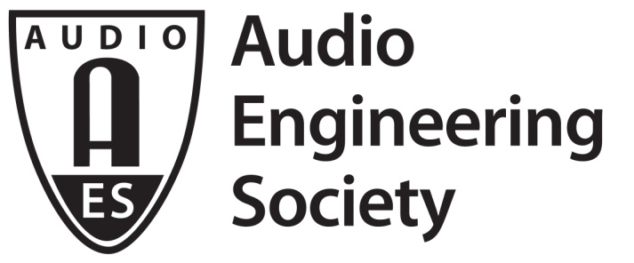

FOR IMMEDIATE RELEASE

AES Show Partner Showcase and Pre-Convention Event Series Access Continues Through December 18

— AES Show Fall 2020 Convention virtual Partner Showcase, AoIP Summit, Zoom and Podcast Webinar and TechTours events bring new and innovative ways to explore products and technologies to a worldwide audience —

New York, NY, December 7, 2020 — AES Show Fall 2020 Convention attendees have the opportunity to take-in this year’s Partner Showcase virtual booths and exhibitions in a new, online format, as well as several on-demand pre-convention events, including the AES Show AoIP Summit, Zoom and Podcast Webinar and TechTours sessions. Taking place over the Audio Engineering Month of October, with extended access available through December 18, the 149th International Audio Engineering Society Convention has been visited by thousands of attendees from around the world for hundreds of livestreamed and on-demand events presented in a variety of formats.

This year the Audio Engineering Society launched a new and innovative series of showcase and virtual trade show exhibition experiences in conjunction with the AES Show Fall 2020 Convention – the AES Show Partner Showcase, hosting on-demand events, presentations and an array of sessions featuring over 60 exhibitors. Partner Showcase exhibits from each brand include live sessions, on-demand videos, product launches, partner discounts, information downloads and collateral materials. AES Show featured Platinum Partners include Amazon Devices, Focusrite, Focusrite Pro, Genelec, NTP Technology (DAD, Penta), and the Recording Academy Producers and Engineers Wing.

Focusing on areas of high importance to many audio professionals today, this year’s AES Show hosted several pre-Convention events, including the Podcast and Zoom Audio Webinar, available for on-demand replay, now, for AES Show attendees. Webinar topics covered an array of techniques and technologies aimed at improving users’ online audio communications and productions, with sessions hosted by Waves Audio, Focusrite, Cloud Microphones and Synthax RME/Digigram.

Also available on-demand is this year’s highly-popular AoIP Summit – a full day of audio networking and AoIP technology-related presentations and panels led by industry experts, hosted by partners AIMS, Focusrite Pro, Synthax RME/Digigram, Audinate, L-Acoustics, and Sweetwater. Over nine hours of on-demand video cover AoIP protocols and standards, interoperability challenges and opportunities, educational usage, using networked audio in sound reinforcement studio applications, and more. The first in an ongoing series, the AES will host its next AoIP Summit on February 25, 2021, further delving into solutions available through the application of the latest AoIP technologies.

In another new hugely popular AES Show experience taking advantage of this year’s online format, AES Show TechTours went virtual, offering visits to “7 Audio Wonders of the World,” hosted in association with Amazon Devices. These AES Show exclusive tours offer attendees guided, behind-the-scenes highlights of some of the most storied recording studios in the world and insightful dialog with studio personnel, including Skywalker Sound (Nicasio, CA), Galaxy Studios (Mol, Belgium), The Village Studios (Los Angeles, CA), Blackbird Studios (Nashville, TN), Abbey Road Studios (London, UK), United Recording Studios (Los Angeles, CA) and Capitol Studios (Los Angeles, CA).

*Note – Abbey Road AESShow TechTour no longer available

AES Show Fall 2020 Convention attendees can access the Partner Showcase, AoIP Summit, Zoom and Podcast Webinar and TechTours events through December 18 at AESShow.com.

…ends 473 words

Photo File 1: AES_Show.JPG
Photo Caption 1: AES Show Fall 2020 Convention virtual Partner Showcase, AoIP Summit, Zoom and Podcast Webinar and TechTours events available online through December 18

About the Audio Engineering Society
The Audio Engineering Society, celebrating over 70 years of audio excellence, now counts over 12,000 members throughout the U.S., Latin America, Europe, Japan and the Far East. The organization serves as the pivotal force in the exchange and dissemination of technical information for the industry. Currently, its members are affiliated with 90 AES professional sections and more than 120 AES student sections around the world. Section activities include guest speakers, technical tours, demonstrations and social functions. Through local AES section events members experience valuable opportunities for professional networking and personal growth. For additional information, visit aes.org.

Join the conversation and keep up with the latest AES News and Events:
Twitter: #AESorg (AES Official)
Facebook: facebook.com/AES.org

AES Marketing Communications:
Email: robert.clyne@aes.org
Tel: 615-662-1616, Fax: 615-662-1636,
Clyne Media, Inc.,
169-B Belle Forest Circle, Nashville, TN 37221;
Web: http://www.clynemedia.com

