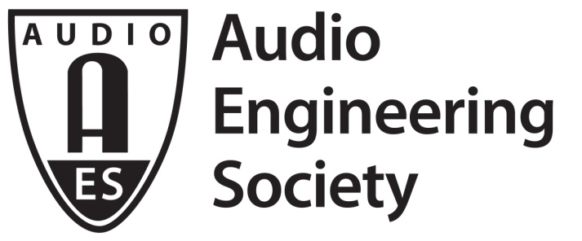

FOR IMMEDIATE RELEASE

AES’s Audio Product Education Institute Hosts Product Development Symposium During AES Show Fall 2020

— APEI will offer three days of product development sessions by top industry experts —

New York, NY, September 22, 2020 — The newly formed Audio Product Education Institute (APEI), an initiative of the Audio Engineering Society (AES), will host a three-day Product Development Symposium as part of the online events of AES Show Fall 2020. Moving the AES Show online has unbound time and place restrictions, allowing the expansion across all of October, now dubbed Audio Engineering Month. This has further made it possible for the traditional Convention Product Development Track to expand into a full AES Symposium format prior to the Convention’s Technical Program. The sessions are scheduled for October 14, 15 and 16. All Access registration for AES Show Fall 2020 is required to attend the Product Development Symposium, available now at AESShow.com.

Across the three days, multiple sessions will expand from the AES Product Development Track, as the Audio Product Education Institute will promote and illuminate the methodologies, practices and technologies involved in developing and bringing audio products to market, spanning the APEI’s six educational pillars: Interactive Voice and DSP; Supply Chain and Sourcing; Modeling and Measurement; Product Management; Automotive Audio; and Artificial Intelligence and Machine Learning.

The Symposium’s sessions will be chaired and presented by experienced audio product professionals who are experts in each field, and are recommended for those seeking to increase their skills and understanding of what it takes to launch successful audio products. Acoustics, electronics, DSP, software engineering, and product and marketing management will all be addressed through a real-world perspective. A detailed schedule will be available on the APEI and AESShow.com websites soon.

APEI will be offering sponsorship opportunities that provide access to a large audience of product development professionals. There are multiple media and content inclusions in the program available based on the sponsorship level. Please contact j.martins@aes.org for details.

APEI is continuously looking for presenters for future events. If you would like to participate, please contact scott.leslie@aes.org to learn more. For more information, please visit audioproducteducationinstitute.org.

…ends 315 words

Photo File 1: APEI_at_AESShowFall2020PromoBlueWeb.JPG
Photo Caption: The Audio Product Education Institute will host product development sessions across three days of the AES Show Fall 2020 Convention’s Audio Engineering Month in October.

About the Audio Engineering Society
The Audio Engineering Society, celebrating over 70 years of audio excellence, now counts over 12,000 members throughout the U.S., Latin America, Europe, Japan and the Far East. The organization serves as the pivotal force in the exchange and dissemination of technical information for the industry. Currently, its members are affiliated with 90 AES professional sections and more than 120 AES student sections around the world. Section activities include guest speakers, technical tours, demonstrations and social functions. Through local AES section events members experience valuable opportunities for professional networking and personal growth. For additional information, visit aes.org.

About the Audio Product Education Institute (APEI)
The Audio Product Education Institute (APEI) was launched in January 2020, as an initiative of the Audio Engineering Society (AES), to focus on promoting methodologies, practices and technologies involved in developing and bringing audio products to market. The Institute roadmap intends to focus on six educational pillars: Interactive Voice and DSP; Supply Chain and Sourcing; Modeling and Measurement; Product Management; Automotive Audio; and Artificial Intelligence and Machine Learning. For more information, visit https://audioproducteducationinstitute.org.

Follow APEI on social channels:
LinkedIn: http://linkedin.com/company/audio-product-education-institute
Twitter: @ApeiInstitute
Facebook: http://facebook.com/audioproducteducationinstitute

Join the conversation and keep up with the latest AES News and Events:
Twitter: #AESorg (AES Official)
Facebook: facebook.com/AES.org

AES Marketing Communications:
Email: robert.clyne@aes.org
Tel: 615-662-1616, Fax: 615-662-1636,
Clyne Media, Inc.,
169-B Belle Forest Circle, Nashville, TN 37221;
Web: http://www.clynemedia.com

