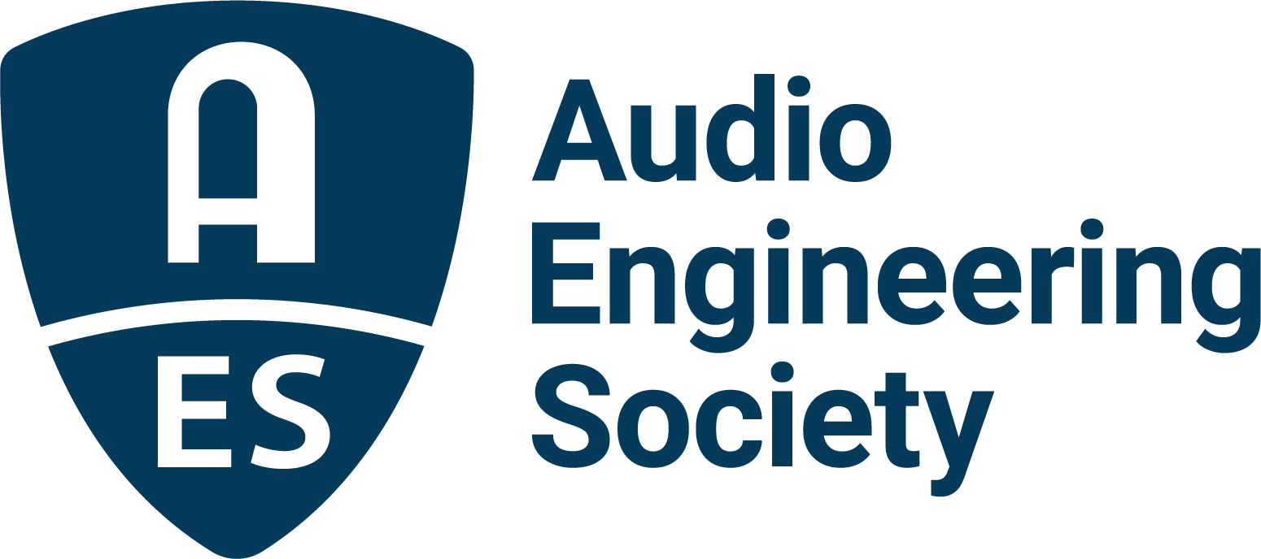

FOR IMMEDIATE RELEASE

AES Fall Online 2021 Production Session: “Anatomy of a Hit Album Under Quarantine – Harmonium Symphonique”

New York, NY, October 19, 2021 — Attendees of the AES Fall Online 2021 Convention will be treated to an in-depth session about the making of Histoires sans paroles – Harmonium Symphonique, a symphonic re-interpretation of the music of influential 1970's Montreal-based progressive folk-rock band Harmonium, which was recorded, mixed and mastered during the pandemic through a long-distance collaboration between engineers in Montreal and Los Angeles. The session, titled “Anatomy of a Hit Album Under Quarantine – Harmonium Symphonique” will be streamed on Saturday, October 23, from 3:00pm – 4:00pm EDT.

The project, released by Canadian record company GSI Musique, was a large undertaking, especially due to the extra precautions necessary during the COVID pandemic, but the production team used a number of online tools like Zoom, Google Docs, Dropbox and streaming in real time via Audiomovers to conference, trade mix notes, monitor progress and see the project to fruition while maintaining distance. The session’s panel includes Harmonium founding member Serge Fiori, who was also co-producer of the project; Charles-Émile Beaudin, recording engineer from Studios Piccolo in Montreal; Simon Leclerc, arranger and orchestral conductor Orchestre Symphonique de Montréal; Reuben Cohen, Lurssen Mastering; Gavin Lurssen, Lurssen Mastering; Rick Winquest, L.A.-based film and television scoring engineer; and moderator Brian (Bt) Gibbs, Co-Chair for AES 151 Fall Convention 2021, as well as a producer and immersive mixing engineer (Skyline Entertainment & Publishing).

The Histoires sans paroles – Harmonium Symphonique studio sessions included recording the 68-piece Orchestre symphonique de Montreal (OSM) and choir at Montreal's 1,900-seat Maison symphonique (Symphony House) – with all involved practicing safe social distancing and other pandemic precautions. The album, within just seven weeks after its release, was certified platinum in Canada, and staggeringly, this album has done the unthinkable: going platinum the OLD way, sticking to physical units and downloads. The project has not been released to streaming services and is only available via online orders. In this session you will hear directly from the artist and the recording and mastering engineers on how they made Histoires sans paroles – Harmonium Symphonique a reality.

Visit the AES Fall 2021 Online Convention website for complete program details, and register now to join the AES for Convention activities throughout the month, including additional Special Events, Tech Tours and the Topically Tracked Technical Program (Oct. 20 – 23), Immersive Audio Days (Oct. 26 – 27) and Audio Education Days (Oct. 30 – 31).

AES Fall Online 2021 Convention Sponsors are Amazon Devices, Amazon Lab126, Dell Technologies, Fraunhofer, IMES (Iron Mountain Entertainment Services), iZotope, L-Acoustics, New Audio Technology, NTP Technology and The Recording Academy® Producers & Engineers Wing®.

…ends 419 words

Photo File 1: SergeFiori.JPG
Photo Caption 1: Harmonium founding member Serge Fiori, who also served as co-producer of Histoires sans paroles – Harmonium Symphonique (Photo credit: © Jean-Charles LaBarre)

About the Audio Engineering Society
The Audio Engineering Society, celebrating over 70 years of audio excellence, now counts over 12,000 members worldwide. The organization serves as the pivotal force in the exchange and dissemination of technical information for the professional audio community. Currently, its members are affiliated with 90 AES professional sections and more than 120 AES student sections around the world. Section activities include guest speakers, technical tours, demonstrations, online events and social functions. Through Conventions, Conferences, Training and Development, and Member Events, as well as the Society’s vast online resources, members experience valuable opportunities for professional networking and personal growth. For additional information, visit aes.org.

Join the conversation and keep up with the latest AES News and Events:
Twitter: #AESorg (AES Official)
Facebook: facebook.com/AES.org

AES Marketing Communications:
Email: robert.clyne@aes.org
Tel: 615-662-1616, Fax: 615-662-1636,
Clyne Media, Inc.,
169-B Belle Forest Circle, Nashville, TN 37221;
Web: http://www.clynemedia.com

