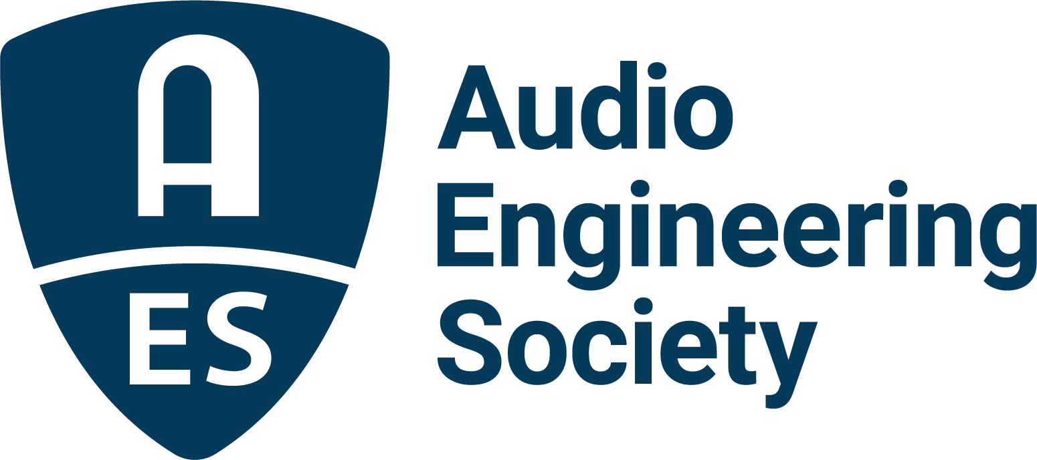

FOR IMMEDIATE RELEASE

AES Fall Online 2021 Music Production Archiving Session: “How You are Protecting Legacies: Topline Results from the Recording Academy P&E Wing and Iron Mountain Entertainment Services Survey”

New York, NY, October 19, 2021 — The Recording Academy P&E Wing and Iron Mountain Entertainment Services (IMES) will give attendees of the AES Fall Online 2021 Convention a first look at results from the recent survey of the P&E Wing and AES music production and engineering community on current practices and challenges in audio archiving in the session “How You are Protecting Legacies: Topline Results from the Recording Academy P&E Wing and Iron Mountain Entertainment Services Survey.” This survey, which received responses from over 1,400 participants, followed on the heels of an archiving summit hosted by IMES and the P&E Wing in June 2021 titled “Protecting Legacies: The Art, Science and Value of Musical Archives,” a first-of-its-kind summit addressing issues around the archiving and preservation of recorded music. The session, which will be streamed on Thursday, October 21, from 3:00pm – 4:00pm EDT, features a panel of industry notables including Maureen Droney, Sr. Managing Director, Recording Academy Producers and Engineers Wing; Cheryl Pawelski, two-time GRAMMY® Award-winning producer and co-founder of Omnivore Records; and Meg Travis, Director, Global Head of Marketing, Iron Mountain Entertainment Services.
Focused on the critical role archiving and preservation play in artists’ careers, the summit featured key stakeholders in the music community comprising audio engineers, archivists, educators, managers, artists and attorneys, who gathered virtually to share their points of view, including stories about some of the nightmare scenarios they’ve encountered working with poorly archived recordings. They also discussed concerns and ideas on how to educate and encourage the application of best practices to the documentation and preservation of recorded projects. Though perhaps the least glamorous part of completing a project, archiving is also arguably one of the most crucial for the long-term value of the recording. As Lance Podell, Senior Vice President & General Manager, Iron Mountain Entertainment Services, said, “It’s only rock ‘n’ roll if you can find it.”

Immediately following the archiving summit, the P&E Wing worked closely with IMES to develop a survey that is related to modern production workflows and how they affect archival practices within the industry. The survey was distributed to the P&E Wing membership and to broaden the base of audio professionals contributing to the survey, AES members were invited to participate. Join us to hear some of the survey results and what your colleagues are saying about what is – and what isn’t – working in archiving, workflow, and preservation technology.

Visit the AES Fall 2021 Online Convention website for complete program details, and register now to join the AES for Convention activities throughout the month, including additional Special Events, Tech Tours and the Topically Tracked Technical Program (Oct. 20 – 23), Immersive Audio Days (Oct. 26 – 27) and Audio Education Days (Oct. 30 – 31).

AES Fall Online 2021 Convention Sponsors are Amazon Devices, Amazon Lab126, Dell Technologies, Fraunhofer, IMES (Iron Mountain Entertainment Services), iZotope, L-Acoustics, New Audio Technology, NTP Technology and The Recording Academy Producers and Engineers Wing.

…ends 482 words

Photo file: Droney_Pawelski_Travis.JPG
Photo caption: Pictured L-R: The panelists for the upcoming session “How You are Protecting Legacies: Topline Results from the Recording Academy P&E Wing and Iron Mountain Entertainment Services Survey”: Maureen Droney, Sr. Managing Director, Recording Academy Producers and Engineers Wing; Cheryl Pawelski, two-time GRAMMY® Award-winning producer and co-founder of Omnivore Records; and Meg Travis, Director, Global Head of Marketing, Iron Mountain Entertainment Services. The session will take place on Thursday, October 21, from 3:00pm – 4:00pm EDT, as part of the AES Fall Online 2021 Convention.

About the Audio Engineering Society
The Audio Engineering Society, celebrating over 70 years of audio excellence, now counts over 12,000 members worldwide. The organization serves as the pivotal force in the exchange and dissemination of technical information for the professional audio community. Currently, its members are affiliated with 90 AES professional sections and more than 120 AES student sections around the world. Section activities include guest speakers, technical tours, demonstrations, online events and social functions. Through Conventions, Conferences, Training and Development, and Member Events, as well as the Society’s vast online resources, members experience valuable opportunities for professional networking and personal growth. For additional information, visit aes.org.

Join the conversation and keep up with the latest AES News and Events:
Twitter: #AESorg (AES Official)
Facebook: facebook.com/AES.org

AES Marketing Communications:
Email: robert.clyne@aes.org
Tel: 615-662-1616, Fax: 615-662-1636,
Clyne Media, Inc.,
169-B Belle Forest Circle, Nashville, TN 37221;
Web: http://www.clynemedia.com

About Iron Mountain Entertainment Services
Iron Mountain Entertainment Services (IMES), the media and entertainment division of Iron Mountain Incorporated®, is the go-to physical and digital media archiving service for the media and entertainment industries. IMES partners with clients ranging from the broadcast, film, music and sports sectors to brand archives and individual artists' collections and estates, to protect and activate media archives to preserve our collective cultural heritage. A global leader in media preservation, restoration and archive management, IMES offers industry-leading archive, storage, chain-of-custody processes and physical and digital content preservation solutions to ensure the complete protection of some of the world’s most treasured and iconic assets. Visit https://www.imes.media for more information.

About The Recording Academy
The Recording Academy represents the voices of performers, songwriters, producers, engineers, and all music professionals. Dedicated to ensuring the recording arts remain a thriving part of our shared cultural heritage, the Academy honors music's history while investing in its future through the GRAMMY Museum®, advocates on behalf of music creators, supports music people in times of need through MusiCares®, and celebrates artistic excellence through the GRAMMY Awards—music's only peer-recognized accolade and highest achievement. As the world's leading society of music professionals, we work year-round to foster a more inspiring world for creators. For more information about the Academy and its Producers & Engineers Wing, please visit www.producersandengineers.com or @ProdEngWing on Instagram.

