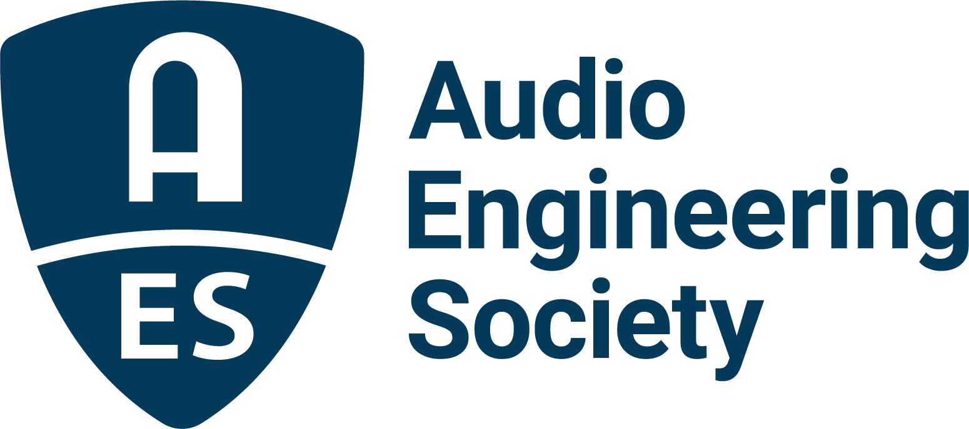

FOR IMMEDIATE RELEASE

St. Vincent and Julian Raymond to Headline AES Fall Online 2021 Convention Platinum Producers Event

— GRAMMY®-winning producers explore music creation and production, from writing to producing a successful song —

New York, NY, October 18, 2021 — The Audio Engineering Society’s Fall Online 2021 Convention’s Technical Program is being held October 20 – 23, in addition to other AES Convention events going on throughout the Audio Engineering Month of October. This year’s Platinum Producers event will host GRAMMY®-winning artist and producer St. Vincent in a discussion with GRAMMY-winning producer and songwriter Julian Raymond on some of the inspirations and struggles that come with art and production, and on the intricacies and opportunities of working and sharing their craft with other producers and engineers in the industry. The event will be available to all registered Convention attendees on Thursday, October 21, 4:00pm EDT, at AESShow.com.

Annie Clark made her recorded debut as St. Vincent in 2007 with Marry Me, leading to her quickly becoming regarded as one of the most innovative and fascinating presences in modern music. St. Vincent’s subsequent albums have met with critical acclaim and commercial success eclipsing that of its predecessor, including Actor (2009), Strange Mercy (2011), and her eponymously titled fourth album, which won the 2014 GRAMMY for Best Alternative Album, making her only the second female artist ever to win in that category. She is also known for working with a variety of top artists and producers, including her collaborative album with David Byrne, Love This Giant, and co-producing her album MASSEDUCTION with Jack Antonoff. In the Platinum Producers session, St. Vincent will delve into her past experiences and struggles, recounting moments that have helped shape her career and find her place in the world of popular music. Together, she and Raymond will offer insights and details on writing and producing and discuss in-depth details on a variety of St. Vincent recordings. Raymond, who currently holds the position of SVP of A&R at Big Machine John Varvatos Records, is known for developing a variety of new bands, as well as for his work as the executive producer and composer for the documentary Glen Campbell: I’ll Be Me, which garnered accolades and recognition including an Academy Award and a Best Country Song GRAMMY for the song “I’m Not Gonna Miss You,” recorded by Campbell.

Visit the AES Fall 2021 Online Convention website for complete program details, and register now to join the AES for Convention activities throughout the month, including additional Convention Keynotes, Special Events, Tech Tours and the Topically Tracked Technical Program (Oct. 20 – 23), Immersive Audio Days (Oct. 26 – 27) and Audio Education Days (Oct. 30 – 31).

AES Fall Online 2021 Convention Sponsors are Amazon Devices, Amazon Lab126, Dell Technologies, Fraunhofer, IMES (Iron Mountain Entertainment Services), iZotope, L-Acoustics, New Audio Technology, NTP Technology, The Recording Academy Producers and Engineers Wing.

…ends 437 words

Photo File 1: St._Vincent.JPG
Photo Caption 1: GRAMMY®-winning artist and producer St. Vincent will explore music creation and production, from writing to producing a successful song, with Julian Raymond in a special AES Fall Online 2021 Convention Keynote presentation on Thursday, October 24 at 4:00pm EDT.

Photo File 2: Julian_Raymond.JPG
Photo Caption 2: GRAMMY®-winning producer and songwriter Julian Raymond will explore music creation and production, from writing to producing a successful song, with St. Vincent in a special AES Fall Online 2021 Convention Keynote presentation on Thursday, October 24 at 4:00pm EDT.

About the Audio Engineering Society
The Audio Engineering Society, celebrating over 70 years of audio excellence, now counts over 12,000 members worldwide. The organization serves as the pivotal force in the exchange and dissemination of technical information for the professional audio community. Currently, its members are affiliated with 90 AES professional sections and more than 120 AES student sections around the world. Section activities include guest speakers, technical tours, demonstrations, online events and social functions. Through Conventions, Conferences, Training and Development, and Member Events, as well as the Society’s vast online resources, members experience valuable opportunities for professional networking and personal growth. For additional information, visit aes.org.

Join the conversation and keep up with the latest AES News and Events:
Twitter: #AESorg (AES Official)
Facebook: facebook.com/AES.org

AES Marketing Communications:
Email: robert.clyne@aes.org
Tel: 615-662-1616, Fax: 615-662-1636,
Clyne Media, Inc.,
169-B Belle Forest Circle, Nashville, TN 37221;
Web: http://www.clynemedia.com

