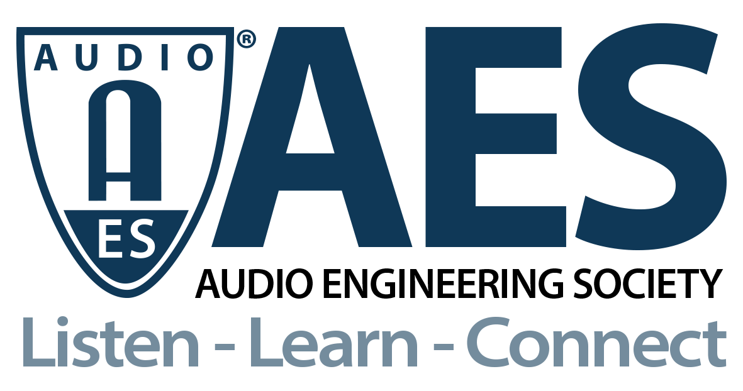

FOR IMMEDIATE RELEASE

AES Audio Product Education Institute Webinar to Explore Acoustic Vehicle Alert Systems (AVAS) and Automotive Sound Design

— AES APEI event will discuss the role of audio in electric vehicles, new regulatory requirements and how car manufacturers and technology providers are responding —

New York, NY, April 26, 2021 — The Audio Product Education Institute (APEI), an initiative of the Audio Engineering Society, will host a new webinar on Automotive Audio on Tuesday, April 27, 2021, at 8:00 AM Pacific (11:00 AM EDT). This will be the first open discussion in the audio community focusing on Acoustic Vehicle Alert Systems (AVAS) and Automotive Sound Design – a new and immediate need for automotive audio engineers and carmakers alike.

Warning sounds designed to alert pedestrians to the presence of electric drive vehicles have been an industry requirement for more than 10 years and are now mandatory for all new electric and hybrid electric vehicles. European Regulation approved in 2014 determines that, “The sound should be easily indicative of vehicle behavior and should sound similar to the sound of a vehicle of the same category equipped with an internal combustion engine.” But how are car manufacturers and technology providers addressing those requirements?

The session will cover the legislation around silent vehicles and the regulations created both in Europe and the U.S., how these regions’ guidelines differ, and how they could conflict with existing vehicle noise regulations. The exterior sound design of vehicles and AVAS, and by extension interior sound enhancement, will be covered including creative tools for design, tuning, testing, and validation. Sound quality will be reviewed, from objective and subject testing through jury testing and sound quality metrics. And, finally, the session will explore the deployment of AVAS and exterior sound as it is implemented on embedded hardware for mass production.

As automotive OEMs race to define their own individual audio identity, APEI’s Automotive Pillar Chair Roger Shively (JJR Acoustics, LLC) will welcome presentations and a panel discussion with three automotive industry experts, who will share their experiences in automotive brand sound and the overall development process. In this session, attendees will hear from Jeroen Lanslots (Product Manager) and Agnieszka Oltarzewska (Product Manager Acoustics), two sound design and acoustic engineering experts at Siemens Digital Industries Software in Belgium, together with Dr. Markus Bodden, the founder and CEO of Neosonic, a German company active in the field of Active Sound Design for the automotive industry.

All the panelists and presenters have extensive experience in experimental acoustics for automotive applications, managing hardware and software solutions for acoustical analysis, sound quality and material testing. The webinar will address the different perspectives of vehicle audio, from sound for electric vehicles to audio brand identity.

This AES Audio Product Education Institute Automotive Audio webinar is part of an ongoing event series that underscores the AES’s commitment to providing its membership and the industry at large with practical knowledge in designing and implementing real-world applications and innovative sound systems.

AES APEI Automotive Sound Design and AVAS Webinar registration: https://audioproducteducationinstitute.org/acoustic-vehicle-alert-systems-avas-and-automotive-sound-design/

…ends 451 words

Photo File 1: AES_APEI_4_27_Event.jpg
Photo Caption 1: The AES Audio Product Education Institute will explore Acoustic Vehicle Alert Systems (AVAS) and Automotive Sound Design in its next webinar on April 27 at 11:00am EDT.

About the Audio Engineering Society
The Audio Engineering Society, celebrating over 70 years of audio excellence, now counts over 12,000 members throughout the U.S., Latin America, Europe, Japan and the Far East. The organization serves as the pivotal force in the exchange and dissemination of technical information for the industry. Currently, its members are affiliated with 90 AES professional sections and more than 120 AES student sections around the world. Section activities include guest speakers, technical tours, demonstrations and social functions. Through Conventions, Conferences, Training and Development and Member Events, and the Society’s vast online resources, members experience valuable opportunities for professional networking and personal growth. For additional information, visit AES.org.

About the Audio Product Education Institute (APEI)
The Audio Product Education Institute (APEI) was launched in January 2020, as an initiative of the Audio Engineering Society (AES), to focus on promoting methodologies, practices and technologies involved in developing and bringing audio products to market. The Institute roadmap intends to focus on seven educational pillars: Voice and DSP; Supply Chain and Sourcing; Modeling and Measurement; Product Management; Automotive Audio; Artificial Intelligence and Machine Learning; and Business Management. For more information, visit https://audioproducteducationinstitute.org.

Join the conversation and keep up with the latest AES News and Events:
Twitter: #AESorg (AES Official)
Facebook: facebook.com/AES.org

AES Marketing Communications:
Email: robert.clyne@aes.org
Tel: 615-662-1616, Fax: 615-662-1636,
Clyne Media, Inc.,
169-B Belle Forest Circle, Nashville, TN 37221;
Web: http://www.clynemedia.com

