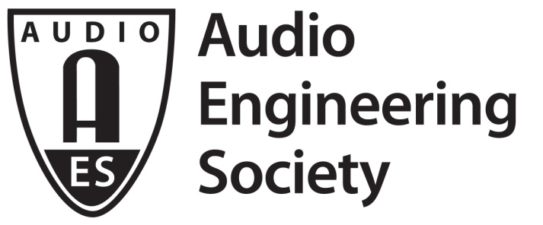

FOR IMMEDIATE RELEASE

AES Audio Product Education Institute Automotive Audio Webinar “Direct Validation of Computational Acoustic Results for Automotive Cabin Simulations” to Take Place January 19, 2021

— AES APEI initiative hosts online sessions on Automotive Audio, exploring practical approaches in designing and implementing automotive sound systems —

New York, NY, January 13, 2021 — The Audio Product Education Institute (APEI), an initiative of the Audio Engineering Society, will host the first of a series of webinars on Automotive Audio on Tuesday, January 19 (12:00pm EST). Titled “Direct Validation of Computational Acoustic Results for Automotive Cabin Simulations,” the webinar will explore automotive sound system implementation and design in a program presented by APEI's Automotive Pillar Chair Roger Shively (Co-founder and Principal, JJR Acoustics, Seattle, WA). Featured presentations will explore simulation, visualization, tuning and auralization of a car cabin by industry experts Mads Herring Jensen (technical product manager for the Acoustics Module of COMSOL) and Christof Faller (founder and managing director, Illusonic).

Jensen’s session, “Modeling Strategies and Techniques in Car Cabin Acoustics” will cover the important role that simulation and virtual models play in the integration of sound systems into the car cabin environment as well as their calibration. Various modeling approaches and techniques used when assessing these systems will be discussed. Jensen will explain how the low to mid frequency behavior of car cabins is captured with a full wave models, while the high frequency behavior is typically captured with ray acoustics techniques, along with the emergence of new numerical methods and improved hardware shifts the frequency at which ray techniques are applied. The presentation also discusses boundary conditions as well as source characterization.

Faller’s presentation, “Visualizing, Tuning, and Auralizing Car Cabin Simulation Results,” will discuss a useful method for visualizing the results from an FEA or Ray Tracing models, where impulse response information is taken directly from a simulation model or generated from amplitude and phase measurement and imported into an Illusonic tool for reviewing time and frequency data for each point in the measurement data file. In automotive applications, the number of data points could correspond with microphones set in an array for each listening position. The resulting data can be grouped for review and comparison to measured data for the purpose of model updates. The data can also be grouped and averaged for a virtual equalization as well as auralization. This process will be reviewed and demonstrated.

Opening remarks and a question-and-answer period following the two sessions will be led by Shively, guided by the perspective of his 34 years of experience in engineering research and development, which includes significant experience in product realization and in launching new products at OEM manufacturers around the world.

This AES Audio Product Education Institute’s Automotive Audio webinar is part of an ongoing event series that underscores the AES’s commitment to providing its membership and the industry at large with practical knowledge in designing and implementing real-world applications and innovative sound systems.

Mads Herring Jensen:
Mads Herring Jensen joined COMSOL in 2011 and is the technical product manager for the Acoustics Module. Before starting at COMSOL, he worked in the hearing aid industry for five years as an acoustic finite element expert. Mads has a PhD in computational fluid dynamics from the Technical University of Denmark.

Christof Faller:
Christof Faller received an M.S. (Ing.) degree in electrical engineering from ETH Zurich, Switzerland, in 2000, and a Ph.D. degree for his work on parametric multichannel audio coding from EPFL Lausanne, Switzerland, in 2004. From 2000 to 2004 he worked in the Speech and Acoustics Research Department at Bell Labs Lucent and its spin-off Agere Systems, where he worked on audio coding for satellite radio, MP3 Surround, and the MPEG Surround international standard. He is currently managing director at Illusonic, a company he founded in 2006.

Webinar registration: https://us02web.zoom.us/webinar/register/WN_gAEHrM4rS8e6lCtx07qrmA

…ends 581 words

Photo File 1: AES_APEI_2021_Automotive_Webinar.jpg
Photo Caption 1: APEI Automotive Audio Webinar - Direct Validation of Computational Acoustic Results for Automotive Cabin Simulations, Tuesday, January 19, at 12:00pm EST.

About the Audio Engineering Society
The Audio Engineering Society, celebrating over 70 years of audio excellence, now counts over 12,000 members throughout the U.S., Latin America, Europe, Japan and the Far East. The organization serves as the pivotal force in the exchange and dissemination of technical information for the industry. Currently, its members are affiliated with 90 AES professional sections and more than 120 AES student sections around the world. Section activities include guest speakers, technical tours, demonstrations and social functions. Through Conventions, Conferences, Training and Development and Member Events, and the Society’s vast online resources, members experience valuable opportunities for professional networking and personal growth. For additional information, visit AES.org.

About the Audio Product Education Institute (APEI)
The Audio Product Education Institute (APEI) was launched in January 2020, as an initiative of the Audio Engineering Society (AES), to focus on promoting methodologies, practices and technologies involved in developing and bringing audio products to market. The Institute roadmap intends to focus on six educational pillars: Interactive Voice Con; Supply Chain and Sourcing; Modeling and Measurement; Product Management; The Legal World; and Artificial Intelligence and Machine Learning. For more information, visit https://audioproducteducationinstitute.org.

Join the conversation and keep up with the latest AES News and Events:
Twitter: #AESorg (AES Official)
Facebook: facebook.com/AES.org

AES Marketing Communications:
Email: robert.clyne@aes.org
Tel: 615-662-1616, Fax: 615-662-1636,
Clyne Media, Inc.,
169-B Belle Forest Circle, Nashville, TN 37221;
Web: http://www.clynemedia.com

